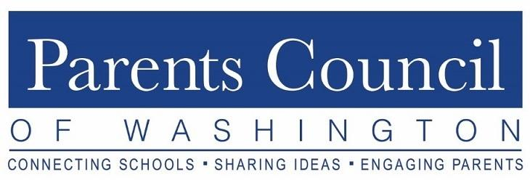

Virtual Film Screening and Moderated Discussion
Tuesday, October 20, 2020
Via Zoom
Discussion of Miss Representation and The Mask You Live In
Moderated by Judith Warner

The following is a summary of a moderated discussion following the week-long virtual screening opportunity of two documentaries: Miss Representation and The Mask You Live In. The discussion was moderated by Judith Warner, a senior fellow at the Center for American Progress, New York Times columnist, and author of And Then They Stopped Talking to Me: Making Sense of Middle School among other titles.

Judith Warner began the discussion with observations based on her lived experiences as a mother of two daughters who graduated from independent schools.

- In Warner’s book, she explored parental fears for their children, particularly in middle school, often being shaped by the parents’ own memories as opposed to what their children are actually experiencing.
  - Parental comments and expectations influence children. Parents often approach children’s middle school time of life with fear and dread based on their experiences.
  - Anxiety can blind parents as to what is happening in their child’s world.
  - Adults can and should focus on the things they can influence or control, instead of focusing too much on external dangers, such as media or stranger danger. Instead, parents should:
    - focus on what we do/do not say, what we model
    - reinforce a child’s best, genuine, whole self
    - see and celebrate who the child is
  - Parents can get caught up in cultural competitiveness and pressure (particularly in Miss Representation). Why not “opt out”?
    - Mental health experts say the popular crowd is not a good place to be and children should not give in to the need to create a perfect image.
    - Parents celebrate the very things that they critique, because they can be the key to social success – being a winner and/or popular.

- The Mask We Live In
  - The documentary portrays generalizations about boys and men with interviews with young men in the extremes.
  - We should think about underlying themes that go beyond representations and media critiques, such as
    - what WE are doing,
    - what our SCHOOLS are doing,
    - what is going on in our world.
  - An interviewee in the film summed up the real danger with the line “In our win-at-all-cost structure, it’s strictly about the win at the expense of character development.”
    - The need to be #1 causes significant unhappiness, and the subsequent issues of drugs and alcohol, especially prevalent among the upper middle class in comparison to other socioeconomic classes.

- Generations of parents have had fears surrounding child development. External dangers can distract parents from what is actually happening.
  - Many of the external dangers are actually declining.
  - There has been evidence of some societal progress since the making of Miss Representation (2011), e.g., the ‘Me Too’ and ‘Times Up’ movements, new journalists, and ‘OK Boomer.’ A new generation of voices is rising up to say, “We won’t tolerate this.”

Highlights from Q&A

Carla Taylor-Pla of the PCW Board moderated a question and answer period following the discussion. Below are highlights.

- Opting out is not always a realistic option, we see this particularly in the settings of college admission and academic pressure. Achieving security and stability may not line up with parental preconceived visions of success.
- Having a narrow focus on achievement, e.g., grades, leadership, extra-curricular activities, does not necessarily lead to happiness. A goal is to raise secure, well-rounded children, but many children are anxious, insecure, and competitive.
- Balance achievement and happiness by listening to children and encouraging them to be their best selves. Understand and adapt for each child’s unique challenges.
- Gender is a spectrum. Try not to perpetuate the gender binary by listening carefully and keeping an open mind.
- Children will identify with who they authentically are, whether that is traditional or non-traditional, popular or non. They often try on some identities in order to figure out who they are. Parents need to reserve judgment and stay present.
- School culture is important. Schools can break up cliques, assign seating, and ensure everyone is treated the same. Parents can help their children show decency and inclusivity in small actions.
- The pandemic has created new challenges with academic instruction as well as social interaction that typically occurs in the school setting. Some evidence has shown that the pandemic has made kids less anxious due to, for example, fewer time demands, some distance from toxic social environments, and opportunities to reconnect with people and activities that make them happy.
- Including emotional intelligence and embracing the total person in teaching is gaining traction in independent schools. We see more teaching around character building, listening, hopefulness, and empathy.
- Children and parents benefit from social media literacy. Schools are working on this too.

