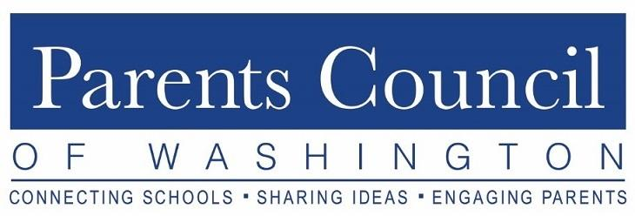
PCW Orientation Summary
Tuesday, October 6, 2020
Zoom Webinar
Guest Speaker: Katherine Reynolds Lewis

Introduction: Maximizing PCW Partnership in Your School Community

Parents Council of Washington (PCW) President Frazier Schulman welcomed PCW Representatives and Parents Association Presidents from member schools. PCW is excited to announce this year’s theme, “Whole Student. Whole School.”

PCW is a non-profit organization, comprised of 15 volunteer board members and one part-time administrator. The mission of the organization is to promote excellence in education by fostering closer communication among parents, students, and independent schools. Over 50 member schools pay annual dues to support 8-10 PCW programs each school year, including two new programs this Fall. Programming will be online through 2020. Board members serve as liaisons to member schools and welcome questions and suggestions from PCW school representatives throughout the year.

PCW Representation

Julie Buchanan, PCW Board Member, provided information on how to share, connect, and engage school communities.
- Monthly checklist with responsibilities and guidelines to promote PCW programs will be distributed by email around the 25th of each month.
- PCW Board liaisons will send information to PCW Reps to distribute to their school communities.
- Program schedule contains an overview of programs planned for the 2020-2021 school year.
- Important resources: Board liaison, program schedule and month-to-month guide, monthly checklist. All are available on the PCW website under “Resources for Reps.”
- Social media presence on Facebook and Twitter.

A brief Q&A with Jenn Lustbader, PCW Board Member, followed the slide presentation.

Featured Guest Speaker - Katherine Reynolds Lewis

Katherine Reynolds Lewis is a Certified Parent Educator, Award Winning Journalist, and the author of The Good News About Bad Behavior.

Key questions: What is my role as a parent? Why don’t kids do what you ask? Is there something different about kids today than 30 years ago?

Self-Regulation Crisis
- Self-regulation crisis based on NIMH Study of 10,123 US Teens. 1 in 2 teens will have mood, substance, behavioral or anxiety disorder by age 18:
  - 32% anxiety disorder,
  - 19% behavioral disorder (ADHD, ODD),
  - 14% mood disorder,
  - 11% substance abuse. (some children suffer from more than one condition.)
- Suicide increasing among youth; from 2006-2016, tween suicide rate doubled.
- Kids do not need more carrot v. stick motivation - instead focus on thought and behavior management.
- What helps kids regulate behavior? Connection with parents, communication, and focus on capability building.

Connection: Element 1
- Parents’ Presence - heart rate starts to synchronize when parents and children together
- Physical Touch - Holding hands with spouse reduces flight or fight response.
- Empathy - Social isolation is similar to physical pain.
- Modeling - Kids learn how we deal with stress through parents: Take a deep breath. Calm ourselves down first and that will help our children self-regulate.
- How Do You Connect with Children?
- weekly designated family time
- cuddles and roughhousing
- playing games
- inside jokes
- creating traditions
- connect before you correct, e.g., instead of saying “Don’t play Minecraft because you play it too much,” say “I know you like Minecraft, but that’s not what we do in our family when school is going on.”

Power of Communication: Element 2
- Talking vs. Communication: Our goal is not just to get kids to do what we want, but to stimulate their critical thinking. We do this through empathy, e.g., ‘Your emotions are OK’ and ‘I can handle your strong feelings.’

- How Do You Communicate with Children?
  - Encouraging and positive language
  - Giving information to stimulate critical thinking. We assume they know what we know, but they don’t.
  - Asking questions
  - Planning and thinking ahead: Help them to build executive function skills for themselves.
  - Leaving notes and signs: e.g., backpacks, walls, as reminders and encouragement

Capability Building: How do We Build Capability in Children?: Element 3
- Kids are capable of more than we give them credit for, e.g., a 4-year old can use child-safety scissors with supervision. Household chores are linked to happiness.
- Anchor positive traits: Comment on the positive, even the tiniest improvements in their actions towards what you’ve asked them to do.
- Let kids fail: Growth happens in failure - Feel like you’re a stronger person when you learn from it. Role play with your children for difficult situations beforehand.
- Ask for help: Ask your kids for help.
- Teach emotional awareness to your kids.

Conclusion

This is a difficult time for parents. Have confidence that we will get through this and that kids with develop new coping skills during the pandemic. A question and answer period followed the presentation.

