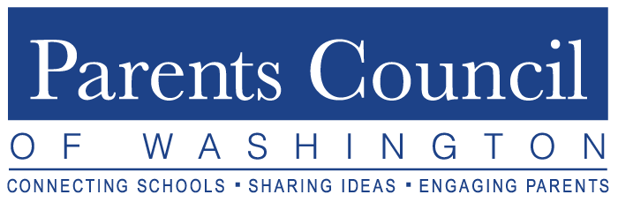
2019-2020 Theme – Healthy. Connected. Engaged.

Mission

To promote excellence in education by fostering communication among parents, students and independent schools in the Washington, DC area through programs, resources and networking opportunities.

Vision

Connecting Schools. Sharing Ideas. Engaging Students/Parents/Faculty/Administrators.

Who We Are

Established in 1964 to create connections, collaborations and community around education and parenting, PCW is governed by a rotating volunteer Board of Directors. All members of the Board (15 at present) are parents of member school students or graduates, serving 3-year terms. The Board, with the help of a part-time administrator, organizes and coordinates all programs and resources.

Who We Serve

PCW is a nonprofit membership organization serving the interests of its member school communities. Eligible members are independent schools (grades K-12) in the Washington, DC metropolitan area, paying annual dues based on type of school and enrollment, and appointing school representatives to liaison with PCW to benefit their school communities via programs, resources and networking opportunities.

- Current Member Profile:

- Member Schools Represented (52)

- Lower (40), Middle (38), Upper (32)
- DC (20), Maryland (21), Virginia (11)
- Co-ed (39), single gender/girl (8), single gender/boy (5)
- Religious affiliated (22), secular (30)

- Students Represented (approximately 25,000)

What We Offer

PCW provides member school communities (administrators, faculty, staff, parents, and students) with robust programs (typically 8-10 per year), abundant resources (via our website, including program summaries), and ample networking opportunities all pertaining to education, child development and/or parenting.

- ANNUAL PROGRAMS (with an indication of date and to whom the event is open)

- Orientation Program – September 17 (Phyllis Fagell, author/school counselor)
for PCW School Representatives and Parent Association (PA) Presidents

- Lower School Forum – October 22 (panel presentations)
for all in our member lower school communities

- Fall Speaker Event – November 14 (Lisa Damour, PhD)
for all in our member school communities & the general public

- Best Practices/Movie Screening – December 5 (Stress Resilience)
for all in our member school communities

- Upper School Student Leader Breakfast – February 4
for selected 11/12th grade member school students

- Middle School Student Leader Breakfast – February 18
for selected 7th grade member school students and counselors/administrators

- Deans of Students’ Breakfast – March 9
follow-up to USSLB for member upper school Deans of Students

- Movie Screening – April 2
targeted for member school parents

- Parent Association (PA) Presidents’ Forum – May 12
for incoming and outgoing member school PA Presidents

- RESOURCES
- PCW website and access to calendar with upcoming events
- Archived summaries of past PCW programs
- Complete e-binders from all Best Practices programs
- Reflections from member Heads of Schools
- Member school contact information
- Social media/Facebook posts & topical articles
- Checklists and materials for PCW School Representatives & PA Presidents
- Student reflections on issues of relevance to today’s teens
- Ongoing school/parent takeaways

- NETWORKING/BENEFITS
- Various opportunities (for Reps, PA Presidents, Administrators, Faculty, Parents, Students)
- Connecting schools, sharing ideas, engaging students/faculty/parents/administrators
- Dynamic local and national best-selling authors presenting at events
- Visibility for/among independent schools in the Washington, DC area

How We Do It

- PCW Board member liaisons maintain contact with member school administrators, PA Presidents, and
PCW Representatives to coordinate, advertise and deliver PCW programs, resources and opportunities.

- PA Presidents and PCW Representatives share program/resource information with their school communities and encourage attendance at programs (i.e. Fall Speaker, Lower School Forum, Best Practices Forum, Movie Screenings).

- PA Presidents and PCW Representatives attend programs as well (Orientation, Fall Speaker, Lower School Forum, Best Practices Forum, Movie Screenings); and PA Presidents attend the PA Presidents’ Forum.

- Member school administrators and faculty present at a variety of the programs, while other local and national level speakers and authors are highlighted at programs such as our Fall Speaker series.

- Interested and well-suited member schools host annual PCW programs.

- PA Presidents and PCW Representatives interested in a position on the PCW Board of Directors are encouraged to contact administration@parentscouncil.org.

www.parentscouncil.org www.facebook.com/ParentsCouncilofWashington www.twitter.com/PCWschools

Updated: September 11, 2019

