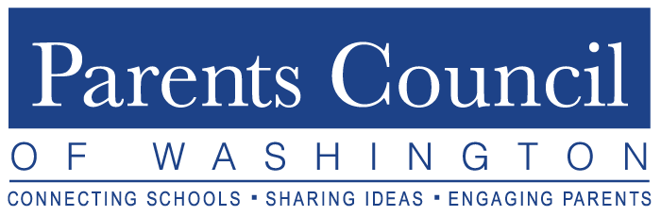 2019-2020 Program Schedule Healthy. Connected. Engaged.

Program | Date | Time | Venue | Audience | PCW Rep Role
PCW Orientation  (Phyllis Fagell, LCPC) | Tuesday,  September 17 | 8:30am Networking  9:00-11:00am Program | Holton-Arms School | PCW Reps  PA Presidents | ATTEND!  Distribute Material
Lower School Forum  (Panel Presentations) | Tuesday,  October 22 | 8:30am Networking  9:00-10:30am Program | McLean School of Maryland | All in Our Member Lower School  Communities | Publicize/Promote  ATTEND!  Distribute Material
Fall Speaker  (Lisa Damour, PhD) | Thursday,  November 14 | 8:30am Networking  9:00-11:00am Program | National Presbyterian School | Everyone Welcome  (even public) | Publicize/Promote  ATTEND!  Distribute Material
Best Practices/  Movie Screening  (Stress Resilience) | Thursday,  December 5 | 9:00-11:30am  Movie and Panel | Bethesda Row Cinema | All in Our Member School  Communities | Publicize/Promote  ATTEND!  Distribute Material
Student Event  (Upper School) | Tuesday,  February 4 | 8:30am Networking  9:00-12:00pm Program | Bullis School | Member School Selected Students (2) | Ensure Dean of Students has date on calendar and knows to select students; Distribute Material
Student Event  (Middle School) | Tuesday,  February 18 | 8:30am Networking  9:00-12:00pm Program | The Langley School | Member School Selected Students (2) and School Counselor | Ensure Administrator/ School Counselor has date on calendar and knows to select students; Distribute Material
Deans’  Breakfast | Monday,  March 9 | 8:00-10:30am Program | The Potomac School | Upper School Deans of Students | Ensure Dean of Students has date on calendar
Movie Screening  (Title: LIKE) | Thursday,  April 2 | 9:00-11:30am Movie | Bethesda Row Cinema | All in Our Member School  Communities | Publicize/Promote  ATTEND!
Parent  Association  Presidents’  Forum | Tuesday,  May 12 | 8:30am Networking  9:00-11:00am Program | The Primary Day School | Incoming and Outgoing Parent Association Presidents | Encourage school incoming and outgoing  PA Presidents to attend; Distribute Material

*Distribute Material = Access/distribute info & flyers beforehand; then program summaries/write-ups from PCW website after program completion. Updated 9/11/19

