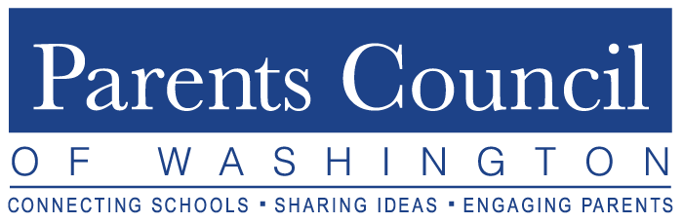
2019-2020
Board Liaisons to Member Schools
(listed by Member School)

Member School Board Liaison
The Academy of the Holy Cross Margaret Farrell
Alexandria Country Day School Joan Friedrichs
Beauvoir School Suzanna Kang
Browne Academy Malvika Paddock
Bullis School Susan Newell
Burgundy Farm Country Day School* Susan Newell
Charles E. Smith Jewish Day School Elizabeth Savage
Commonwealth Academy Joan Friedrichs
Concord Hill School Suzanne Dowd
Congressional School Mena Burke
Connelly School of the Holy Child Michelle Sullivan
Edmund Burke School Michelle Sullivan
The Field School Elizabeth Savage
Flint Hill School Melissa Dennis
Foxcroft School Suzanne Dowd
Georgetown Day School Melissa Dennis
Georgetown Preparatory School Frazier Schulman
Georgetown Visitation Preparatory School Margaret Farrell
Gonzaga College High School Suzanne Dowd
Green Hedges School Carla Taylor-Pla
The Harbor School Frazier Schulman
Holton-Arms School Julie Buchanan
Holy Trinity School Mena Burke
The Lab School of Washington Elizabeth Savage
Landon School Julie Buchanan
The Langley School Julie Buchanan
Lowell School Carla Taylor-Pla
Madeira School Joan Friedrichs
Maret School Melissa Dennis
McLean School of Maryland Margaret Farrell
National Cathedral School Suzanna Kang
National Presbyterian School Malvika Paddock
Norwood School Melissa Dennis
Oneness-Family School Mena Burke
Our Lady of Good Counsel Katherine Corsico
The Potomac School Malvika Paddock
The Primary Day School Michelle Sullivan
The River School Carla Taylor-Pla
Sandy Spring Friends School Katherine Corsico
Sheridan School Frazier Schulman
Sidwell Friends School Suzanne Dowd
The Siena School Elizabeth Savage
St. Albans School Suzanna Kang
St. Andrew’s Episcopal School Katherine Corsico
St. Anselm’s Abbey School Margaret Farrell
St. Patrick’s Episcopal Day School Katherine Corsico
St. Stephen’s & St. Agnes School Michelle Sullivan
Stone Ridge School of the Sacred Heart Joan Friedrichs
Washington Episcopal School Malvika Paddock
Washington International School Mena Burke
The Woods Academy Julie Buchanan

* Unsure about Renewal Updated: September 12, 2019

