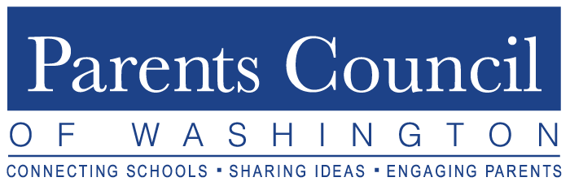

2019-2020 Program Schedule

Healthy. Connected. Engaged.

Program | Date | Time | Venue | Audience
PCW Orientation  (Phyllis Fagell, LCPC) | Tuesday,  September 17 | 8:30am Networking  9-11:00am Program | Holton-Arms  School | PCW Reps  PA Presidents
Lower School Forum  (Panelists) | Tuesday,  October 22 | 8:30am Networking  9-10:30am Program | McLean  School of Maryland | All in our Member Lower School Communities
Fall Speaker  (Lisa Damour, PhD) | Thursday,  November 14 | 8:30am Networking  9-11:00am Program | National Presbyterian School | Everyone Welcome  (even public)
Best Practices/ Movie Screening  (Stress Resilience) | Thursday,  December 5 | 9:00-11:30am Movie  followed by Panel | Bethesda  Row  Cinema | All in Our Member School Communities
Student Event  (Upper School) | Tuesday,  February 4 | 8:30am Networking  9-12:00pm Program | Bullis School | Member School Selected Students (2)
Student Event  (Middle School) | Tuesday,  February 18 | 8:30am Networking  9-12:00pm Program | The  Langley  School | Member School Selected Students (2) and School Counselor/Admin
Deans’  Breakfast | Monday,  March 9 | 8:00-10:30am  Networking/Program | The Potomac  School | Upper School Deans of Students
Movie Screening  (Title: LIKE) | Thursday,  April 2 | 9:00-11:30am Movie | Bethesda  Row  Cinema | All in Our Member School  Communities
Parent  Association  Presidents’  Forum | Tuesday,  May 12 | 8:30am Networking  9-11:00am Program | The  Primary Day  School | Incoming and Outgoing Parent Association Presidents

www.parentscouncil.org Updated 9/12/19

Parents Council of Washington

2019-2020 Theme -- Healthy. Connected. Engaged.

Mission

To promote excellence in education

by fostering communication among independent schools.

Vision

Connecting Schools.

Sharing Ideas.

Engaging Parents & Students.

Who We Are

Nonprofit established in 1964,
governed by all-volunteer Board of Directors.

Who We Serve

Independent K-12 schools
in Washington, DC metropolitan area.

What We Offer

Eight to ten annual programs

focused on education, child development, and/or parenting;
written and other varied resources; multiple networking opportunities.

How We Do It

- PCW maintains contact with administrators,
Parent Association (PA) Presidents and PCW Representatives
to coordinate/advertise/deliver PCW programs.

- PA Presidents and PCW Representatives attend programs,
share program/resource information with school communities,
and encourage attendance at applicable programs.

- Member school administrators/faculty present
at multiple programs; local and national speakers/authors
are highlighted at other programs such as the Fall Speaker series.

- Interested and well-suited member schools host PCW annual programs.

PA Presidents/PCW Representatives interested in a PCW Board position,
please contact administration@parentscouncil.org.

