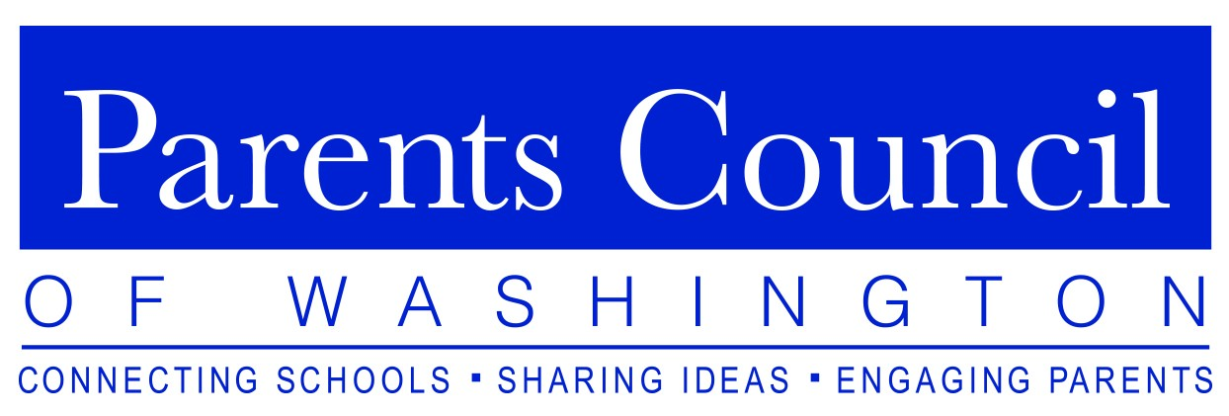
presents the
LOWER SCHOOL FORUM
Healthy. Connected. Engaged.
Tuesday, October 22, 2019
The McLean School of Maryland
8224 Lochinver Lane, Potomac, MD 20854

8:30am to 9:00am – Refreshments and Networking
9:00am to 10:30am – Panelist Presentations/Q&A

Esteemed panelists will be discussing topics of interest to PCW
member Lower School parents, administrators, and faculty,
followed by a question-and-answer period.

Anna Carello  Associate Head of School  Beauvoir School | Edwin P. Gordon  Head of School  Congressional School
Frankie Engelking  Director of Student & Community Wellness McLean School | Scott Lawrence  Head of School  The Primary Day School

Learn more and RSVP at www.parentscouncil.org

