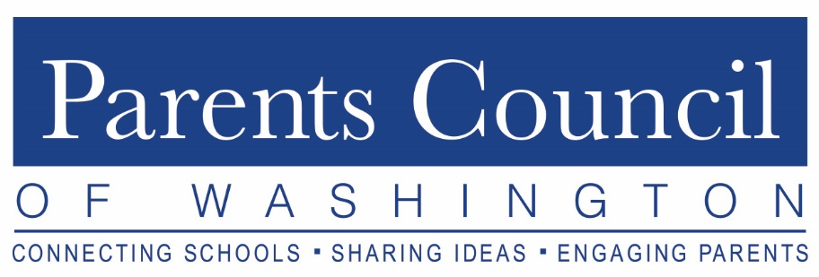

Please join us for a screening of the film
BEYOND MEASURE

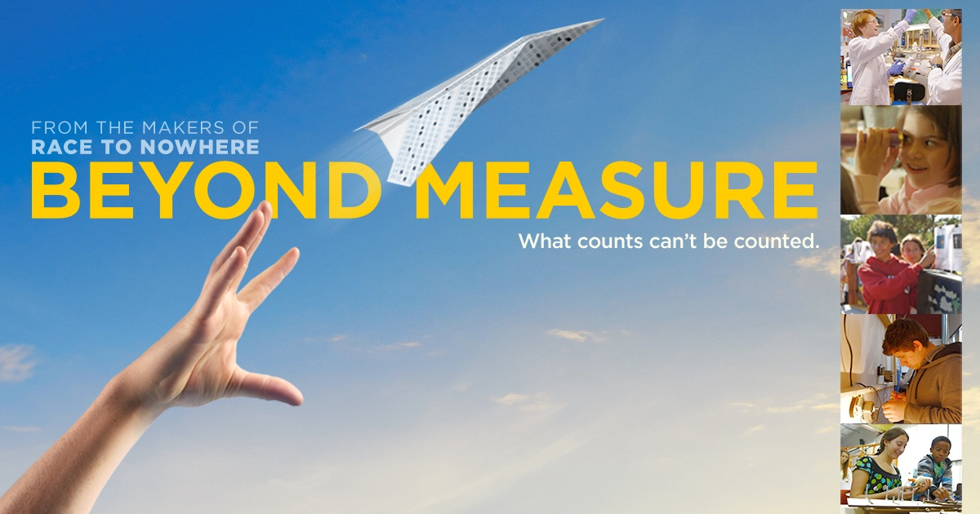
Tuesday, January 15, 2019
9:30 - 11:30 am
(Snow Date: January 31, 2019)

Landmark Theatres
Bethesda Row Cinema
7235 Woodmont Avenue
Bethesda, MD 20814

The Parents Council of Washington is pleased to offer a free screening of the documentary film Beyond Measure for our member school communities. This documentary offers a positive picture of what is possible in American education, highlighting schools that foster critical thinking, communication, exploration, experimentation, collaboration, and creativity as keys to the successful education of children from all backgrounds. As stated by director/producer Vicki Abeles, Beyond Measure sets out to “challenge the assumptions of our current educational story.”

Don’t miss this dynamic morning of film-based learning. Beyond Measure shares the excitement of what schools can be when they are student-centered and value personal growth over test scores. We hope it sparks a discussion for educators and parents among our member schools.

For more information and to RSVP, visit www.parentscouncil.org.

