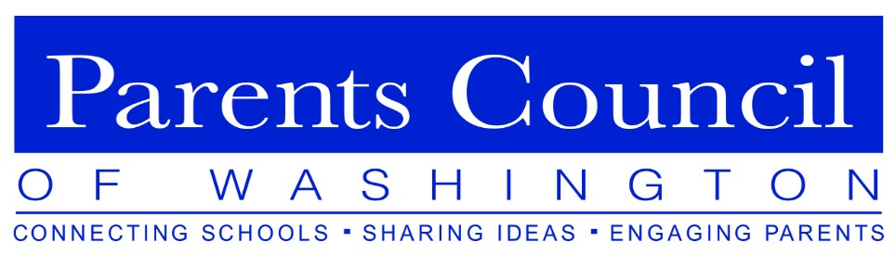

PCW Parent Association Presidents’ Forum
May 2, 2018
Norwood School

The Parents Council of Washington (PCW) Parent Association Presidents’ Forum for incoming and outgoing Parent Association (PA) Presidents was held on May 2, 2018, at Norwood School. Matthew Gould, Norwood Head of School, welcomed everyone and spoke of the importance of PA Presidents, referring to them as the spirit and heart of the schools. PCW event co-chair Frazier Schulman introduced the new format for the event. Rather than starting the morning with a panel of current PA Presidents, small groups (based on the size of the school) would convene at tables to discuss and report out 3-5 great ideas to share with the entire group. Frazier went on to discuss PCW’s mission and an overview of events throughout the school year, including the 2018-2019 PCW theme, “The Road to Well-Being: Empowering Our Students.”
PCW Board Member Malvika Paddock invited the group to attend the PCW Orientation Program for PCW Representatives and PA Presidents on the morning of Tuesday, September 18, 2018 at Holton-Arms School. Participants were asked to consider how to better capitalize on PCW as a resource for themselves and their schools.

Table Discussions:
Suggested topics of discussion were presented for the tables, and then the tables created smaller work groups to focus on specific issues. The topics were:
- Communications
- Calendar Management
- Volunteers
- Community
- PA Budgets
- School Administration
- Balance
A sampling of the ideas that were generated included:
- The use of Co-Presidents can be a beneficial way to approach PA leadership. Job sharing is an effective way to allow both working and non-working parents to participate in leadership positions.
- Select a PA liaison to the school to serve as the single point of contact between the PA and the school. This can help minimize confusion -- good communication between the PA and the administration is critical.
- Distribute a PA events calendar on a card at the beginning of the school year to help recruit volunteers and ensure attendance at events.
- Look at ways for schools to share PA bylaws.

Questions and Answers:
A sampling of the questions and responses included:
- Question: How many PAs have a teacher/staff member on the committee?
Answer: Some have one (possibly the School Liaison or Communications staff person), usually as a nonvoting member). Having this person present may result in a more formalized system to conduct meetings. A number of PAs conduct certain portions of their meetings – e.g., budget, nominations and certain school issues – in private, without the teacher/staff member present.
- Question: Has anyone had experience with cutting a long-standing event from the PA calendar?
Answer: As parent volunteers are becoming increasingly more difficult to recruit, it may be necessary to do away with a particular event. It is important to receive the school administration’s approval prior to cutting an event. Although it may be painful to go through, it usually fades from memory rather quickly.
- Question: Are there any suggestions for capturing institutional knowledge?
Answer: Information can be centralized using Dropbox or Google.
- Question: How do you best manage volunteers? What do you do with well-intentioned volunteers who act in counter-productive ways?
Answer: Find a project that is a good match for your volunteer and that best utilizes his/her strengths. If there are oft-voiced complaints, listen to what they are saying and then figure out how to get some closure and make improvements. In some cases, the administration may need to get involved.
- Question: How do you prevent a PA President from being overwhelmed with requests/comments from parents?
Answer: Use a committee structure for the PA and request that parents go first to the appropriate committee members with concerns and suggestions. It is important that there are defined responsibilities before someone takes a PA position. Specific guidelines are key for both the job holder and the rest of the school community. Some schools have 2-year PA terms. For the first year, volunteers learn/shadow and in the second year, do the job.
- Question: Does the PA President have an automatic seat on the School’s Board?
Answer: At a number of schools, the PA President does have an automatic seat on the School’s Board, either as a voting or non-voting member. If the PA President does not, the PA President often is invited to certain Board meetings, or portions thereof.

