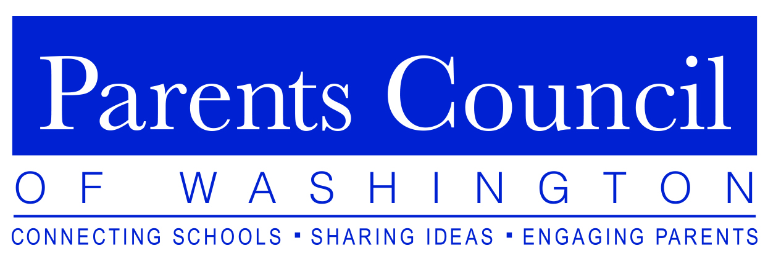

The Parents Council of Washington presents

How to Talk to Your Kids about Money

Featuring Ron Lieber, The New York Times “Your Money” columnist
and best-selling author of the book

The Opposite of Spoiled: Raising Kids Who Are
Grounded, Generous, and Smart about Money

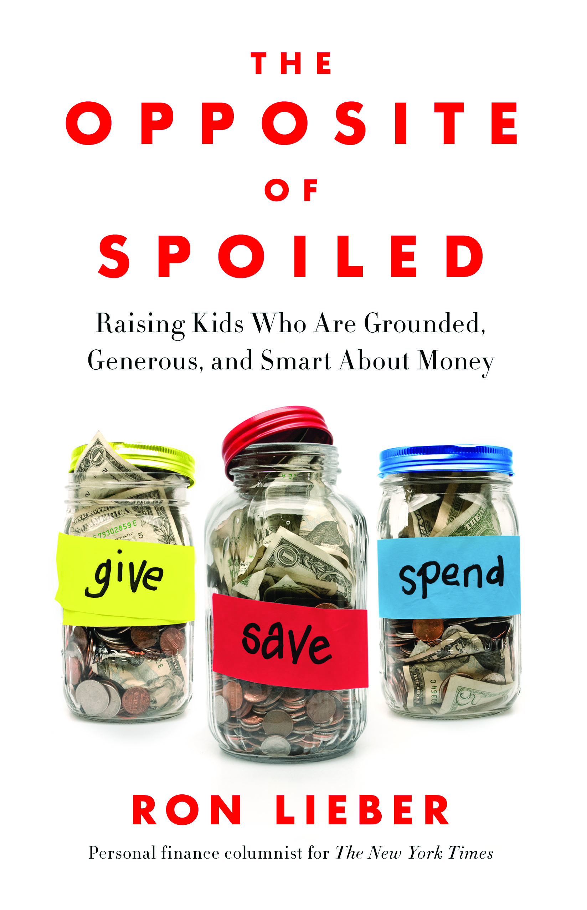
Tuesday, April 7, 2015
National Cathedral School
Hearst Hall
3612 Woodley Road NW,
Washington, DC 20016

8:30 – 9:00 am ~ Light breakfast
9:00 – 10:30 am ~ Presentation
10:30 am ~ Book signing

Please bring the toughest question your child has ever asked about money, and stories of your own efforts to raise grounded kids, who know how to save, splurge, and give in the most mature and meaningful ways.

The Opposite of Spoiled will be available for purchase.

Paid parking available in the Cathedral garage.

Please RSVP by clicking here.

For more information visit www.parentscouncil.org.

