PARENTS COUNCIL OF WASHINGTON BEST PRACTICES

DIVERSITY PRACTICES IN OUR SCHOOLS

JANUARY 20, 2011



THE PARENTS COUNCIL OF WASHINGTON

BEST PRACTICES PROGRAM
DIVERSITY PRACTICES IN OUR SCHOOLS

THURSDAY, JANUARY 20, 2011

HOSTED BY
THE WASHINGTON EPISCOPAL SCHOOL

WWW.PARENTSCOUNCIL.ORG

PARENTS COUNCIL OF WASHINGTON

2011 PCW BEST PRACTICES AGENDA
Thursday, January 20, 2011
8:45 AM to 11:30 AM
Washington Episcopal School

Diversity Practices in our Schools: An opportunity to share ideas that encourage and support effective diversity programs in our schools.

Agenda

8:45 – 9:00 AM Registration, Coffee and Conversation

9:00 AM Welcomes from Nancy Wright, WES Middle School Division Director
and Joan Levy, Parents Council of Washington Best Practices Chair

PLEASE WRITE DOWN AND SAVE YOUR QUESTIONS FOR THE Q&A PERIOD
FOLLOWING THE PRESENTATIONS

9:15 - 9:35 AM Georgetown Day School Presentation by
Elizabeth Denivi and Mariama Richards, Diversity Co-Directors

9:35 - 9:55 AM Norwood School Presentation by Joseph Conrad, Co-Chair of the
Students of Color Committee, Quanti Davis, Director of Multicultural
and Ethical Education and Nicole Mitchell, Norwood Board Member

9:55 - 10:15 AM Washington Episcopal School Presentation by Jackie Thorton,
Teacher and Faculty Diversity Committee Member, Maurice and
Beverly Ross, Co-Chairs of the Parent Diversity Initiative and
Kristie Postorino, School Counselor and Faculty Diversity
Committee Chair

10:15 - 10:40 AM Questions and Answers Session

10:45 - 11:30 AM Breakout sessions to small group discussions; Lower, Middle and
Upper school for discussions regarding programs and activities that
relate specifically to grade divisions.

Thank you for your participation. Please complete the evaluation form to help us plan future PCW programs. Summaries of this morning’s program and e-binder contents, containing each school’s description of their diversity programs, will be sent to all participants.
TABLE OF CONTENTS

SUBMISSIONS BY
PARENTS COUNCIL OF WASHINGTON MEMBER SCHOOLS
ON THEIR DIVERSITY PRACTICES AND PROGRAMS

The Bullis School pages 4-5

The Georgetown Day School pages 6-30

The Georgetown Visitation Preparatory School pages 31-34

The Gonzaga College High School page 35

The Grace Episcopal Day School page 36

The Green Acres School pages 37-39

The Holton-Arms School page 40

The Landon School pages 41-42

The Maret School pages 43-44

The National Cathedral School pages 45-48

The Norwood School pages 49-69

The Potomac School pages 70-71

St. Albans School pages 72-74

St. Andrew’s Episcopal School pages 75-76

St. Patrick’s Episcopal Day School pages 77-92

The Sidwell Friends School pages 93-95

The Stone Ridge School of the Sacred Heart page 96

The Washington Episcopal School pages 97-98

The Washington International School page 99
THE BULLIS SCHOOL

Diversity Practices in our Schools

Bullis is a learning community where inclusion and appreciation of diversity are core values. The school seeks to cultivate a learning community where difference is appreciated and understanding is actively promoted in every aspect of school life.

Diversity is an integral part of the Bullis experience for students, faculty members and parents. Bullis infuses diversity throughout its curriculum, and each department strives to develop coursework that reflects our diverse community and world.

Bullis students have the opportunity to participate in specific diversity programs and activities throughout the school year, such as:

- Students from all three divisions (lower, middle and upper schools) participate in assemblies celebrating Hispanic Heritage, Martin Luther King, Jr., Black History Month, Women's History, and Lunar New Year.

- Our student led Gay Straight Alliance initiates meaningful diversity work through assemblies and other programmatic initiatives.

- One of the most active upper school student clubs is “Diversity Awareness at Bullis” (DAB), which promotes cultural awareness amongst Bullis’ diverse community. The club sponsors dinners, films, speakers, participation at conferences and other activities.

- Each year, a group of Upper School students attends the Student Diversity Leadership Conference where they receive training on how to identify and address issues of diversity in their schools. Upon their return, these students work with members of DAB on how to best address specific school issues. These students later share their work with their classmates via assemblies and advisory activities.

Bullis faculty members are committed to creating a learning environment that is inclusive and just, and to producing learners ready to lead in an increasingly multicultural world. A group of 25 faculty and staff is meeting as part of a Diversity Task Force to identify key issues in the community, examine the school's current diversity statement, examine the diversity report from 2003, and examine the diversity coordinator position and how it fits into Bullis’ future diversity plans. In addition, each year 3-6 teachers are sent to the National Association of Independent Schools (NAIS) People of Color Conference.

The Bullis parent association does not have a Diversity subcommittee and does not organize programs specifically around the topic of diversity.

Follow up questions can be addressed to:
Susan Richman, Bullis Parent Representative to the Parents Council of Washington
Bryan Whitford, Faculty Advisor, Diversity Awareness at Bullis
Joanne Szadkowski, Director of Development
Sara Romeyn, Social Studies Department Chair

THE GEORGETOWN DAY SCHOOL

Diversity Initiatives & Programming

Student Clubs
- Diversity Connections (HS & MS)
- Rainbow Connection: GLBTS (Gay, Lesbian, Bisexual, Transgender & Straight) support group/ awareness club (HS)
- Asian Club (HS)
- WAVE Women’s Leadership Group (HS)
- Black Culture Club (HS)
- Jewish Culture Club (HS)

Student Affinity Groups
- SIS Program, affinity group for ninth and eleventh grade women (HS)
- FUSION: Multiracial affinity group (HS)
- AWARE: Association of White Anti-Racist Educators, affinity group (HS)
- YMOC: Young Men of Color, affinity group (MS & HS)
- YWOC: Young Women of Color, affinity group (MS &HS)
- Affinity group for GLBT students (HS) (When Needed)
- Student of Color Mentoring (LS & MS)

Student Conferences
GDS White Privilege Conference (HS)
Metro DC Student Diversity Leadership Conference (LS/MS/HS)
Student Diversity Leadership Conference (HS)

High School Diversity Leadership Retreat
Fall & Spring

All School Assemblies

Thanksgiving/Harvest – Gratitude

Christmas – Peace
Passover – Freedom
Martin Luther King Jr. – Equality
Gay Pride – Respect

Each division offers additional multicultural assemblies throughout the year

Parent Groups & Programming
- Parents of Students of Color – Affinity Group, Including an Event for Students and Parents at the Beginning of the School Year
- Parent Gay/Straight Alliance – Open Meetings and Affinity Group Programming
- HoLA GDS- Open Meetings for Parents Who are Interested in Hispanic and Latino Culture at GDS
- Parent Service Association- Working with the Co-Chairs
- Parent Education Series in Conjunction with The Counseling Department

Staff Groups and Programming
- SEED Program – Seeking Educational Equity and Diversity
- Staff Gay/Straight Alliance Meetings & Retreat
- Staff of Color Meetings & Retreat
- AWARE: Association of White Anti-Racist Educators, affinity group (LMS)

Administrative /Teaching Responsibilities
- Ninth Grade Seminar and Orientation
- Grade Level Support of Multicultural Education & Anti-Bias Curricula
- New Staff Training
- Student Support Team (HS)
- Staff Recruitment: Hiring Fairs & Interviews
- Advise Safe Place Theater Company (MS)
- Administrative Liaison to the Board Diversity Committee
- Professional Development for Staff
- Resources for All School Constituents

Programs

Equity and Justice

Meet Our Team
Elizabeth Denevi
Diversity Co-Director
202-274-3206

Mariama Richards
Diversity Co-Director
202-274-3275

Tradition
A Tradition of Diversity and Inclusion
When Georgetown Day School opened its doors in 1945, it did so as the first integrated school, public or private, in a segregated city. The parents who founded GDS wanted an alternative and believed that an integrated school would provide their children with a better and broader education. In a country where racial prejudice was all too prevalent, GDS created an environment of creative learning for all, where the individual dignity of each student was respected.
Today, that commitment to diversity remains a bedrock philosophy of GDS, fostering the intellectual, ethical, and spiritual dimensions of its students' lives. GDS encourages respect for the variety of beliefs and backgrounds reflected in its diverse community of students, teachers, and parents.

Vision
From Historic Beginnings
Georgetown Day School has evolved from its historic beginning as a color-blind institution to one that understands and celebrates the differences that make each of us unique and the universal values that we share. GDS's commitment to diversity has been reaffirmed by the Board of Trustees and by the 2001 Strategic Plan as a core value to pursue "with intentionality and energy." The creation of the Diversity Task Force and the appointment of a diversity coordinator by the Head of School in 1999 strengthened the vitality of this effort. Subsequently, the Board adopted a diversity policy statement and empowered the Board Diversity Committee to assist the administration and the GDS community in supporting a school environment where all are welcome and respected.
The Office of Diversity
- Serves as a resource to parents, students, and staff
- Consults with administration and staff on how best to serve a diverse population
- Facilitates community dialogue
- Mediates racial and cultural misperceptions
- Counsels and mentors students
- Assists in the development of a multicultural curriculum
- Provides diversity and mediation training for faculty and students
- Represents GDS regionally
Equity & Justice Programs @ GDS
Students, parents, and faculty are actively involved in supporting diversity at GDS and ensuring that every student and family feels that they are full and welcomed members of the community. The School both supports affinity groups that recognize shared experiences and promotes cross-cultural dialogue.

9th Grade Diversity Seminar
The 9th grade seminar was developed as an extension of the School's mission statement and as a part of the GDS Strategic Plan. All 9th graders attend one class a week for the first semester, completing readings and short journals on issues relating to ability, age, ethnicity, gender, race, religion, sexual orientation, and socio-economic status.
Diversity Connections
A high school student club promoting equity and justice, Diversity Connections hosts discussions on topics related to diversity. It sponsors a weekend retreat open to all interested students. Diversity Connections serves as an umbrella organization supporting additional student diversity leadership groups such as Rainbow, a gay/straight alliance; Black Culture Club; Fusion, a club for multiracial students; and Brenner, a women’s leadership group.

Parents of Students of Color (POSOC)
POSOC is a networking group that meets regularly throughout the year to support families with students of color. POSOC also sponsors a picnic at the beginning of the school year for the entire GDS community.

Students of Color Mentoring Program
This after-school program—featuring math workshops, cultural field trips, visits with high school students, critical-thinking exercises, and the like—is designed for students in grades 5-8 and is facilitated by high school students and teachers of color from both campuses.

Parent Gay-Straight Alliance ("PGSA")
The Parent Gay-Straight Alliance ("PGSA") is a group of parents, teachers and staff, gay and straight, working together to support the well-being of gay, lesbian, bisexual and transgendered ("GLBT") individuals, their families and the GDS community. The PGSA is a discussion forum and an educational resource that fosters respect for diversity of many types and promotes greater awareness of GLBT issues that affect the members, the school and our community. All are welcome to participate.

Board Diversity Committee
Board members, parents, and administrators serve on this committee, which provides advice and counsel on issues of equity and the implementation of the goals of the Strategic Plan

Parent Diversity Discussion Series
Sponsored by the Board Diversity Committee, each Parent Diversity Discussion series covers topics such as affirmative action, gender issues and sexism, white racial identity development, adoptive families, and multi-ethnic identity. Discussions are open to all members of the GDS community.

SEED
Seeking Educational Equity and Diversity (SEED) is a national curriculum development program that focuses on infusing equity and multiculturalism into classroom practice. Lower, Middle, and High School representatives meet regularly to examine issues of equity and diversity and to develop strategies for making the GDS curriculum more inclusive.

Faculty Discussion Groups
The Office of Diversity works in conjunction with the larger administrative team to create relevant programming for faculty and staff. In addition to supporting affinity groups for our staff of color and gay and lesbian staff, the Office is responsible for school-wide initiatives.

Beyond GDS
In addition to in-house diversity programs, we encourage students to attend other diversity conferences in the DC Metro Area and abroad. Conferences include the DC Metro Middle School Diversity Leadership Conference, the DC Metro Student Diversity Leadership Conference for high school students, East Ed Summer Institute on Multicultural Education, NAIS People of Color Conference, and the MAVIN Multiracial Conference. Teachers also regularly participate in professional development programs geared towards multicultural education.

Equity Collaborative
A week-long leadership program for public and independent school educators, held each summer at GDS.
The goal of the Georgetown Day School Equity Collaborative is to help educators develop an institutional roadmap for creating and supporting multicultural education and anti-bias curricula in both public and independent schools. Our focus is on organizational development and strategic planning for equity and diversity initiatives. Participants engage in a collaborative process to design initiatives for change, to promote acceptance of multicultural education, to foster heartfelt commitment, to build alliances and create cross-cultural connections, and to sustain energy. Ultimately, our hope is that this work will lead to the transformation of the culture and climate in our schools.

Special Features
- In-depth organizational-development focus beyond an introductory level
- Public-independent school partnership
- Team approach: schools are asked to send at least 2 members
- Strategies for hiring, orienting, and retaining staff members from traditionally underrepresented groups
- Student-centered anti-bias programs and practices
- Specific focus areas for different school constituents—classroom teachers, admission representatives, principals, trustees, parents, et al.
- Discussion of case studies and problem-solving methods
- Ongoing opportunities for online communication among collaborative participants

GDS is the recipient of the 2004 National Association of Independent Schools Leading Edge Award for Equity and Justice, which recognizes outstanding programs that focus on creating and sustaining a diverse, inclusive, and supportive school environment.

Questions about the Collaborative? Contact Kristen Chasse at 202-274-3203 or kchasse@gds.org

Georgetown Day School
4200 Davenport Street, NW
Washington, DC 20016
202-274-3206

Articles Published by the National Association of Independent Schools

http://www.nais.org/publications/ismagazinearticle.cfm?Itemnumber=144319&sn.ItemNumber=145956&tn.ItemNumber=145958

Whiteness
Helping White Students and Educators Understand Their Role in a Multicultural Society
Elizabeth Denevi
Fall 2001
A year ago, when I was teaching in California, some of my high-school students hosted affinity group discussions on ethnic and racial identity. Signs were posted in the lunchroom telling students where their affinity group would meet. A white student leader and I waited patiently in the classroom designated for Euro-American/white students and teachers. No one else came to this meeting. After lunch, as I was debriefing with the student leaders, one of my students of color turned to me and said with a look of disbelief: "Do white people know they are white?" It was an excellent question, and we spent the next half hour trying to think of ways we could help white people see their race as an essential part of diversity and multiculturalism.
As I learned from my experiences as a white teacher and from my Ph.D. research on adolescent ethnic identity development, if we are to help independent schools become truly multicultural communities, we have to begin to talk about what it means to be white in our schools.
It's important to take a close look at white identity in the hopes of uncovering and naming what usually passes for "normal." Just as with other racial groups, whiteness is not a monolith; it is a process of cultural development that is socially constructed and that encompasses many different ways of being white. By "socially constructed," I mean that race is not an essential characteristic but rather a social category. We understand whiteness in relation to other people, and whiteness is produced or constructed by our interactions with friends, the media, literature, family, and teachers. Notions of biological racial categories were made popular in the late 19th century, but scientific racism has nothing to do with biology. The gene that makes my hair curly and someone else's straight is the same gene that makes my eyes brown and someone else's blue. But the myth of essential racial characteristics is still part of our culture, and so it is important to begin by locating race as a social, and not a biological, identifier.
That said, it is then necessary to understand race in a historical, social, and political context. The term "white" did not emerge until the latter part of the 19th century in American society. James Banks, a leading scholar of multiculturalism at the University of Washington, writes about new immigrants from Ireland, Eastern, Southern, and Central Europe who challenged notions of whiteness upon their arrival in the U.S. In an effort to experience the American dream, many white ethnic groups assimilated and their distinct ethnic characteristics, such as language, were abandoned or erased in order to become "American." Some immigrants, moving through Ellis Island, changed their names (or had their names changed for them by immigration officials) so they sounded more "American," further contributing to the homogenization of white ethnics. By the early 20th century, multiple ethnic categories had become one racial category.
Valerie Babb writes about the development of the term "white" in her book Whiteness Visible. She states, "For the different ethnicities and classes who left Europe to come to an unfamiliar wilderness where new structures had to be devised to meet new needs, whiteness furnished a social order that forged a nascent national identity and minimized potential class warfare." To create this exclusive national identity, it was necessary to fabricate a shared Anglo-Saxon past that would give a variety of whites a common heritage even if this past was in direct conflict with the multiple ethnicities and classes that made up American society. By creating a white racial identity, as opposed to an English or Irish one, a nation of white ethnics could become a race that would create an identity and, at the same time, serve as a rationale for excluding non-whites. English superiority and domination in the colonies was replaced by white superiority.
It is not unusual for a new group to develop a norm that represents the group's character, and here the norm was established by rejecting other groups with a different character. In a time of rapid social transformation, Babb writes, whiteness was a unifying force that diffused social tensions, consolidated social and economic power, and integrated new white immigrants into a "white American fabric." Babb exposes a great American irony: With whiteness as a naturally superior racial identity, whites could reconcile undemocratic principles like slavery and limited voting rights with higher democratic ideals. This means of creating white hegemony brings us back to identity, but it is an identity created through difference. Here exclusion is not the ability to say who is white, but rather the power to determine who is not white. Colonists were the chosen white people who solidified their identity by being different from Native Americans and enslaved blacks. Thus, another irony emerges: Even though cultural mixing was a huge part of the formation of an American identity, there was this desire for racial purity that would privilege one group over another. Babb writes that by the mid to late 19th century "the social label of whiteness mitigated potential class strife among white ethnics and that, more and more, whiteness became synonymous with American-ness as the identity of the nation was cemented to the identity of a single created race. The question of who was a 'real' American was increasingly answered with the response that it was one who was white, thus giving this race a position of national privilege."
In the first quarter of the 20th century, obvious and pervasive cultural rituals and institutions sustained whiteness as the American norm along with white superiority. Cultural images erased racial plurality and established whiteness as a privileged social category, again illustrating the irony of a multiracial country portraying itself as monoracial. Even though whiteness is often veiled and hidden as the norm, we need an awareness of whiteness as a system and ideology that has privileged some and not others if we are to exist and thrive as a multiracial, multiethnic society. Without a thoughtful investigation of white identity and white privilege, their roots and present meaning, we will continue to perpetuate an illusion of a unified, democratic society.
So then, what is whiteness? What does it mean to be white in this country? As I was growing up, I never heard these questions asked. I grew up in Silicon Valley as it was coming into being, and everyone looked, talked, and sounded like me. I was raised in an Italian- and Irish-Catholic family, and both sides of my family immigrated to the U.S. around the turn of the century. I remember very little religious diversity in my hometown; the Christian kids envied the handful of Jewish kids who got to miss extra days of school. In my senior class of 550 students, we had one African American. When I went to college just outside of Chicago, my university was very segregated, and it was not until I attended graduate school in New York City that I really experienced a diverse living environment. I had the privilege to work with some very distinguished American historians who helped me see the blind spots in my own education. When I worked with Eric Foner, one of the leading scholars of 19th century American history, I realized that I had never really studied slavery. I, who had supposedly received an excellent education, did not know that Japanese-Americans had been interred during World War II. As I was working on a project and talking to my family about this chapter in American history, my mom told me an incredible story. In high school, Toro, one of my father's best friends, was Japanese-American. When his family was ordered to Idaho for internment during World War II, my dad and the rest of his friends took turns guarding Toro's house. It was both shocking and sad to me that I had never heard this story. So the understanding of my position and privilege began as an intellectual transformation, and it was not until I returned to teaching that my emotional transformation began.
In the fall of 1996, I moved back to Silicon Valley, and my first year there was wonderful. I started teaching Ethnic Voices, an advanced-placement English elective for juniors and seniors, and the first group of young women I worked with was incredible. The following school year, I had a very different experience. The class was split evenly along racial lines: eight white students and eight students of color. What I didn't realize was that I tipped the balance; my whiteness counted. The students of color were experiencing many different levels of racism, and I was having a very difficult time managing the class. My attempts to address white privilege were unsuccessful because I had not figured out what being white meant for me. Because I had not done my own work, it was impossible for me to guide my white students, and their resentment turned to anger. They went after the kids of color with cries of reverse racism and denouncements of quotas that prevented white kids from being accepted to elite universities. I was in way over my head. About six weeks into the term, the eight students of color showed up at my desk. They told me they had decided to drop the class, and they were willing to get an F and risk college acceptances because the racism they were experiencing was intolerable. They were thoughtful, composed, and serious. I was rocked to the core. They said that they were not blaming me, but in essence, it was about my accountability. Because I had not come to terms with my identity, the class was facing its own crisis. They looked at me intently and asked what I could do. What could I do? I told the students I would find a way to make it better. I asked them to give me two weeks, and they agreed. Then I cried for three days. I sat in the dean of students' office, and together, we found a way to finish the semester. Did I fix things? Of course not, because I couldn't. I performed triage. I got us through, but it was by no stretch of the imagination a successful semester. But I learned the most valuable lesson of my teaching career: As Parker Palmer states, you teach who you are. How could I confront white privilege and racism when I did not know who I was? At this time, I knew I had to go back to school to try to understand what had happened in my class and to begin my own personal identity exploration.
Once I realized that I needed to figure out what being a white, upper-middle-class woman meant for me, I began to look for some narratives that might help my own exploration. Ruth Frankenberg's study of 40 white women, in a text called White Women, Race Matters, significantly impacted my understanding of whiteness. In describing how race shaped the lives of women, she offers a very helpful definition of whiteness with three dimensions. "First, whiteness is a location of structural advantage, of race privilege. Second, it is a 'standpoint,' a place from which white people look at [themselves], at others, and at society. Third, 'whiteness' refers to a set of cultural practices that are usually unmarked and unnamed." This definition establishes an important frame that locates privilege as one central aspect of whiteness. In addition, whiteness is a standpoint or perspective, a lens through which white people view the world, which means that my experience as a white person directly affects how I see and understand my surroundings and interactions with others. Finally, whiteness is positioned as the norm, so it has not been necessary to look explicitly at whiteness, leaving it as undiscovered territory.
Once we have this understanding of what whiteness is, we can begin to look at how whiteness functions in forming views on race. Frankenberg offers three such modes. She begins with the "essentialist mode," which refers to the idea that people of color, biologically speaking, are different, inferior, less human, less civilized than white people. The second mode is "color evasiveness," also known as color-blindness, which says we are all the same under the skin, so any failure to achieve on the part of people of color is the fault of people of color themselves. The final mode she calls "race cognizance" or "the autonomy of culture." In this mode, any inequality refers not to ascribed or essential characteristics, but to the social structure. Looking at the history of racial discourse in the U.S., these three phases of racial development emerged chronologically in this order, but in today's society, given different contexts, one or all of these phases might rise to the surface.
Of the three phases Frankenberg examines, color evasion, the second phase, offers great insight for those white students and educators trying to come to terms with a white identity. As she interviewed white women from across the country, she found that most of the women expressed a desire not to see race, or at least not to acknowledge racial differences. Frankenberg probed this issue and found that this was a way for these women to distance themselves from essentialist racism. If they didn't notice race, then they couldn't be racist: "Very frequently," she writes, "race privilege is a lived but not seen aspect of white experience, given socially segregated material environments and discursive environments that militate against conscious attention to racism." This, then, suggests that noticing color is a bad thing to do, suggesting that non-whiteness or "color" is bad. Here is where color evasiveness becomes so perilous: "The sharp cutting edge of color-blindness is revealed here: within this discursive repertoire, people of color are 'good' only insofar as their 'coloredness' can be bracketed and ignored," Frankenberg points out. "Colorblindness, despite the best intentions of its adherents, in this sense preserves the power structure inherent in essentialist racism."
To deny difference is to deny the impact that race has on people's lives. As opposed to saying there are no differences at all among people, color evasion is a selective attention to difference, saying that color does not matter. In this way, a white woman who is not comfortable talking about race can selectively avoid the topic and instead focus on differences that she is comfortable with. This is simply another kind of oppression disguised as a polite discourse. It is this selective engagement with difference that exposes color-blindness as a way of maintaining the power and privilege of the dominant group. Here, these white women had the privilege of not seeing their color, and, subsequently, denying others their racial identity.
Color-evasion can play a role in a subtle but insidious kind of racism termed "aversive racism," and as Beverly Tatum notes, aversive racists have "internalized the espoused cultural values of fairness and justice for all at the same time that they have been breathing the 'smog' of racial biases and stereotypes pervading the popular culture." Color-blindness masks itself as non-biased, but since one group is free to ignore the racial identity of another, discrimination exists. Thus, a seemingly nonprejudiced stance has major power implications. Here the denial of race locates a desire to be fair next to the power to discriminate. If it is clear what the right thing to do is, aversive racists will act in a way that supports their non-prejudiced view of themselves. However, if a situation is not clear and an action can be justified on the basis of some factor other than race, prejudiced feelings towards African Americans will surface.
Tatum gives an excellent example of how this subtle form of bias manifests itself. White college students were given transcripts and asked to evaluate candidates for admission to their college. When the transcripts were presented to the white students, all of the qualifications were equal; the only difference was the race of the candidate. The study found that when the students were not qualified, black and white students were both rejected, irrespective of race. When the candidates were somewhat qualified, white students were favored over black students by a slim margin. However, when the candidates were highly qualified, the white students overwhelming chose white candidates. So, even when all qualifications are equal, applicants were not perceived as equal, especially when both black and white applicants were highly qualified. Blacks were good, but whites were better.
Paul Kivel, a social activist and writer, states, "We must begin here -- with this denial of our whiteness -- because racism keeps people of color in the limelight and makes whiteness invisible." To turn our attention to whiteness using Frankenberg's definition, we must begin by acknowledging that whiteness is a privileged way of seeing the world that is usually not talked about. In 1989, Peggy McIntosh published White Privilege: Unpacking the Invisible Knapsack, and still, to this day, it is one of the best pieces on the topic of white privilege. Her central thesis is that white people have not had to acknowledge how they benefit from racial discrimination. White people might understand the disadvantages of racism, but they deny the advantages they receive because of white privilege.
It is disconcerting to realize that privilege and prejudice exist side by side; one informs the other. As I elevate myself, someone else is disadvantaged. As with racism, whites are taught not to see their privilege, but, nevertheless, we carry around an invisible knapsack filled with unearned privileges. McIntosh lists over 40 ways she experiences white privilege daily. For example, she usually does not have to speak for her entire race; she can move and be assured of finding fair housing; if she is pulled over by the police, she can be relatively sure she was not singled out due to race; she can swear, dress down, or not return a phone call without people attributing her choices to the poverty, illiteracy, or bad morals of her race. It was difficult for McIntosh to recognize her white privilege, and she literally had to keep a tape recorder next to her bed in order to capture the semiconscious thoughts that helped to illuminate her privilege. I encourage all white educators to make their own lists, to write down the ways they receive unearned benefits. In this way, they can begin to recognize the role that race plays in their lives and how race is one lens through which all of us view the world.
Valerie Babb notes that, in reality, the privilege of whiteness benefits no one. It distances and segregates people and fosters pain and resentment. The inequities in such privilege are obviously painful to people of color. But they can also be painful to white people, many of whom feel that it strips them of their individuality and turns them into unappealing stereotypes. Because the culture that creates white privilege convinces many whites that certain cultures or topics are not worthy of study (non-Western literature, for instance), whites often struggle with their ability, and willingness, to participate in a diverse world.
To the students in my Ethnic Voices class who had difficulty with the ethnicity writing assignment, I assigned McIntosh's essay. For these white students who previously had no awareness of their whiteness, the article gave them insight into their racial identity. They could read McIntosh's list of unearned privileges and begin to construct their own lists, and this affected the way they saw themselves because they began to see with different eyes. And some even began to comment on a concept I refer to as the "double-edged sword" of white privilege. As students are granted their privileges, they are often denied aspects of their identity. This privilege cuts both ways. For example, one student wrote that white privilege isolated her; people judged her, and even if there was an inherent benefit to that judgment, she felt that she was never really known in the process. Often, when she says where she is from, people just assume she is rich, snobby, and spoiled. Yes, this provides her with a kind of privilege, but at the same time, the person judging her may not be able to really know her because of her privilege. This leads to the question of what happens to the white student who receives the benefits, but is not seen for who she really is. Where does she have the opportunity to move beyond assumptions, especially if the assumptions are incorrect?
A second aspect of the "double-edged sword" of white privilege is cultural disconnection. Many of the white students I have taught talk about the guilt, embarrassment, and shame they feel when they think about their racial and ethnic identity. Where do these feelings come from? And can these feelings be mitigated by class status or strong ethnic identity? Gary Howard, president and founder of the Reach Center, a nonprofit organization in Washington working to help people understand diversity, says that sometimes it is difficult for white people to feel good about their history. As the limitations of privilege and membership in a dominant group become apparent, many whites will turn away from their heritage and towards other traditions and cultures in order to create a sense of belonging. For many, the first recognition of white privilege can bring on intense feelings of guilt, but there is something else present for my students. It may be a feeling of loss, of not having a culture to celebrate during Multicultural Week.
It seems as if there is no counterbalance to the privilege, no firm identity to return to -- only feelings of emptiness, sadness, and shame. To suddenly have to acknowledge you are white, and that you have benefited from that identity while others are excluded, is difficult. The privilege maintains itself by locating itself as normal, and it can grow and strengthen because it is never examined or called into question. If I am just a regular kid, what's the problem? Yet, when I suddenly understand that I am white, and understand the full implications of that whiteness, and I'm seeing this aspect of my identity for the first time, the exposure is intense, difficult to grapple with. Henry Giroux, author and professor of cultural studies at Penn State University, writes that it is difficult for white students to see themselves as both antiracist and white; the terms seem mutually exclusive.
In schools, what is needed is a space for white kids to move beyond polarized notions of race to the development of a continuum of white identity. Instead of either drowning in guilt or accepting whiteness as the norm, Giroux says that students need to be "part of a broader new discourse of ethnicity, so that white youth can understand and struggle against the long legacy of white racism while using the particularities of, as Stuart Hall puts it, 'their own culture as a resource for resistance, reflection, and empowerment.””
So once we have recognized white privilege, how can we move towards acceptance, accountability, and action to promote equity? I often have students who are empowered by the recognition of white privilege. They can separate their individual identity from their group membership. They can recognize their privilege and begin to think about ways of sharing their power, of giving up some of those privileges to gain something greater: a better sense of community, less prejudice, and a clearer sense of who they really are beyond the color of their skin. In short, they need the space to talk about being white, what it means to them, and how they can use their privilege to confront racism and class barriers.
What we need to do today is to expand our notion of what it means to be white. Current conceptions of whiteness are stereotypical, narrow, and constricting. We also have to separate myths from realities so we no longer allow people to assume unearned superiority, and we can do this by rejecting racism and developing a white racial identity that is not based on racial supremacy. Quoting Janet Helms, Tatum writes: "He or she must accept his or her own whiteness, the cultural implications of being white, and define a view of self as a racial being that does not depend on the perceived superiority of one racial group over another."
Feeling guilty about white privilege creates paralysis; what white people need is a firm commitment to their own identity development and a willingness to confront the legacy of white racial domination. Paul Kivel, author of Men's Work and Uprooting Racism, provides an excellent analysis of the need for white accountability: "When we talk about unequal distribution of benefits and disadvantages, we may feel uncomfortable about being white. We did not choose our skin color. Nor are we guilty for the fact that racism exists and that we have benefited from it. We are responsible for acknowledging the reality of racism and for the daily choices we make about how to live in a racist society. We are only responsible for our own part, and we each have a part."
If you're a white educator, what is your part? For 25 years of my life, I did not know I had a role. I experienced life through the lens of white privilege, and it was not until I was asked by my students to step up to the challenge that I realized how hindered I was by my privilege. I was isolated from communities of people whom I needed to learn from and who had something to gain from me. I was distanced from an immigrant past that has so much to teach me about my family and how I am a part of a larger history. I was disconnected from my students, and this made my job more difficult. I could not be the teacher I wanted to be until I could take an in-depth look at my own racial and ethnic identity to be able to teach who I am. Finally, I was not the human being I strive to be because of my unconscious and sometimes conscious participation in a system that benefits me at the expense of others. The resistance to acceptance and accountability is real: the fear of losing something, of giving up certain advantages with the risk of not getting anything in return. What will happen if we lose what we have? I have worked so hard to get where I am, and now that will be taken away? Yet white educators have to be willing to take the risk because the consequences of white privilege are too great. It is not enough for mainstream society to just accept more people of color. White people have to accept their history and their role, and work to create a society that is free of racism. This is an extraordinary moment. The opportunity awaits us all.
Elizabeth Denevi is codirector of multicultural seminars at St. Stephen's and St. Agnes School(VA). In addition, she is an associate with the Eastern Educational Resource Collaborative (East Ed), and an adjunct professor at the University of Virginia.
References:
Babb, Valerie. (1998). Whiteness Visible. New York: New York University Press.
Banks, James. (2000). "The Social Construction of Difference and the Quest for Educational Equality." Education in a New Era.
Frankenberg, Ruth. (1993). White Women, Race Matters: The Social Construction of Whiteness. Minneapolis: University of Minnesota Press.
--. (1997). Displacing Whiteness: Essays in Social and Cultural Criticism. Durham: Duke University Press.
Giroux, Henry A. (Summer 1997). "Rewriting the Discourse of Racial Identity: Towards a Pedagogy and Politics of Whiteness." Harvard Educational Review. Vol. 67:2.
Howard, Gary. (Sept. 1993). "Whites in Multicultural Education: Rethinking Our Role." Phi Delta Kappan.
Kivel, Paul. (1996). Uprooting Racism: How White People Can Work for Racial Justice. New Society Publishers.
McIntosh, Peggy. (1988). White Privilege and Male Privilege: A Personal Account of Coming to See Correspondences Through Work in Women's Studies. Wellesley, MA: Center for Research on Women.
Palmer, Parker. (1998). The Courage to Teach. San Francisco: Jossey-Bass Publishers.
Tatum, Beverly Daniel. (1992). "Talking about Race, Learning about Racism: The Application of Racial Identity Development Theory in the Classroom." Harvard
Educational Review. Vol. 62:1.
--. (1997). Why Are All the Black Kids Sitting Together in the Cafeteria? Basic Books.
http://www.nais.org/publications/ismagazinearticle.cfm?Itemnumber=147150&sn.ItemNumber=145956&tn.ItemNumber=145958

White on White
Exploring White Racial Identity, Privilege, and Racism
Elizabeth Denevi
Summer 2004
INDEPENDENT SCHOOLS COMMMITTED to the development of a multicultural community find they can't progress without confronting the question of white racial identity and privilege. As a white woman who has spent a great deal of time working with schools on this subject, I know the importance and value of this process. The work I've seen in schools has never included guilt sessions or the pummeling of school administrators. The process has never been about criticizing schools into paralysis. Rather, the work I have seen is firmly rooted in the research on identity development and social justice initiatives. It involves critical analysis so that we can understand systems of privilege and racism. It requires reflective practice so participants can reference their own experiences. And it includes extensive dialogue, especially about early encounters with racial difference and current attitudes towards diversity.
Yet I also know that community work on white identity can be profoundly uncomfortable, and many who begin the work quickly pull away as soon as it becomes too painful. Janet Helms, a leading researcher on identity development, calls this pulling-away process "reintegration." Reintegration comes after a white person has developed a growing awareness of racism and white privilege and needs to resolve the tension between noticing and not noticing behavior that may contradict previously held notions of social equality. Instead of trying to abandon his or her racist attitudes, a white person in the reintegration phase may blame or fear people of color. White people who speak out against racism know how hard it can be, and the temptation to return to silence and collusion is very real. So, schools need to develop opportunities for whites to talk about race, whiteness, and privilege in order to create more white allies. In a professional development seminar program I co-facilitate, most of the white participants and many people of color cite our exploration of white identity development as the most revealing and important work they have done as teachers. During the last ten years, an explosion of research on this topic has created a wealth of materials. What is needed now is the will to work in a systematic way — not only for the benefit of people of color, but for everyone in independent schools.
Robert Carter's (1990) research on white college students has shown a direct relationship between racism and racial identity development: white students with a more developed sense of their own racial identity tended to espouse fewer racist beliefs. In her work with white youth, Patricia Marshall (2002) unfortunately found that most teachers are unaware of the importance of racial identity development, especially for white students. She notes the naiveté of assuming white students are neutral about their contacts with people of color: "Through racial-group socialization," Marshall writes, "many white youths (similar to many white adults) experience some degree of anxiety vis-à-vis the current and imminent demographic shifts resulting from increases in the population of people of color." Many white youths have been taught — albeit unconsciously — that their way of living is the American way and often feel a need to defend their culture against "them," creating animosity and fear of interaction with others and locating whiteness as "rightness." The point is clear: schools emerge as a critical place where we can educate white youth as racial beings. "Without teacher intervention," Marshall says, "these students are unlikely to recognize the inherent racial-group hierarchy manifest in the mainstream focus of traditional curricular content and the marginalization of people of color through add-on units in February or any other time of the school year…. Educators need to create deliberate learning opportunities that promote healthy racial identities."
What is true for white students is also true for adults. In her anthology entitled White Privilege, Paula Rothenberg (2002) writes:
Once I began to recognize how much of my success is a consequence of unfair advantage, I cannot help but begin to seek ways to make amends. This does not mean that I am not smart nor does it mean that I have not worked hard — I have worked very hard in my life to accomplish my goals — but it does mean that I recognize that there are others equally smart who worked equally hard and who have a great deal less to show for it simply because they are not white.
This concept of making amends is a critical aspect of becoming antiracist. Instead of wallowing in guilt or denying the impact of slavery because "my family never owned slaves," white teachers and students can recognize their relative privilege and work constructively to use that privilege to develop, implement, and learn anti-bias curricula.

THE HIDDEN WOUND
The long legacy of white privilege/racism has come at a huge price for both whites and people of color, but it is usually the effects on whites that have remained absent from our consideration. The writer and poet Wendell Berry states it unequivocally in The Hidden Wound (1989):
If I had thought it was only black people who have suffered from the years of slavery and racism, then I could have dealt fully with the matter long ago; I could have filled myself with pity for them, and would no doubt have enjoyed it a great deal and thought highly of myself. But I am sure it's not so simple as that. If white people have suffered less obviously from racism than black people, they have nevertheless suffered greatly; the cost has been greater perhaps than we can yet know. If the white man has inflicted the wound of racism upon black men, the cost has been that he would receive the mirror image of that wound into himself. As the master, or as a member of the dominant race, he has felt little compunction to acknowledge it or speak of it; the more painful it has grown, the more deeply he has hidden it from himself.
One way of looking specifically at white identity development is through the establishment of white racial affinity groups. "Affinity group" refers to a gathering of people who all share a similar experience: in this case, being white. This does not mean that everyone shares the same experiences, but rather that participants recognize that their racial identity has an effect on the way they move through the world. Affinity groups don't take the place of multiracial dialogue, but rather add to cross-racial communication. They give whites a space to reflect on what being white means to them. In my experience, cross-racial dialogue is usually enhanced by affinity group work because participants have an opportunity to be clear about their own racial experience before trying to understand another's.
Initially, participants may say, "I already know what it means to be white. I want to hear what the black folks are saying," or "Dividing us up won't make anything better. Self- segregation is just as bad as imposed segregation." In multiracial settings where there may be several affinity groups meeting, it is interesting to watch as whites often walk hesitantly to their meeting space as if they don't really want to go, while people of color walk intently to their dialogue groups. There is almost a palpable fear, and sometimes expressed resistance, against coming together explicitly as white people. To respond to this resistance, I use two strategies. One is to have participants read a piece of literature before we begin that will set a context for our work together, perhaps a contemporary work such as Julia Landsman's A White Teacher Talks about Race or a classic text such as James Baldwin's introduction to The Fire Next Time, "My Dungeon Shook." A second strategy is to include in the group some people who have participated in affinity groups before. They can often allay fears, helping new participants understand the importance of acknowledging their racial group membership. Many whites say they feel uncomfortable identifying as "white" because when they hear the term, they think "racist." They may have no conception of whiteness as a shared perspective.
Affinity groups signify an important area of development for white people. Using a clear set of guidelines for dialogue, white educators can come together explicitly around whiteness and look at strategies for moving through discomfort. I often begin with expectations and ask participants what it is like to be with a group of white people. Are they comfortable? Uncomfortable? There is usually a range of responses that help to break the ice, enabling the group to explore their roles as whites committed to challenging racism. Participants spend some time finishing the phrase: "Being white in my school means…." This exercise can help them understand why being white may be an important identity in schools. Some talk about their frustration with other white colleagues and the desire to just write them off as racists. Others remind the group that it is the responsibility of whites to challenge racism, and how can this happen if whites avoid other white colleagues? The group tries to openly acknowledge prejudices and develop strategies for challenging racist messages by creating new messages not based on stereotypes and misinformation. Ultimately, the dialogue reduces tension and diminishes the taboo of talking explicitly about race. Whites have a place they can ask questions, struggle with issues, and gain support from allies in a similar position.
In addition to white affinity group work, there is also a need to talk explicitly about whiteness and privilege/racism in larger school communities. With the support of the local association of independent schools in greater Washington, DC (AISGW) and the Eastern Educational Resource Collaborative (East Ed), a group of colleagues conducted a panel discussion entitled "Whiteness: Identity, Privilege, and Accountability." About 175 educators came to the presentation, one of the best-attended events the association ever hosted. Moderated by an African-American equity agency director, the panel consisted of myself, a white head of school, an African-American director of diversity, and a white professor of multiculturalism from a local university. Our purpose was to increase awareness and understanding of the role of white identity and development, and to highlight our accountability as educators committed to academic excellence, student achievement, and a healthy school environment. For us, it was critical to name and describe the workings of white privilege so people could begin to identify and challenge both subtle and overt forms of racism and denials of racial privilege.
SILENCE, DENIAL, AND/OR AVOIDANCE ARE ALL FORMS OF COLLUSION, AND ONE OF THE BEST WAYS TO BEGIN TO BE ANTIRACIST IS TO DEVELOP A MODE OF PERSONAL RESISTANCE.
As part of my presentation, I referenced Alice McIntyre's (1997) research on "white talk," a coded language of avoidance. McIntyre describes this language as "talk that serves to insulate white people from examining their/our individual and collective role(s) in the perpetuation of racism." It is a way for whites to distance themselves from the difficult task of engaging in an exploration and critique of whiteness. White talk, McIntyre says, manifests itself as the uncritical acceptance of biased comments through avoidance, interruption, dismissing counter-arguments, silences, and/or colluding with each other to create a "culture of niceness" that makes it very difficult to discuss the white world. By identifying white talk, the goal is to recognize the price whites pay for this kind of collusion and begin to see how privilege is maintained is maintained.
One of the main forms of white talk is minimization, signaling that achievement depends on personal ability and that racism is not really prevalent. Another manifestation is defensiveness disguised in disclaimers such as, "I'm not racist. I have friends who are people of color. I don't see color. I went to a workshop on white privilege." Providing other examples of white talk, Paul Kivel (2002) writes about the tendency to blame the "angry" person of color, attacking her or him for her or his anger as opposed to asking what has happened for it to take so much outrage to get our attention. Another insidious form of avoidance is "if only" statements, declarations that set conditions on one's commitment to racial justice: "If only people of color weren't so angry; if only people of color realized that I am different from other white people; if only people of color would give white people a chance; if only people of color didn't use phrases like ‘all white people'; if only people of color didn't ask for special treatment; if only this student of color would just try to get along." These kinds of statements shift the responsibility from those in power to those who are marginalized and oppressed by white privilege. There is also redefinition of the issue by stating that there is "reverse racism" because people of color attack white people or that everyone is prejudiced. This is a counterattack that offers competing victimization: "She took my slot at Harvard; they're taking away our jobs; white males have rights, too; white people are under attack." When faced with issues of white privilege and racism, I often hear whites say that they didn't mean to hurt anyone. Their actions were unintentional or "It was just a joke." Finally, there is also a great deal of paternalism in schools, "This student of color will benefit so much from being at our school; we can do a lot for this kid." All of these examples of white talk further entrench white power by impeding authentic discussions of whiteness and privilege and the consequences of racism for everyone.
In the face of these tactics, white allies need to have responses ready so they are not caught off guard by stereotypical or racist comments. One tactic I use is to ask more questions: why do you believe this to be true? With more information, I can tailor my response. I try to share my own experiences as a counterbalance, not as an attack, so at least I know the person has different or additional information. In schools, time is often cited as the barrier to all meaningful discussion, implying that we would talk about these issues if we only had the time. My strategy is to set the time, as contrived as that may sound. The most important piece of the interaction is to mark my discomfort. If I am very upset, I will often say, "I am not comfortable with the comment you just made." At the very least, I have given the person something to think about. I then try to follow up, either immediately or later. One key point is to remember that it is never too late to go back to someone and relate your experience. One time I approached a colleague after months had passed since she made a subtle yet racist comment. I prefaced the request to meet as best I could: "I know this is very awkward, but I have been thinking a lot about something you said and would like to respond more thoughtfully." If the situation is too charged, I look for a third party to help facilitate. My goal is to have a range of responses by developing strategies for interrupting bias that work for me. Silence, denial, and/or avoidance are all forms of collusion, and one of the best ways to begin to be antiracist is to develop a mode of personal resistance.
As this work expands and more discussions of white privilege occur in school communities and classrooms, educators will need to talk explicitly about the costs of white privilege to white people. At his presentation during the 2003 White Privilege Conference, Tim Wise, a leading white activist, referred to this as the "holy grail" of white privilege work. Wise talked about how the lives of white people were diminished because of racism: denial of family histories because of assimilation, segregated lives, lack of knowledge of others, and a lessening of one's own humanity because of complicity with a system of oppression. A woman of color once asked me pointedly: "Why would white people want to give up their privilege? I wouldn't if I had it." This is a critical question and one that deserves our attention because once white people can feel the impact of racism on their own lives, they may work harder to end it.
Tobin Shearer (2002) examines "White Spaces," places where racism situates itself in whites because of a pattern of internalized superiority: "how our whiteness hurts us, how it holds us back." The first space he examines is isolation, a space where white people cannot see themselves as part of a group. To counteract this space, whites need to connect with other whites who may be struggling to recognize their privilege. Another space is control, where white people want a solution to racism. They want to fix the problem because they are so used to being in control and able to determine outcomes. Here white people need to understand that they are caught in a larger web of forces beyond individual control. A third space is loss, the fact that whites do not recognize or grieve what they have lost because of racism. In the process of becoming white, they gave up significant parts of their culture, history, and stories. To challenge this space, whites have to reclaim who they are: "When these tasks of reclamation are undertaken with full knowledge of how the dominant society tries constantly to shape white people into racists," Shearer writes, "the journey of reclamation can be joyful and life-giving. It can also become a profound act of resistance to racism." The final space Shearer discusses is loathing, the active distaste and mistrust of other white people that can be seen when white people lash out at other whites. To fight against these feelings, whites must meet others where they are and accept themselves, despite the challenges.
I have had the privilege of working with hundreds of independent school teachers, students and parents on issues of race, and the vast majority really want to do the difficult work of exploring white identity and addressing privilege. Educators who are struggling to come to grips with their white identity know that there is no way to avoid the hard discussions if they really hope to eradicate racism. Whites and people of color are having profoundly different experiences in independent schools. By pretending we are all the same under the skin and that color doesn't matter, we are denying a fundamental social experience not rooted in biology, but in the history of this country. Our responsibility is to understand how larger systems of oppression may be functioning in our schools, despite our best intentions. We can create opportunities to do racial identity development work in racial affinity groups or in cross-racial settings as long as the ground rules and outcomes are explicit. Finally, if we are clear about who we are, and if we can both name our commitment to equity and recognize how white privilege works, our institutions will better serve everyone.
Practice "distinguishing" behavior: interrupting prejudice and/or racism, advocating for social justice, being an ally, using your privilege to dismantle systems of oppression.
WHAT WHITE EDUCATORS CAN DO
- Explore your own whiteness; become firmly rooted and aware of your own ethnic identity; think about what it means to be white in your school.
- See yourself as diverse; make sure that "multicultural" is not synonymous with "other than white."
- Distinguish between individual and group identity.
- Understand the social, political, and historical role of teaching:
  - We will teach the way we were taught unless we learn another way.
  - Teachers are not neutral; teaching strategies and methods are not objective.
  - We all speak from a particular standpoint based on our experiences.
  - There is no essential, observable single truth; rather, there are multiple truths.
  - Everything is not relative, but rather we recognize that cognition, the way we think and learn, is dependent upon experience and context.
- Understand and implement multicultural teaching strategies; design a curriculum that is explicitly anti-racist; be committed to raising issues of identity development in my classroom.
- Learn the distinction between speaking for someone and speaking with someone; be committed to dialogue, as opposed to discussion, when appropriate.
- Recognize the difference between intentions and outcomes. As Ellis Cose writes in The Rage of the Privileged Class (1993), schools are full of people "who, without intending to, create racial hurdles or hostility, manage to create a fair amount of both. That they cannot see what they have done is due partly to the fact that they meant no harm and partly to a disinclination to examine whether the assumptions they hold dear are in accord with reality."
Elizabeth Denevi is co-director of diversity at Georgetown Day School (Washington, DC) and an educational consultant
References
Berry, Wendell. (1989). The Hidden Wound. New York: North Point Press.
Carter, Robert. (1990). "The Relationship Between Racism and Racial Identity Among White Americans: An Exploratory Investigation." Journal of Counseling and Development, Vol. 69.
Cose, Ellis. (1993). The Rage of the Privileged Class. New York: Harper Perennial.
Kivel, Paul. (2002). Uprooting Racism: How White People Can Work for Racial Justice. New Society Publishers. Lee, Enid. Presentation for Teaching for Change, Washington DC, 2003.
Marshall, Patricia L. (2002) "Racial Identity and Challenges of Educating White Youths for Cultural Diversity." Multicultural Perspectives, 4(3), 9–14.
McIntyre, Alice. (1997). Making Meaning of Whiteness. Albany: State University of New York Press.
McLaren, Peter. (1994). "Multiculturalism and the Post-Modern Critique: Toward a Pedagogy of Resistance and Transformation." Between Borders: Pedagogy and the Politics of Cultural Studies. Edited by Henry Giroux and Peter McLaren. New York: Routledge.
Perry, Pamela. (2002). Shades of White: White Kids and Racial Identities in Schools. Durham: Duke University Press.
Rothenberg, Paula S. (2002). White Privilege: Essential Readings on the Other Side of Racism. New York: Worth Publishers
Shearer, Tobin Miller. (March/April 2002) "White Spaces." The Other Side.

http://www.nais.org/publications/ismagazinearticle.cfm?Itemnumber=151664&sn.ItemNumber=145956

Diversity Directors as Leaders
Making the Case for Excellence
Elizabeth Denevi, Mariama Richards
Spring 2009

Now is not a good time for those of us who see ourselves as diversity advocates in schools. In a recent NAIS survey, diversity was not included in the list of 22 challenging aspects of the job that heads of school were asked to rate.¹ Although some surveyed heads did list “diversity” as another area of concern, the fact that it didn’t make the list of top challenges assumes that, for most schools, diversity has been adequately addressed or is not an issue requiring great focus.

Yet, in reality, nagging issues remain in independent schools: persistent low numbers of teachers of color, flat admission numbers for students of color, lack of people of color in department head/senior administrative positions, few heads of color, lower expectations and performance of students of color, white allies growing frustrated with lack of institutional commitment to antiracism, persistent issues of sexism, and growing socioeconomic stress for families trying to afford independent school tuitions.
As colleges and universities look for students with greater leadership skills in the area of cross-cultural communication, most independent schools, it seems, still question the real value of a multicultural education. It may be the moral thing to do, but will it really make kids smarter? In fact, it will, but continued misunderstandings about multicultural and equity pedagogy and on-going systems of resistance and oppression have kept substantive diversity efforts at bay in our schools.
Our contention is that schools can’t achieve excellence without, on the one hand, clear strategic diversity goals and, on the other, informed personnel to lead the process. Diversity directors who are well versed in multicultural education and who have a clear mandate and job description can coordinate and facilitate such initiatives and programs. They can serve as resources for all constituents and provide a critical piece of knowledge that other administrators may not bring to the table. Perhaps the inability of schools to achieve greater equity is directly related to practices that have often marginalized diversity advocates as opposed to using their expertise to create a strategic vision. To move our schools forward, we need a more dynamic conception of leadership that recognizes the value of and necessity for multicultural educators and administrators.
We serve as co-directors of diversity at Georgetown Day School — founded in 1945 as the first racially integrated school in Washington, DC — and we also consult with other schools around the country. We continue to meet smart, talented teachers of color who have suddenly become diversity coordinators/directors with no job description, no experience or relevant training, and no budget. Many of them teach a full load in addition to working on diversity programs. It shouldn’t be hard to see how this is a formula for failure. And, indeed, school communities too often end up blaming the diversity coordinator (who just “couldn’t make it work”) for the school’s inability to move forward on issues of diversity
SCHOOLS CAN’T ACHIEVE EXCELLENCE WITHOUT, ON THE ONE HAND, CLEAR STRATEGIC DIVERSITY GOALS AND, ON THE OTHER, INFORMED PERSONNEL TO LEAD THE PROCESS.
In other schools, one routine argument we hear often is that, since diversity is everyone’s job, we shouldn’t relegate the responsibility to one person or office. Yet, when applied to other areas, this rationale rings hollow. Schools expect all staff members to be technologically proficient, but we are unaware of any school that doesn’t have qualified, designated, and highly trained staff members to direct technology efforts. And even though we are all responsible for the welfare of children in our schools, most schools have a dean of students or a similarly appointed position. Yet diversity remains an area guided by a particularly fuzzy logic, as if there is not an extensive body of research and scholarship dating back over 60 years that has firmly established multicultural and anti-bias education as a discipline and field of expertise.
There are positive signs of the horizon: the research proving that academic excellence is dependent on racially diverse learning environments, the new Association of Independent Maryland Schools (AIMS) statement on diversity and its accreditation tool, greater numbers of white teachers committed to challenging racism, and the growing number of young professionals of color who are interested in teaching in independent schools. Independent schools are, in fact, strategically poised to help lead education throughout this century, but only if they are willing to take a hard look at the progress they’ve made with respect to diversity and the distance they still have to cover.
What follows is a comprehensive list designed to show how diversity impacts every area of school life and why it needs to be at the top of the list of both future challenges and opportunities. With this all-encompassing view, it is essential to have designated, empowered staff members who can design and implement a strategic plan for diversity and who can work with the board, other administrators, and the head of school to bring about lasting and effective change.
Diversity = Academic Excellence
There is significant evidence that students learn best in racially heterogeneous learning environments. Studies led by Patricia Gurin, professor emerita of psychology and women studies at the University of Michigan, have shown that students who experience “the most [racial] diversity in classroom settings and in informal interactions with peers show the greatest engagement in active thinking processes, growth in intellectual engagement and motivation, and growth in intellectual and academic skills.”² Additionally, the field of multicultural education has provided years of research on the relationship between multicultural teaching practice and increased student engagement and performance.³ Although there have been ongoing critiques of multicultural education, both the research and testimony from teachers demonstrate overwhelmingly that teaching from multiple perspectives and having a multiplicity of voices in the classroom is more challenging, more rewarding, and very simply, produces better educated students who can engage with each other and their world in a more authentic and productive way.⁴
The Demographics of Full Enrollment
As the U.S. population becomes more diverse and as tuitions continue to rise, schools will need to diversify their outreach efforts and recruitment of families. In addition to outlining the value of diversity in independent schools, the AIMS statement recognizes that “the ability of AIMS schools to thrive in the future will depend in part upon their ability to make good on the promise of diversity ideals by implementing concrete and far-reaching changes.”⁵ What is true in Maryland is true throughout the country. Schools have to think critically about how they market and make new populations aware of the value of an independent school education. This may mean more targeted outreach efforts to particular constituencies. Our school, for example, holds an admissions open house for gay and lesbian families so prospective parents understand our institutional commitment to supporting all families in our school community. Of course, it also means that schools need to back up their marketing language and outreach with a thoughtful commitment to diversity and multicultural education in order to support all children who enter the schoolhouse.
Effective Leadership and Fewer Headaches
An insufficient approach to diversity almost always ends up wreaking havoc in a school. Effective leadership not only helps schools make the transition to inclusive communities, it does so with fewer headaches. What does effective diversity leadership look like? In our experience, it requires diversity directors who are members of the senior administrative team, and who work with all constituencies to ensure strategic planning and implementation of equity initiatives throughout the school.
By way of illustration, the Georgetown Day School Senior Administrative Team currently has 11 members representing all three divisions and includes the head of school, diversity and business offices, principals, development and admissions offices, and directors of curriculum studies and technology. Each week, we hold an administrative dialogue to look at emerging issues with the hope that multiple perspectives will be considered before any decision is made. Additionally, we function under the premise that the principles of equity and justice should be applied to all areas of the institution. In many schools, all too often, diversity practitioners are left out of this process. As a result, every racial incident or complaint is a “surprise” that then needs to be handled. In contrast, our collective vision allows the school to stay ahead of the curve. Not only are we prepared to have the difficult conversations when they arise, but we are also knowledgeable enough to know what challenges are on the horizon. This is not to say that we aren’t still floored by some of the things that happen, but our process is one of growth, rather than recovery.
Mission-Driven Change: Culturally Responsive Teaching and Learning
Integration of diversity efforts with a school’s mission is one key to successful change. And a clear understanding of multicultural education directly aligns with mission-driven work. Just as mission statements articulate common beliefs and commitments, multicultural education is based on a guiding set of principles, the core premise being the successful education of all children. In our work, we often highlight the triumvirate of hiring, professional development, and evaluation as one place to begin a strategic commitment to increasing equity. By ensuring a diverse candidate pool and having all candidates meet with the diversity directors and the head of school, as well as with other relevant administrators and faculty, a school sends a clear message about its mission during the application process. Finding racial diversity is often referenced as the biggest challenge that schools face. While this is an extremely important goal, it is just as important to hire teachers, regardless of race, who are aware of their own racial identity and who understand how their race impacts their teaching process. At our school, once staff members are hired, they all complete a training session with the diversity office at the beginning of their first year, so we have an opportunity to engage more fully in issues of diversity. Additionally, we offer in-house training opportunities and encourage all staff to seek out other diversity training beyond the school.
Finally, any evaluation process has to include an assessment of staff members on their commitment to the school’s diversity mission and their ability to teach/learn in ways that support a diverse learning community. Without this kind of accountability, a school’s efforts can fall short because, just like our students, we ultimately know that what we are graded on matters most.
Engaged and Empowered Students
Empowered students are much more likely to find success inside and outside of the classroom, and can be our best advertisement to our larger communities. As directors of diversity, we believe that our foremost responsibility is to the students. If students do not see themselves reflected in all aspects of school life such as governance, the curriculum, or cultural celebrations, they are less likely to feel ownership of the school community. We monitor all three of these areas while also developing relationships with the student body to promote self-advocacy. By supporting affinity groups and open forums, we help students have a voice in the welfare of the school.
Engaged and Empowered Staff and Faculty
One of the key reasons teachers like working in independent schools is the relative freedom to develop their own curricula. Georgetown Day School teachers also often cite our commitment to issues of diversity and social justice as one of the main attractions to working at the school, and we actively involve staff in the creation of diversity programming and classes. Like the students, we have staff affinity groups and opportunities for professional development and growth, such as our annual Staff of Color retreat, our SEED group (Seeking Educational Equity and Diversity), and our staff Gay/Straight Alliance.
Invested Families (who will give to the Annual Fund)
It is key that development offices know the power that diversity programming can have on parent philanthropy. When families feel welcomed and included, they are more likely to financially support the school. Often in schools, parent associations seem to be run by the same group of folks: those who are affluent, not racially diverse, and majority female. As a result, many families are reluctant to get involved if they don’t feel as if they fit the profile. With this challenge in mind, our Parent Service Association (PSA) chairs created regular meetings with the diversity office to better understand the work that we do, including our support of the Parents of Students of Color and the Parent Gay/Straight Alliance. Through these dialogues, the PSA reached out to the other parent leadership groups, and, once this happened, it radically changed parent participation. For the first time, fathers were doing more than just grilling as volunteers; they were conducting school tours and leading community-service trips. Parents of color chaired the annual auction, dramatically changing the look and feel of the event. In the end, this inclusiveness meant more financial and emotional support of the school.
Five years ago, we increased our efforts to make Georgetown Day School a safer space for same-gender families and LGBT students. It was through these efforts that LGBT alumni and their parents renewed their financial commitment to the school. To show their support for the work of our office, the Parents of Students of Color gave a collective financial gift to the school. One line of thinking in many independent schools is that diversity programming will anger those alumni who want a school culture to remain the same. There are plenty of examples where this clearly isn’t the case. And, more to the point, what this thinking overlooks is the number of folks who have disconnected because a school has failed to meet their needs.
More Productive Work Environment
Claude Steele’s research on stereotype threat, the threat of being viewed through the lens of a negative stereotype, or the fear of doing something that would inadvertently confirm that stereotype, is one example of how the failure to address inequity can lead to an unproductive workplace.⁶ This kind of fear and threat of judgment does not allow staff or students to do their best. By being explicit about expectations, challenging prejudice and bias, and actively educating students about stereotypes and how they function, we can dramatically improve the quality of a school’s culture.
Strong College Admissions
This year, the University of Michigan included the following essay assignment on its undergraduate admission application:
“We know that diversity makes us a better university — better for learning, for teaching, and for conducting research.” (U-M President Mary Sue Coleman) Share an experience through which you have gained respect for intellectual, social, or cultural differences. Comment on how your personal experiences and achievements would contribute to the diversity of the University of Michigan.
Schools that help students think critically about diversity and explore issues of social justice will better prepare students for colleges that are actively seeking leadership in the area of diversity. Our college counselors regularly cite the ability of students to write and discuss experiences related to diversity and equity and how that ability sets them apart from other candidates. Similarly, college representatives who come to GDS comment on how our students seem to know who they are and how their identities impact the larger community. Many have commented on the fact that we have an affinity group for white students committed to anti-racism. Since colleges actively recruit for all kinds of diversity, they are looking for students who have strong cross-cultural communication skills and who know how to be successful in a diverse learning environment.
Assessment and Accountability
In a recent article from DiversityInc.com, Weldon Latham discussed the value of assessing the climate and culture of diversity in the workplace as a smart business strategy.⁷ Many schools are resting on their proverbial laurels with regard to diversity work and are vulnerable to a diversity crisis. In our experience, the best schools, like the best businesses, consistently monitor, assess, and improve their schools’ climate for diversity and equity. This means that schools need qualified professionals who understand organizational development and the role of diversity and multiculturalism in the culture.
These points delineate a vision of school leadership that places equity at the center, as opposed to the margins, of both our daily and long-term work. Each year, we hear from the participant schools of the GDS Equity Collaborative,⁸ a diversity strategic planning program, that they want their schools to be more equitable; they just don’t know how to get there. What they are essentially asking is for school leaders to become better allies and advocates for change in order to reclaim with pride the term “diversity” and resist efforts to “find another term.” Creating a truly diverse learning environment should be the work of all of us who want to best serve children and their families. In order to ensure excellence and to systematically increase diversity and equity, schools must start with trained and informed personnel and a strategic commitment to being the best they can be.
Elizabeth Denevi and Mariama Richards are the co-directors of diversity at Georgetown Day School (Washington, DC). Denevi is also the author of “White On White: Exploring White Racial Identity, Privilege, and Racism,” which appeared in the Summer 2004 issue of Independent School.
Notes
1. 2007 NAIS Head of School Leadership Challenges Survey, Summary of Findings, December 2007.
2. Expert Report of Patricia Gurin, www.vpcomm.umich.edu/admissions/legal/expert/gurintoc.html.
3. James A. Banks and Cherry Banks, Handbook of Research on Multicultural Education, 2nd Edition, Jossey-Bass, 2003.
4. Banks, Introduction to Multicultural Education, 3rd Edition, 2003.
5. Association of Independent Maryland Schools, Diversity and Independent Schools, www.aimsmd.org/upload/DiversityStatement.pdf.
6. Claude Steele, “Thin Ice: Stereotype Threat and Black College Students,” www.theatlantic.com/doc/199908/student-stereotype.
7. Weldon Latham, “To Avoid Costly Litigation, Assess Your Diversity, DiversityInc.com, September 2008.
8. For more information on the GDS Equity Collaborative, go to www.gds.org/collaborative/.

GEORGETOWN VISITATION PREPARTORY SCHOOL

A brief description of your school's diversity program:
For over 200 years, Georgetown Visitation has been guiding young women to become self-reliant, intellectually mature, and morally responsible women of faith, vision, and purpose. It is the mission of the school to seek and support students from racially, culturally, and socio-economically diverse backgrounds. Here in Visitation's safe, supportive environment, young women may ask the difficult, often uncomfortable questions that will enable them to open their minds and learn to value and respect an individual’s differences. With this openness and acceptance as their foundation, these young women will head off into our complex world with the ability to support our society by communicating across cultures, valuing many different perspectives, and helping to ensure that we achieve our most valued outcomes.

Visitation's Diversity & Inclusion Mission is best stated in the Board of Trustees' “Philosophy of Community Culture:” In keeping with our mission of “Living Jesus,” Georgetown Visitation is committed to fostering an institutional culture that honors the dignity and sacredness of every individual. As a Salesian community, we derive strength from the belief that all people, as children of God, merit respect and equality. To fulfill the mission of preparing students to respond in a Christ-like manner to others, the Church and the global community, we recognize that it is vital to continue to develop and maintain an environment which values diversity, in all its multiplicity. Georgetown Visitation believes that we are strengthened intellectually and morally when diverse voices, perspectives, and backgrounds are present. We believe God calls us actively to embrace empathy, equity, and social justice in our work to educate women of faith, vision and purpose.
(Accepted March 2009 by the GV Board of Trustees)

Curriculum:
Georgetown Visitation’s comprehensive course offering prepares young women to meet the rapidly changing and morally complex world beyond our gates, including such classes as Catholic Social Teaching & World Religions, Cultural Anthropology, Global Patterns of Civilization, Art History, Environmental Science, Comparative Politics, French, and Spanish. Traditional core courses also cover diverse topics, with multicultural readings (e.g., Chinua Achebe, James Baldwin, MLK, Jr., Zora Neale Hurston, Richard Rodriguez) included among the more canonical ones. For example, English III includes a research project on the American immigrant experience -- how different immigrant groups define and experience the American dream, depicted through literature and poetry.

In addition, we have a full-time Learning Support Director who oversees student learning support & a diversity of learning strategies.

Parent programs :
Georgetown Visitation Parent Association Diversity & Inclusion Committee
The mission of the GVPA Diversity & Inclusion Committee is to ensure that all Visitation girls are welcomed into our community in order to grow, thrive, and contribute, regardless of social, economic, political, or legacy status; where they live now or their country of origin; the middle school they came from; or how they learn or think. We work with the administration and Board of Trustees to foster a community of care, inclusion, and education that celebrates our Salesian spirit in the diversity of our student body and their parents, our faculty and staff. We meet our goals through twice‐yearly forums that stimulate the exploration of diversity and address challenging issues in a safe and engaging environment. Recent past GVPA Diversity & Inclusion Committee forums have included: “Celebrating the 50th Anniversary of Little Rock Arkansas High School’s Integration with Guest Speaker Mr. Ernest Green,” “Respectful Discourse in the 2008 Election,” “Overcoming Stigma: The Importance of Being Yourself,” and “Faith, Food & Fellowship: A Celebration of Prayer, Religious Understanding & Peace in our World.”

Student programs/activities:
Asian/Pacific Islander Cultural Club
The goal of this group is to ultimately provide for a better understanding of Asian/Pacific Island culture, not influenced by pop culture or media. By examining a new country each month, the club offers educational activities, including food and dance, educational forums and a special museum series. Its members seek to build a positive, conscious Asian-American community which reclaims its identity by examining culture, colonialism, and immigration.

The Black Women’s Society
The Black Women's Society was formed in the spring of 1983 to support and promote African-American culture and sensitivity among the Visitation community. Over the years, BWS has grown into a large, service-oriented club which not only promotes understanding of and awareness for issues in the African American community, but also fosters leadership and mentorship. BWS is a service-oriented organization of hard-working young women from all ethnic backgrounds. Membership is open to all members of the Visitation community, as we welcome students, faculty and parent support. Throughout the academic year, BWS sponsors many events which also benefit the BWS Scholarship Fund with support to an incoming student of color in the amount of $1000.

Kaleidoscope
Founded in 2000, Kaleidoscope is a club offering students of all grades the opportunity to discuss issues of importance to them, running the gamut from classroom concerns to current events. The club meets weekly at lunch, and discussions are motivated by whatever is on the students' minds at the time. Often these discussions help form the topic of our annual Diversity Day, a full-day "teach-in" run by the Kaleidoscope members every spring. Kaleidoscope also offers its members opportunities for off-campus retreats and conferences both locally and nationally, including the Student Diversity Leadership Conference sponsored annually by the NAIS.

Africa Reads
Best Buddies
French Club
Hearts for Haiti
Model United Nations
Salesian Spirituality Club
Stand Up for Justice
Step Team
School-wide programs/activities:
Bountiful Food Feast
The day before students go on Thanksgiving break each year, Visitation's Bountiful Food Feast provides them with opportunities to both dine indulgently and give thanks. The event celebrates world tastes and cultures, honoring the diversity within our community and around the globe.

Diversity Day
Each spring, Georgetown Visitation sponsors Diversity Day, an annual all-school, full-day "teach-in" run by members of the Kaleidoscope Club. The themes for recent Diversity Days have included race, ability, sexual identity and orientation, and gender.

Ameson Foundation Chinese Student Host Week
Irish-American Friendship Exchange Week

What support does your school have to handle diversity issues?:
Georgetown Visitation has two part-time Multicultural Co-Coordinators (each 40% time) for our campus Diversity & Inclusion programs.

Faculty CIRCLE
Visitation’s faculty and staff campus diversity initiative, CIRCLE: Colleagues for an Inclusive Respectful Catholic Learning Environment, is committed to the belief that our strength as a community flows from a mission that is rooted in understanding and celebrating diversity. With Salesian inspiration, CIRCLE’s goals are to support and assist our students as they complement the culture of our school and to examine what we do to make Visitation a welcoming community for all regardless of socio-economic class, religious, cultural, racial, or learning differences.

Board of Trustees Diversity & Inclusion Committee
The Board of Trustees Diversity & Inclusion Committee is charged with the task of ensuring that the School meets its commitment to embracing socio-economic, ethnic, cultural, racial and academic diversity. To fulfill this task, the Committee educates itself and the Board of Trustees on diversity issues and their impact on the School, makes recommendations to the Board concerning diversity initiatives, and ensures that all of the diversity initiatives of the School are consistent with the mission of the School and the teachings of the Church.

Director of Mission & Ministry

Parent contact for follow-up questions:
For more information, please contact GVPA Diversity & Inclusion Co-Chairs, Monica Baker monica@g2pc.com or Lisa Ross Lisa.Ross@ogilvypr.com.

Faculty/administrator contact for follow-up questions:
For more information, please contact Diversity & Inclusion Co‐Coordinators, Raynetta Jackson‐Clay clay@visi.org or Peggy Judge Hamilton hamilton@visi.org.

GONZAGA COLLEGE HIGH SCHOOL
Gonzaga College High School - Diversity Practices
Gonzaga College High School would like to thank the Parents Council of Washington for your invite to attend the Best Practices program on Diversity. Below is a brief description and response of Gonzaga’s Diversity Program.
Gonzaga engages issues of diversity, tolerance and respect in and through a number of different venues. It is discussed across the curriculum, especially in religion, ethics, social justice, English, and history. Gonzaga's faculty has held in-service programs on these topics, and a group of faculty members met throughout last year specifically to discuss them. Gonzaga's Student Assistance Committee (which meets once a cycle) addresses issues of diversity/tolerance/respect, among others.
Obviously, Gonzaga's retreat and Christian service programs, following the teachings of the Catholic Church, teach and reinforce the values of respect and tolerance for others in our immediate community but also in society at large. Both the Campus Ministry and Counseling staffs actively support all our students.
Gonzaga supports the Onyx Club (a club open to all students with a focus on African-American culture), the Hispanic Club (a club open to all students with a focus on Latino culture), and Disciples of Difference (a club open to all students with a focus on diversity/tolerance/respect).
Gonzaga yearly celebrates Black History Month with a special assembly and holds an International Day, which celebrates ethnic and cultural identity across the world.
Gonzaga's Board of Trustees has particular interest in diversity/tolerance/respect, and has developed strategic goals which are examined yearly: i.e., minority enrollments in AP courses and minority applications to the school.
Parent contact and diversity representatives: Anita Williams-Echols (anita.williams-echols@xerox.com) and Racine Tucker-Hamilton (rthmedia@comcast.net)
Faculty/Administrator contact: Tom Every (tevery@gonzaga.org)
Sincerely,
Anita Williams-Echols
Gonzaga Parent /Diversity Representative
Gonzaga College High School
19 Eye Street, NW
Washington, DC 20001
Phone 301-749-0341
Cell 202-359-8383
THE GRACE EPISCOPAL DAY SCHOOL

Grace Episcopal Day School – Diversity Practices

Grace Episcopal Day School’s diversity practices are guided by the school’s Diversity Mission Statement, which reads:
“Grace Episcopal Day School is a community of students, teachers, parents and administrators that cares about and respects all people within and outside the walls of the school. We model and teach love for all humanity, and we value the contributions and perspectives of each individual. Our community welcomes all who share these values regardless of differences such as race, ethnicity, religion, gender, family composition, sexual orientation, disability and social-economic status. Grace Episcopal Day School is committed to preparing students to live, work and thrive in a diverse America and a global society.”;
Grace Episcopal Day School also belongs to the National Association of Independent Schools, and supports the NAIS Principles of Good Practice, including its Equity and Justice principles, which read:
“Creating and sustaining an inclusive, equitable, and just independent school community requires commitment, reflection, conscious and deliberate action, as well as constant vigilance based on the overarching principles of inclusivity, diversity, and multiculturalism.”;
Diversity questions, policies and practices are handled by administrators, faculty and the school chaplain. Diversity discussions have also incorporated response and input from parents and trustees. In recent years the school has hosted several school in-service days to examine diversity; hosted an annual speaker on a diversity-related topic; and participated in the Black Student Fund. Grace’s commitment to diversity is reflected in its student body (47 percent students of color); its Board of Governors (33 percent persons of color); its faculty and staff (21 percent persons of color) and in school classrooms, worship and community life.
I hope that this is helpful and that you will feel free contact me with follow up questions, either via e-mail or by phone at (301) 588-4728. If you could confirm receipt of this e-mail, that would be helpful.
Submitted by:
Eliza Newlin Carney

THE GREEN ACRES SCHOOL

I. Diversity History
Since its founding in 1934, Green Acres has welcomed students and staff from diverse backgrounds. The first racially integrated school in Montgomery County, Maryland, Green Acres expanded our educational framework in the 1990s to address the “Big Eight” aspects of diversity: ability, age, ethnicity, gender, race, religion, sexual orientation, and socioeconomic status. The School remains committed to increasing and welcoming diversity in our students and staff and to appreciating and celebrating diversity within our own School community and in the world beyond.

II. Diversity Statement
At Green Acres School we believe that a vigorous learning environment benefits from collaboration among people of diverse backgrounds and from continual reflection on policies and practices in and out of the classroom. Ultimately, this kind of environment is transformative for everyone. Therefore, Green Acres School fosters an inclusive and uplifting community that welcomes families of diverse ability, age, ethnicity, gender, race, religion, sexual orientation, and socioeconomic status.
We strive for diversity in our student and staff populations; to heighten student, staff, and family awareness of diversity issues; to create a strong curriculum reflecting our diversity; and to foster a sense of belonging for everyone in the Green Acres community. Our students grow to be responsible citizens with the sensitivity, skills, and sense of equity and social justice needed to make our increasingly complex and diverse world a better place.

III. Board and Staff Diversity Committees
Our Board Diversity Committee and Staff Diversity Committee meet regularly to facilitate a broad range of initiatives. The Board Committee works to promote policy, strategic planning, affinity groups, and activities for the School community in support of the Green Acres mission to promote socioeconomic and multicultural diversity. The Staff Diversity Committee concentrates on enhancing our curriculum and promoting inclusive programs and events for students, staff, and families. It addresses topics and questions that arise in relation to curricular programs, issues within the student body, staff issues and connections, and identification of diversity topics for the entire School to address.

IV. Diversity Curriculum
Green Acres’ program celebrates and honors diversity throughout the curriculum — in all subjects and at all grade levels.

As the Early Childhood Unit studies family life, one focus is on family diversity. The children learn that families have many different configurations and that all are worthy of respect. In small groups, they read and discuss stories that include different kinds of families: families with a mother and father, single parent families, multiracial and multicultural families, families with two moms or two dads, families with adopted children, and extended families.

In the Lower School, students experience diversity through a cultural and historic lens. In 1st and 2nd grades, units of study include Weaving Around the World, Shelters Around the World, Roots, Mexico, and Japan. The children explore various cultural backgrounds, traditions, food customs, and the environment — not only in language arts, social studies, and math classes, but in their special subjects as well. Music, handbells, art, creative movement, science, physical education, and library teachers enhance the students’ experiences with songs, stories, dance, art projects, explorations, games, and experiments that illuminate and reinforce their study.

The 3rd grade begins the school year with a unit on Friendship, which extends through the year and is infused into the curriculum. In this unit the students celebrate the uniqueness of each individual. They discuss religious celebrations, heritage, and family makeup and then explore how everyone is connected. Having respect for all is paramount.

Fourth graders study world geography and celebrations throughout the world. They delve into traditions and experiences of various cultures. The children come to recognize not only differences, but similarities among people all over the globe.

In Middle School threading diversity through the curriculum continues. In 5th grade, advisory time is spent as an introduction to the “Big 9” social identifiers: ability, age, ethnicity, body image, gender, sexual orientation, socioeconomic class, race, and religion. Each week the students define and discuss one of the Big 9 and how it speaks to their individual lives.

Sixth graders study discrimination and complete a research project on an individual who has fought discrimination as a final product. The students explore discrimination reflected in stereotypes and bias related to all of the Big 9 identifiers.

In 7th and 8th grades, students delve deeper into the Big 9 and how they affect their everyday lives. The 8th grade World Studies class studies the Civil Rights Movement of the 1950s and 1960s in great detail. Additional topics include Jesse Jackson’s run for president, OJ Simpon, Clarence Thomas’ Supreme Court nomination hearings, Rodney King and the effects of the trial, and Trent Lott’s statement about race in the Senate upon Strom Thurmonds’ 100th birthday. They research and write biographical papers in their Ethics and Community Service classes about people of diverse ethnicities, counties, and cultures.

V. Diversity Initiatives
Students, parents, and staff take an active role in supporting the diversity initiatives at Green Acres. Every effort is made to ensure that everyone feels welcome as part of the community.
The Board and Staff Diversity Committees work collaboratively to support various outreach programs. Parent Affinity Groups evolved from parents seeking more ways to connect to others within the parent community. The groups set up their own meeting schedule and discuss many topics ranging from student involvement to play dates. Currently we have three Parent Affinity Groups:
- Adoptive Families
- Families of Color
- LGBT Parents

The Diversity Coordinator participates in many organizations and provides information to staff and parents about conferences and seminars. Work and outreach are done collaboratively with the Admission Office and Administration to participate in student and job fairs. The conferences and fairs include:
- AISGW Diversity Council’s The Many Bricks of the Schoolhouse Multicultural Workshop for staff
- NAIS People of Color Conference for staff of color
- EastEd workshops for Admission, Development, and Administration seminar for Hiring and Retaining Staff of Color
- AIM and University of Maryland Job Fairs
- The Black Student Fund Fair
- The Latino Student Fund Fair
- MEC Group Student Fair

For More Information
Please contact Jocelyn Johnson, Diversity Coordinator, Green Acres School, jocelynj@greenacres.org, 301-881-4100.

THE HOLTON-ARMS SCHOOL
Diversity Mission Statement
The Holton-Arms School, within the context of its educational mission, seeks inclusion, equity and pluralism in its policies, practices and programs and teaches respect for the rights of all people.
An essential part of the Holton-Arms mission is to prepare young women for a changing world, to endow each girl with a profound sense of respect for herself and her community, and to help each girl reach her full potential.
In founding this school, Jessie Moon Holton believed that education has the power to liberate the mind and spirit. She was a strong advocate of kindness, understanding, cooperation and service. At Holton-Arms we understand the importance of education in achieving flexibility of thinking, respect for differences, moral courage and appreciation for common ground. We also recognize that these educational goals are rarely achieved without occasional conflict; Holton-Arms, therefore, provides a forum for reasoned and honest discussion involving a range of opinions and personal experiences where civility, respect and depth of understanding may be developed.

THE LANDON SCHOOL

Multicultural Support Programs at Landon School

- Our Diversity Support Committee is comprised of the Administrative Leadership Team (including Division Heads and the Assistant Headmaster) and representative faculty from each division, including all Form Advisors for Middle and Upper School. Meetings are monthly, with subcommittee and divisional work in between. Marcos Williams chairs the Diversity Support Committee: Marcos_Williams@landon.net or 301-320-8477.
- After our Boys’ School Audit was done in 2007, we undertook a complete review of the English and Social Studies content and curriculum sequence to be responsive to multicultural support. Materials selection and course sequence from Grade 3 through Grade 12 were informed by this exercise. The Department Chairs review this on an ongoing basis.
- We have instituted a requirement that all faculty members are to experience a rigorous Diversity Training program, and Landon offers SEED Seminars with two Landon SEED-trained seminar leaders.
- We also offer diversity workshops for our parent organizations’ leaders.
- The Civility Code is under our Code of Character and on a par with our Honor Code. Respect is treated with the same review as matters of honor. In the Upper School there is a faculty panel that reviews such cases, advised by student Prefects.
- We have two student-led organizations that support our students of color. One is in the Middle School. One is in the Upper School (Multicultural Student Alliance). We make sure that in our Lower School all significant traditions are celebrated in the course of the year, with many families volunteering to explain their traditions and cultures. The Upper School organization also sponsors a family dinner in the fall and a family picnic in the spring.
- Landon celebrates the Martin Luther King, Jr. holiday and Black History Month with all-school assemblies organized by the Multicultural Student Alliance. The most recent speaker was Tim Wise, who also conducted a faculty seminar involving expectations, stereotypes and bias.
- We have a Multicultural Support Committee in our Landon Mothers Association. Its major activity is organizing our annual all-school Taste of Landon evening when parents share food that reflects their background and culture. Parent contacts are: Harriet Polun (harrtz@aol.com) and Melanie Williams (crucianlady@gmail.com).
- Lower, Middle and Upper School programs emerge from our Character Education curriculum. The Lower School Headmaster leads discussions with Grade 5 boys. The Middle School Ethics series prepares boys with prompts and teacher assistance to tackle difficult discussions regarding stereotypes and similar issues. In the Upper School Advisor reflections occur on the heels of Ethics speeches by faculty members and students, scheduled every 8 days. Middle School now does similar presentations. The Headmaster teaches a class in Ethics to Form III boys.
- Through our Gender Equity Initiative, Landon has many exchange programs in each division with area girls’ schools that include academic, arts and community service components, e.g. science team projects, choral performances, Prefect conversations.
- As the need has arisen, the Headmaster has addressed the concerns of affinity groups for better understanding of how to insure support for all boys.
- The Center for Teaching and Learning Resources at Landon, in combination with the Division Heads, works to help support the needs of all students. Specifically working with the Middle School head, the Learning Specialist is involved with the Running Start program for students in grades 6 and 7 just prior to the start of school. The Center keeps the need for appropriate faculty support for students of color in focus.
- Landon also offers the “Extra Step” program over the summer, which is a program for talented boys who hope to be admitted to private school. The program is free and many boys are later accepted at area independent schools. The majority of participants are students of color. The program is led by Vanessa Burchett (Vanessa_Burchett@landon.net).

1/20/11

THE MARET SCHOOL

Maret School's Diversity Programs

Curriculum: Maret's Mission explicitly states that Maret is a "community that embraces different cultures, interests, perspectives and talents." Throughout the curriculum we integrate the voices of people from all sorts of backgrounds. Literature that is inclusive of different races and sexual orientations are incorporated at all levels. The study of those people under-represented in various nations are often explored. Many of our faculty have been to various diversity training programs to make sure that the curriculum is broad, deep and inclusive. The arts and music programs expose our students to different mediums from all over the world.
Parent Programs: Maret has an active Parent Diversity Committee that puts on a number of programs throughout the year, beginning with Eat, Meet and Greet which is a dinner in September with all the parents of students of color (about 38% of our student's so self-identify). This committee also sponsors some affinity groups and meets at least 4 times a year. In March, in conjunction with some student groups and the Upper School leadership, this committee works on the Mixed Forum which usually deals with complex societal issues.
Student programs/activities: Maret has many active student clubs including DAM (Diversity at Maret) and the Gay/Straight Alliance. These groups work with the faculty to bring to campus regularly assembly programs. We annually sponsor Color Day and Day of Silence. The Mixed Forum is a very important time to discuss and explore diversity issues. In the Lower School, Culture Club is a wonderful monthly event that exposes students to many different cultures around the world. Each year, the School sends four students and three or four teachers to NAIS's POCC (People of Color Conference) which lasts for three days in December.
Diversity Coordinator? - Maret does not believe that a single person should be responsible for diversity issues. Rather all of the adults on campus should promote an environment of inclusion. For the past two years, the Head of School has led a Diversity Task Force (that now includes five other faculty members representing each division) to ensure that there is substantive faculty training around diversity at the School and to ensure that Maret is a safe environment for all of our students. This group has brought in outside speakers, run extensive workshops and continues to monitor present programs and look at enhancing opportunities for discussion. Each year a major part of the professional development budget is used to send faculty to local and national workshops that work on diversity training.
Parent contact for follow-up questions: Judy Bacon
Faculty/administrator contact for follow-up questions: Marjo Talbott, Head of School or Susan Epps, Assistant Head. 1/7/11

NATIONAL CATHEDRAL SCHOOL

Parents Council of Washington Best Practices - Diversity
National Cathedral School

Diversity is part of the Mission Statement of National Cathedral School,

“Diversity enhances and strengthens our community. We continue to seek talented students and faculty from different racial, religious, cultural, and economic backgrounds while promoting equity among all members of the community”.

National Cathedral School is committed to leadership in multicultural education.
Dr. Elinor Scully, Associate Head of School, oversees the long-term strategic planning of Multicultural Education at NCS in partnership with Co-Chairs of Multicultural Education Tawana Purnell, Director of the Lower School, and Susan Mantilla-Goin, Director of Admission & Financial Aid. The Co-Chairs work closely with representative faculty members from each of the three divisions, Upper School, Middle School and Lower School to develop and implement programming, curriculum and best practices related to multicultural education.

Throughout the year, National Cathedral School organizes several events to promote multicultural education and support its diverse community. In November 2010, there was a multicultural education workshop for the faculty members of the three divisions, based on the book Introduction to Multi-cultural Education by James Banks. In this workshop, faculty members used Banks’s framework to explore multicultural education at NCS and ideas for the future. Faculty members split into small focus groups to discuss specific topics and goals for the future, and will continue to meet as the year progresses.

In December 2010, eight Upper School students and 3 faculty members attended the National Association of Independent Schools Student Diversity Leadership Conference in San Diego, California. While the students attended the Student Diversity Leadership Conference, the faculty members attended the People of Color Conference, which shares many of the same goals and workshops, and is held in the same facility. The main focus of the conferences is to provide “a sanctuary and networking opportunities for people of color and allies in independent schools as we build and sustain inclusive school communities." (NAIS Board)
Each Spring, the students attend Diversity Day, a school day with no academic classes, entirely devoted to a theme based on diversity. A student committee composed of mostly Upper School and a few Middle School students work closely with the Diversity Co-Chairs and other faculty members to plan the day. Last year’s schedule is included below:

National Cathedral School Diversity Day 2010
8:00 a.m. Why Is Diversity Day Important? (Cathedral service)
8:50 a.m. Introduction to Film For the Bible Tells Me So:
Reverend Timothy Boggs, Producer and Associate
Rector at St. Albans Church
9:10 a.m. Film Viewing & Debriefing
11:15 a.m. Diversity Spectrum & Facilitation Groups
12:00 p.m. Workshop and Lunch Rotations
1:40 p.m. Speaker: Marc Elliot
3:00 p.m. Talent Show
3:30 p.m. Dismissal

Diversity Day occurs on a Friday and begins with a Cathedral Service, which is organized by students in the Upper School, under the supervision of the Senior Chaplain. This past year, the first activity was a film about how people of faith handle the realization of having a gay child and how to reconcile sexual identity and religion. After the film, the students participated in a “Diversity Spectrum Activity”, created by the Diversity Day Planning committee to celebrate the unique backgrounds and experiences of the students within the NCS community. The entire student body was divided into two groups, facing each other in a single line. The activity involved a statement being read and following the instructions included in the statement. A few examples of the statements read to the students are as follows:
If your parents are married take one step to the right.
If you have ever been ashamed of your clothes, house, or car take one step to the left.
If English is not your first language take one step to the right.
If you have ever said, “that’s so gay,” take one step to the right.
If you are Christian, Jewish or Muslim take one step to the left.
If you have ever heard someone use a derogatory term and have chosen to confront them take one step to the left.

The Upper School students were then divided in to groups, according to their homerooms for a discussion. A couple of the questions asked by the facilitators were: Do you feel that any aspects of your identity were not touched on by this activity? If so, which ones?
Did you learn anything new about yourself or the group?

After the activity and discussions the students participated in Workshops and Lunch Rotations. The workshops consisted of many different activities such as, Cooking foods from different regions of the world with students representing those regions; Superwomen: With Great Power Comes Great Responsibility; What Would You Do?; Children’s Books: Stand with Haiti: Recovery and Relief; and Dual Identity.

The students then returned to the Athletic Center to listen to Marc Elliot, discuss how he developed Tourette’s Syndrome. and how it helped him to understand people’s differences. Mr. Elliot’s remarks were followed by a Q & A session.

Diversity Day ended with a Student talent show where any student could dance, sing or perform in front of the entire student body.

In addition to Diversity Day, NCS has the unique advantage of being a Cathedral School. As such, the students are given a special opportunity to discover their expression of faith in Chapel, in the classroom or in service to the community. The students are encouraged to develop a sense of respect and responsibility towards each other and the world in which they live. The Senior Chaplain supports any club who wants to host a Cathedral service and works with students to plan the service, prepare the scripture readings, select speakers and determine where the offertory will be donated. In the past Cathedral services have commemorated events such as the Holocaust, issues of concern to the students, such as, Homelessness in the City, AIDS Crisis, the Gay and Lesbian Alliance, and other faiths, such as, Hinduism and Islam.

International Programs
The International Programs Department offers many opportunities to strengthen students’ understanding and respect for other countries and cultures within the diverse global community. During Spring Break 2010, three Upper School Faculty members and 16 students travelled to Phnom Penh, Cambodia to volunteer in the Home of Grace Orphanage. This service program alternates each year with an exchange program at The Wesley Girls School in Cape Coast, Ghana, which provides a unique opportunity for Upper School students to study in a Ghanaian school and to learn about the history and culture of one of the oldest independent countries in Africa. The NCS students travel to Ghana, during the Summer, while the Wesley Girls and a few faculty members, including the Headmistress, travel to DC in the Spring.

The Parents Association has an International Committee, which sponsors many International activities throughout the year. One of the many activities of the International Committee is to host the International Food Festival, a wonderful culinary evening, dedicated to celebrating the many different cultures and countries which make up the NCS community. In addition to enjoying food from every region of the world, families and students are invited to enjoy international dance and musical performances.
Another important program of the International Committee is to present the Janet Griffith International Lecture Series.

Clubs and Multi-Cultural Activities
There are more than 30 different clubs and other student organizations, which offer the students opportunities to discover and develop their personal interests. All the clubs are student proposed which allows the clubs to represent the diverse interests of the student body. Some clubs are new and focus on contemporary issues, while others have been in existence for over 10 years, such as the Model UN or the Black Student Union, which celebrated its 25th Anniversary in 2010. The Black Student Union provides a forum for students of color at NCS and enhances school life in general by promoting awareness of Black History, culture and contemporary issues relating to Blacks and other students of color. Another multi-cultural organization is the Equity Board, a subsidiary of the Student Government, which is made up of faculty, administrators and students in the Upper and Middle School. The Upper School Equity Board is co-chaired by a senior and the Upper School Multicultural Education Chair, and includes two representatives from each grade 9-12. The Middle Equity Board has a faculty advisor and students can join the group as a club activity. The US and MS Equity Boards serve the student body by providing an arena for discussion to which students can bring topics, questions and proposals, as well as a proactive committee for planning programs that address equity issues on campus.

Statistics
Students of color constitute 33% of the NCS student body. During the 2010-2011 school year NCS awarded over $2.2 million in financial aid to 19% of the student body.

Contacts
Co-Chairs of Multi-Cultural Education
Mrs. Tawana Purnell, Director of the Lower School
Ms. Susan Mantilla-Goin, Director of Admission and Financial Aid

International Programs Coordinator
Mr. Robert Jefferiss

Parents Association International Committee Co-Chairs
Jeffrey Balkind
Mariana Bush

Black Alumnae Association Chairs
Jennifer Jefferson Hansen
Kristen Crockett

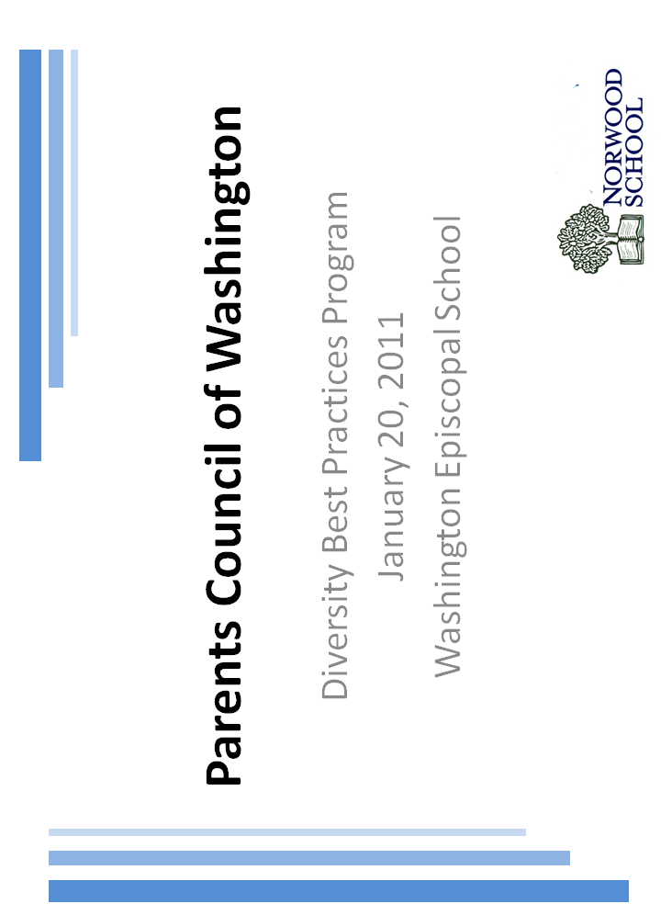
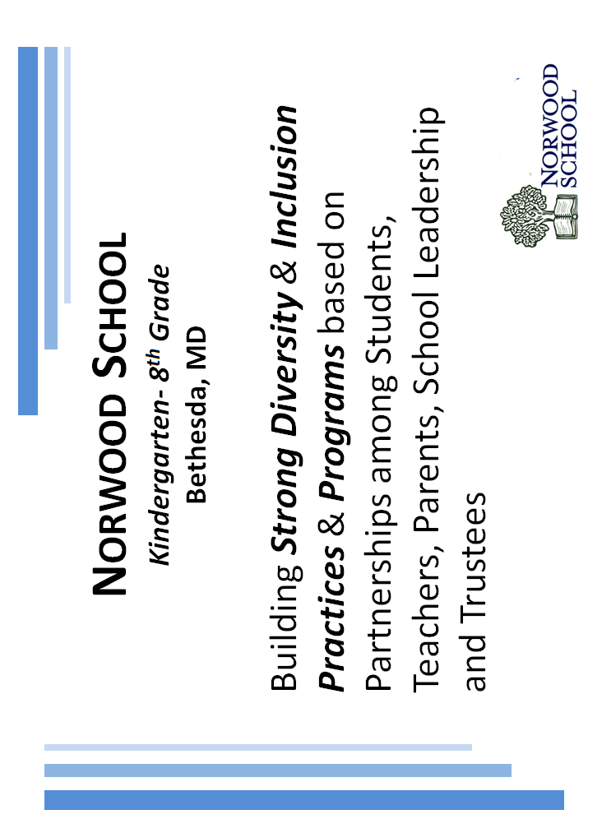
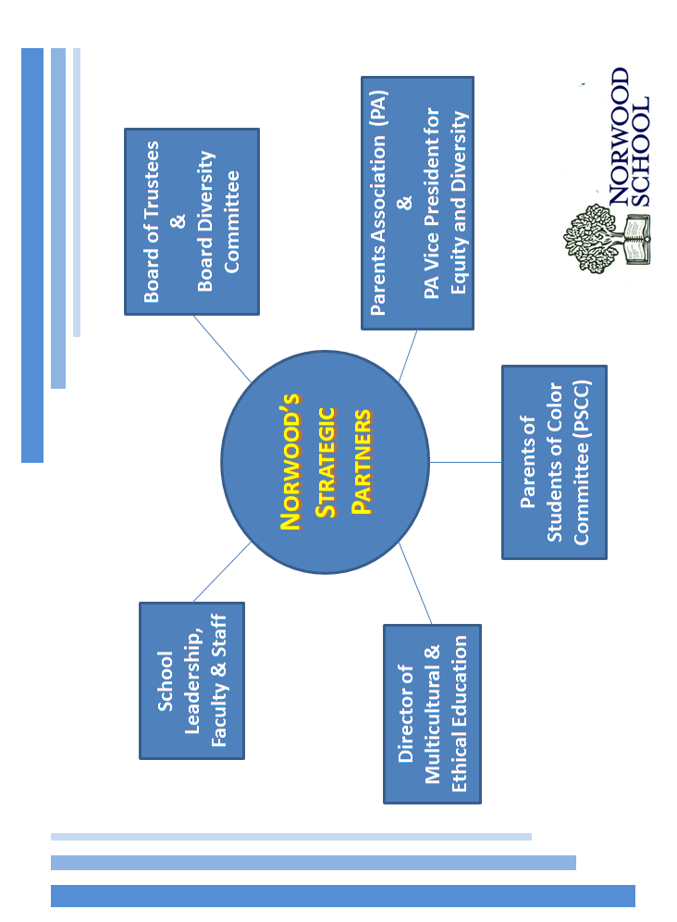
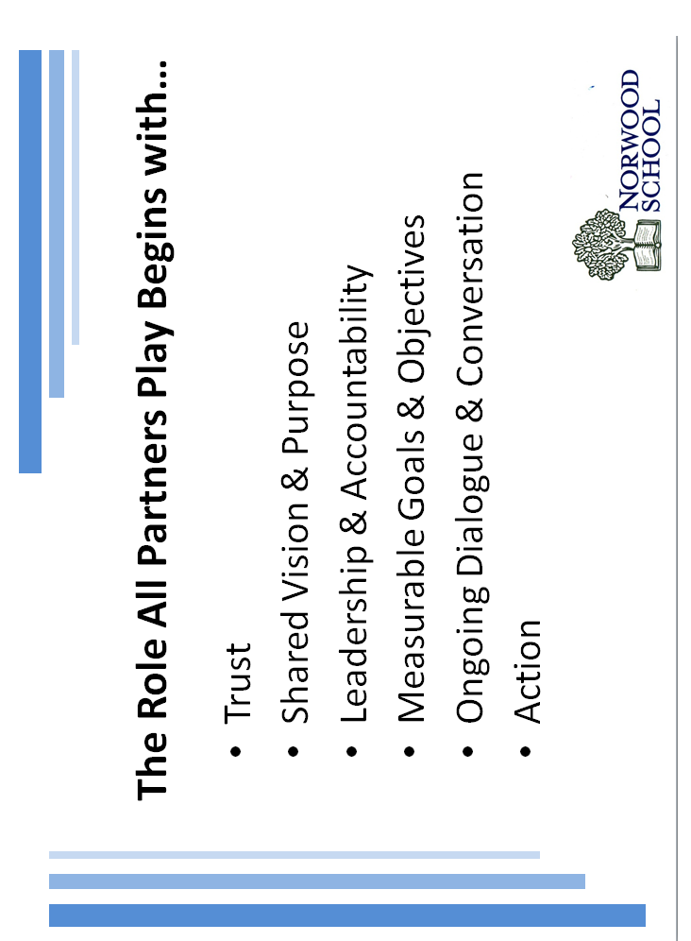
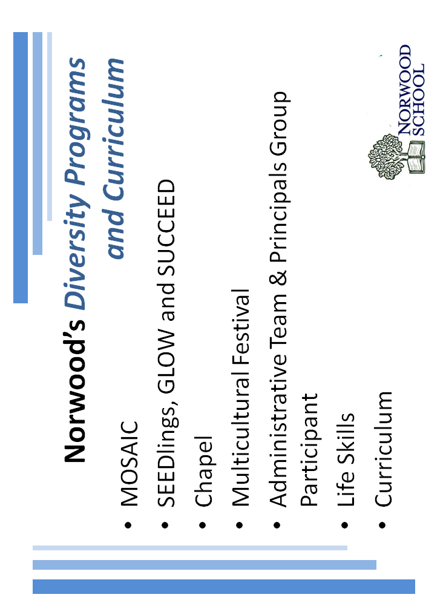
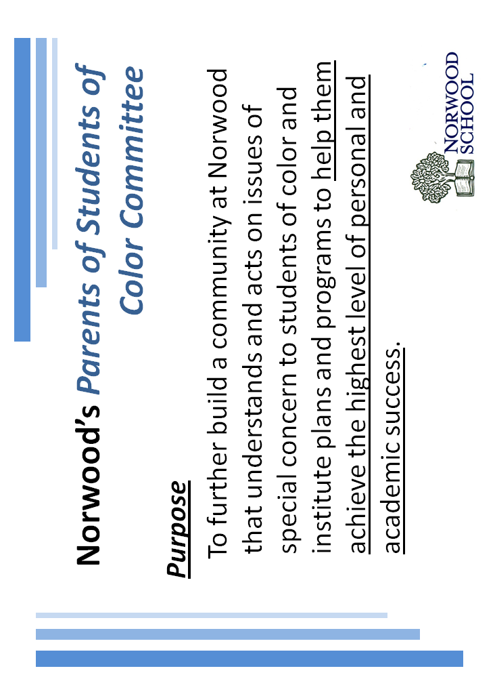
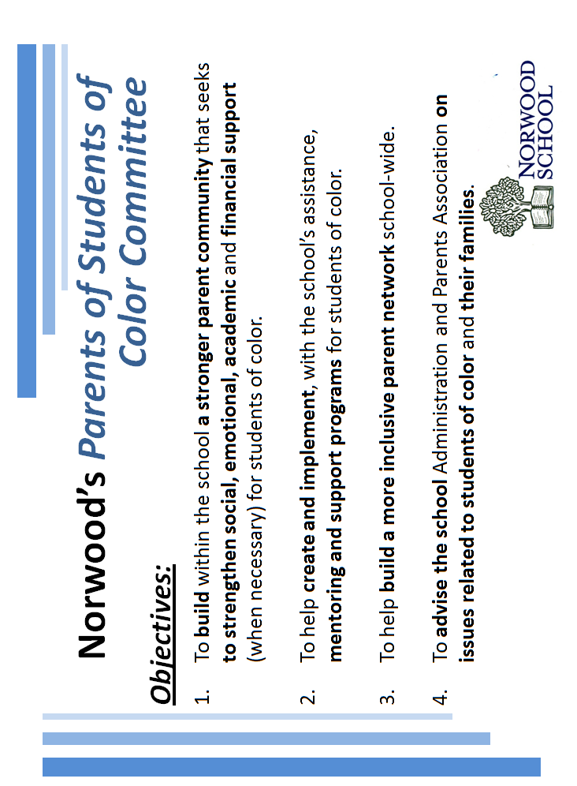
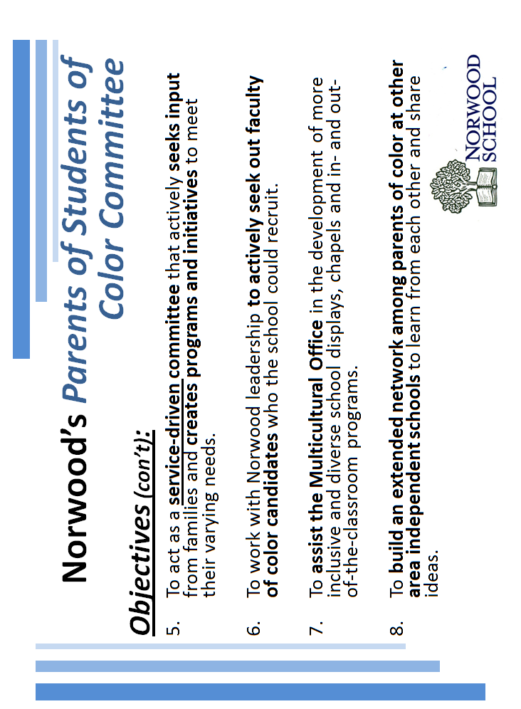
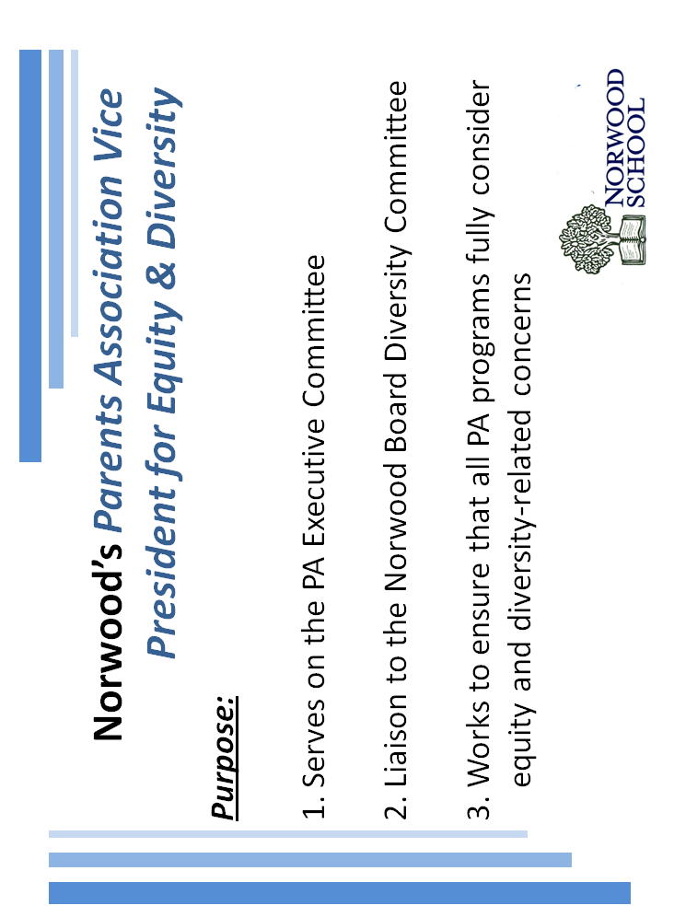
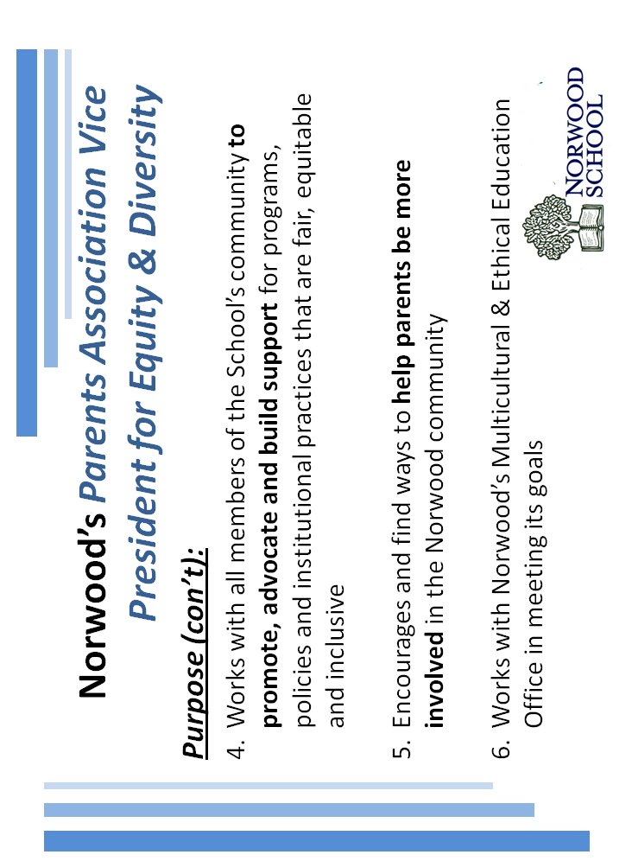
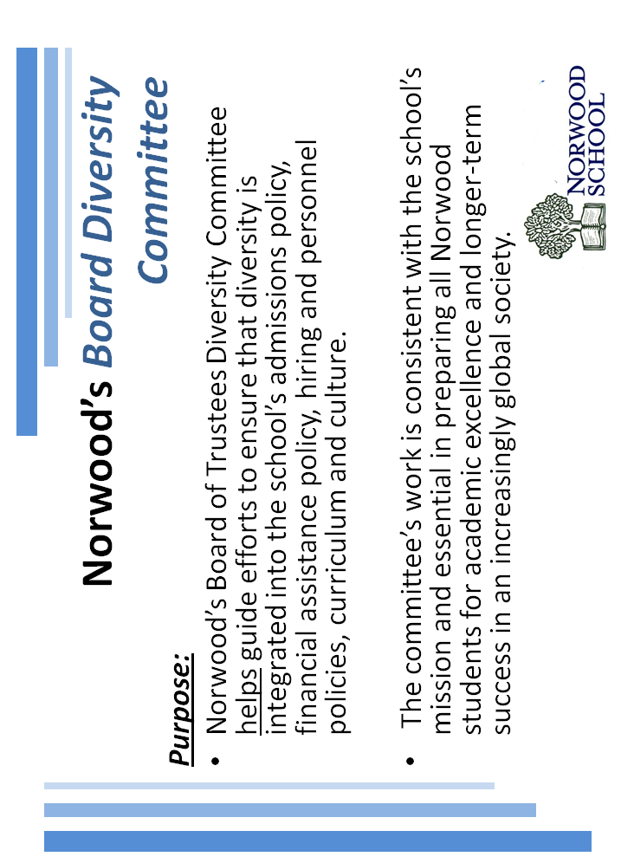
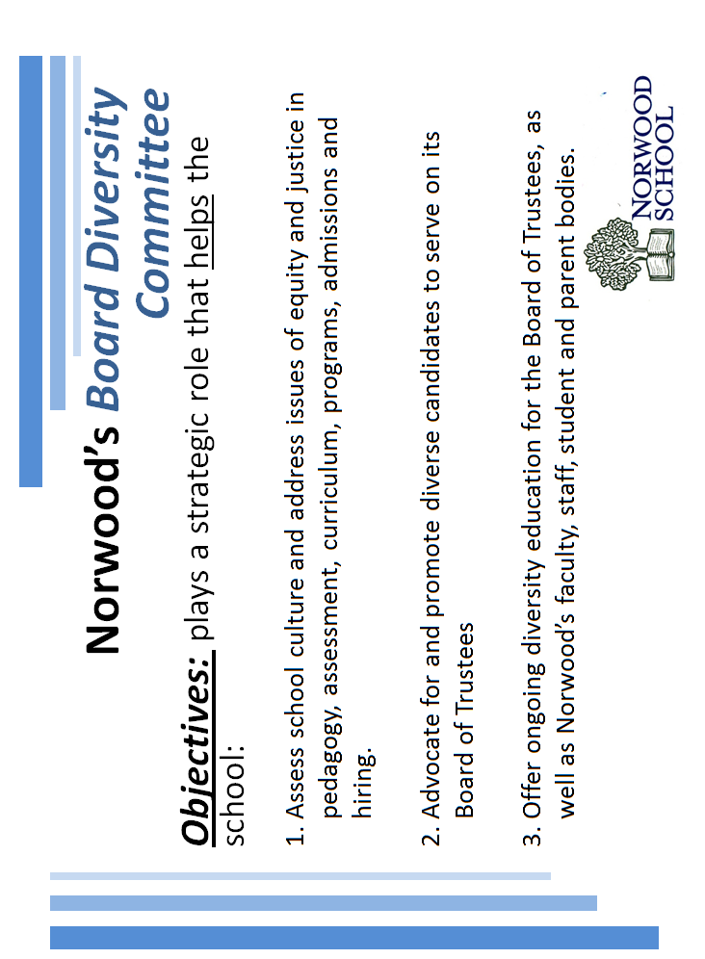
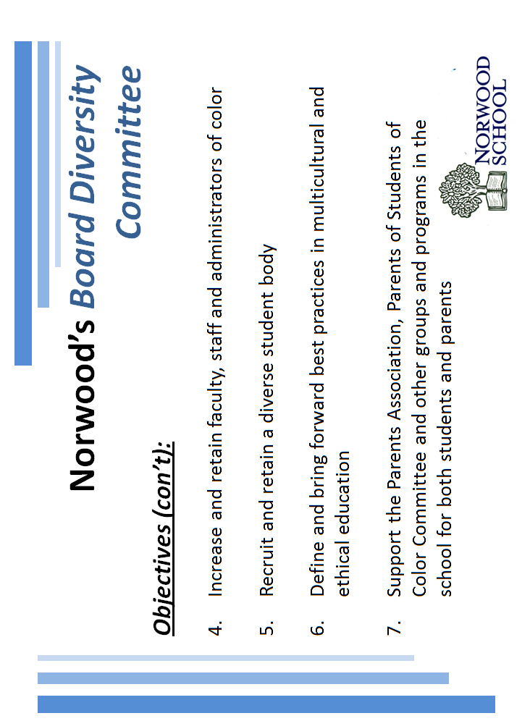
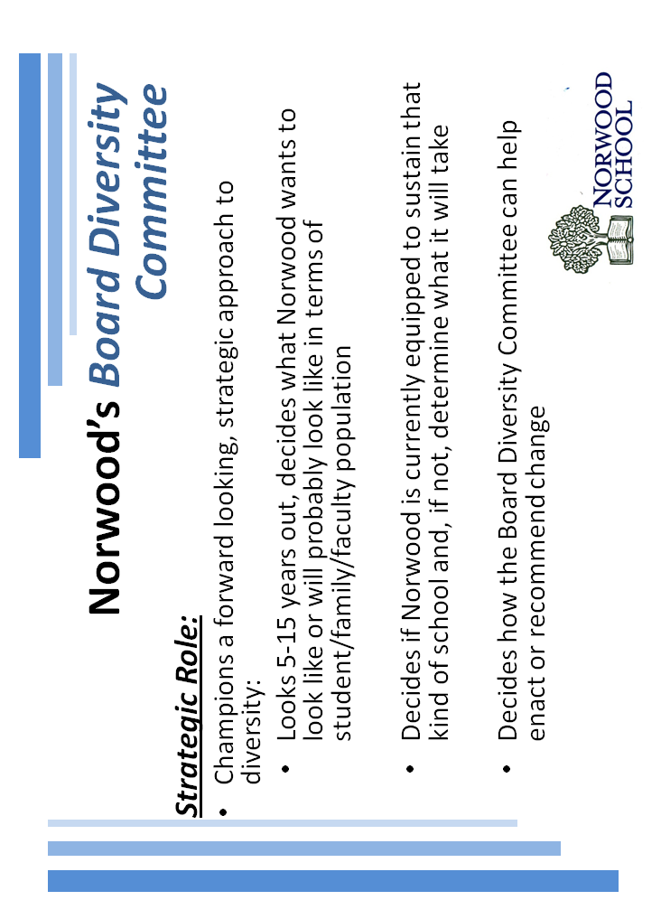
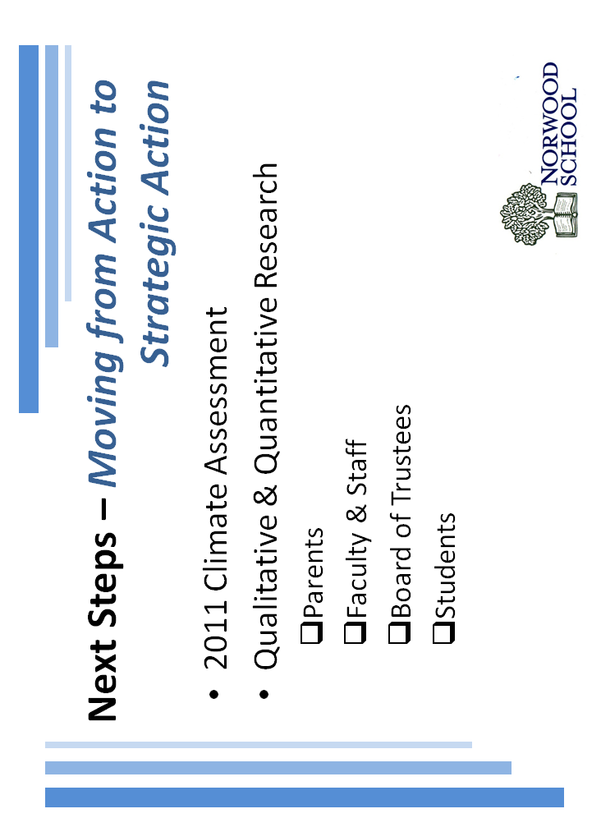
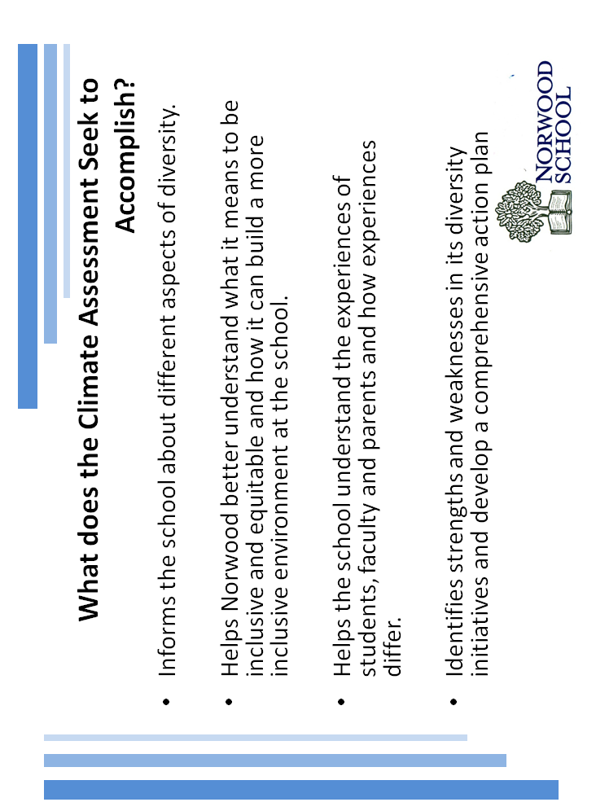
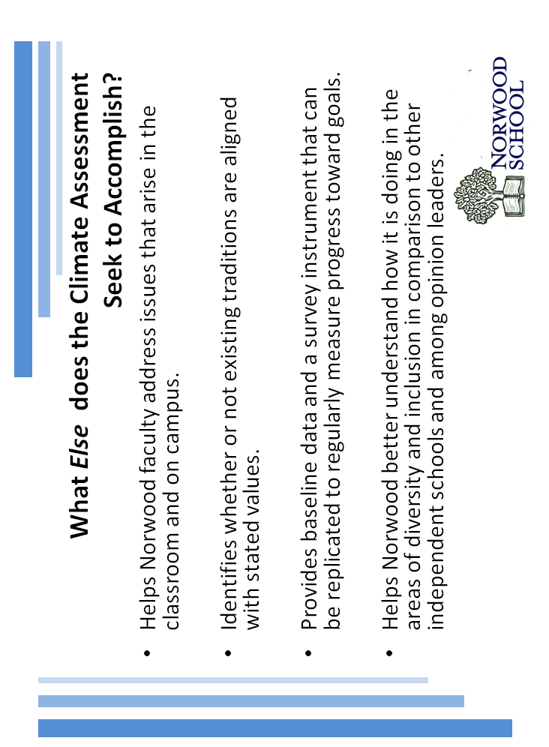

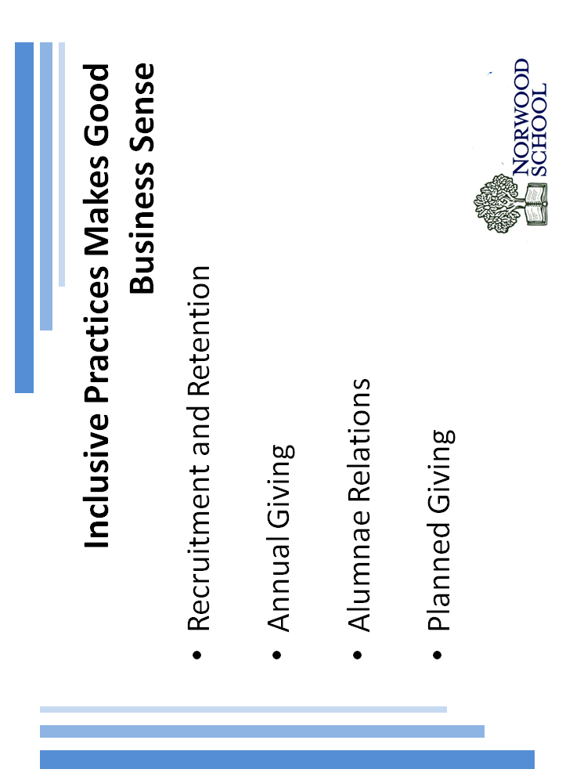
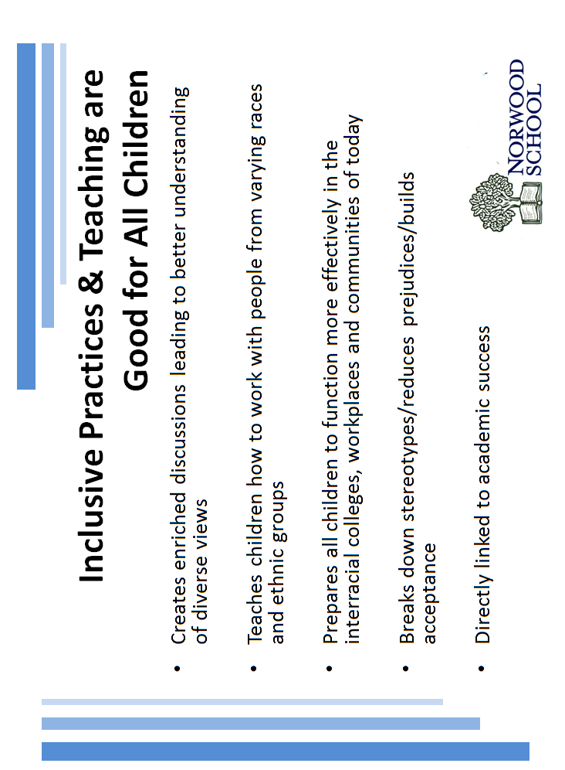
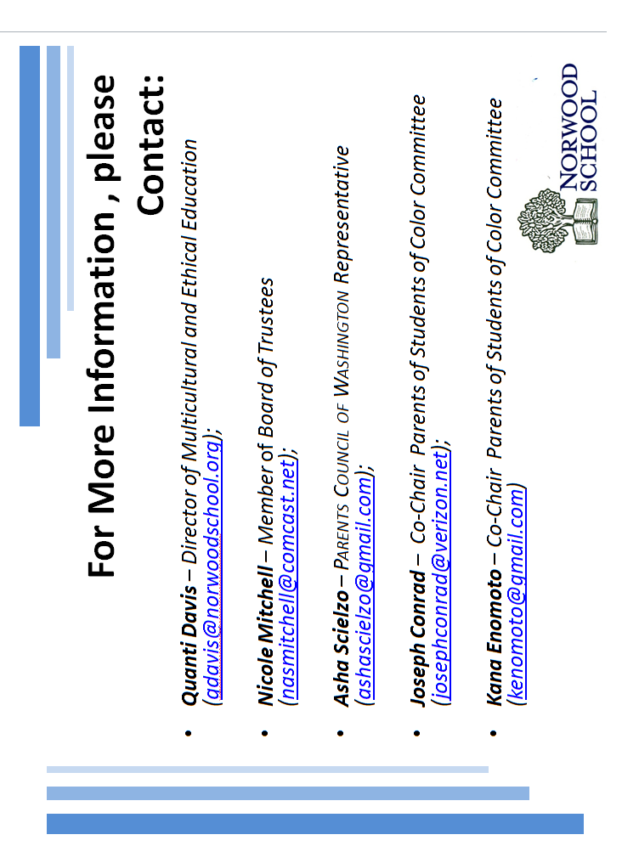
THE POTOMAC SCHOOL

The Potomac School – Diversity Practices

Potomac School’s Mission Statement on Diversity and Inclusion: We strive for diversity and inclusion in the conviction that a learning community is intellectually and morally strengthened when many different voices, viewpoints and backgrounds are engaged and learning from each other.

Potomac has two Diversity Directors – Carla Lukas clukas@potomacschool.org and David Grant dgrant@potomacschool.org.

The Potomac School believes in a program of diversity and inclusion. We believe diversity provides us with an opportunity to have courageous conversations, lean into discomfort, and learn to work collaboratively.

The Parent Diversity Committee was formed several years ago to work with The Potomac School community and faculty to ensure that parents are active partners in fulfilling the school’s mission as it relates to diversity and inclusion.

The goal of the Committee is to foster an inclusive environment for all social and ethnic groups at Potomac, and celebrate the community as a whole. The Committee plans to sponsor and encourage various groups in the community to participate in educational, cultural and social events to promote awareness of cultural and human diversity in the school community.

Diversity Committee Co-Chairs:
Vilma Correia correia4@gmail.com
Eddy Kassaye kassaye@kassysgroup.com
Kris Lee ykrislee@gmail.com

Parent Programs:
Parent run Diversity Committee is open for all to join.

Book Fair has an International Family Night to showcase a variety of cultures and customs within the school community.

Diversity Speaker Series

Student Programs:
Black Student Union (Upper School)

Affinity Groups in each school division

African American Affinity Groups in all divisions

Asian Affinity Groups in Lower, Middle and Upper Schools

The Intermediate School student led advisory discussions/lessons

Upper School Diversity Club

Conversations on Diversity and Equity

Upper and Intermediate School Diversity Days

Classroom Based Programs:
Faculty and Staff Workshops - frequently held for faculty and staff to encourage teaching and practicing an array of skills designed to enhance the cultural competency of all members of the community

Potomac sent several members of its faculty, staff and students to the People of Color Conference (POCC) and the Student Diversity Leadership Conference (SDLC) in December 2010. The dual aims of the conferences are to facilitate people of color coming together for networking and support and to support schools’ efforts to build and sustain inclusive environments. Presentations were made to the school community in January ’11 by the Potomac School attendees.

Faculty Meetings include diversity programs (across school divisions) at least twice a year.

School-wide Programs/ Activities:
Distinguished Speaker Series celebrates Martin Luther King Day each year with a speaker who can talk about the subject of acceptance and tolerance.

The Lower School conducted a survey of our African American parents and the whole faculty to solicit their feedback about the previous year’s affinity program, in the hope of using the information to make any necessary improvements.

Occasional Embassy visits are arranged for parents and children. These are conducted as a way of providing a hands-on cultural and educational experience.

Conversations That Count in each grade level. Diversity is the topic in one high school grade level each year.

Potomac School Diversity Directors attend monthly meetings with other diversity coordinators from various other Washington, DC area independent schools to share ideas and best practices.

ST. ALBANS SCHOOL

Lower School Diversity Committee

The St. Albans Lower School Diversity Committee was established to enhance the program of the Lower School by providing ongoing events and information that offer a broad and varied perspective with regard to culture, ethnicity, religion, gender, sexual orientation, socioeconomic background, and human capacity. The Diversity Committee works to celebrate not only the diversity of our Lower School community, but that of the world in general. The committee currently consists of seven teachers and two students. To date, we have hosted a Peace Corps assembly, developed a weekly lunchtime History Brief activity, and engaged the entire Lower School in age-appropriate anti-bullying seminars. The committee continues to develop and seek activities that will enrich and expand our appreciation of a diverse world.

Curriculum
Through its comprehensive curriculum, St. Albans exposes students to a wide range of intellectually stimulating experiences. The School regularly evaluates its curriculum with regard to diversity.
Instruction has included, often in conjunction with the National Cathedral School for Girls: (1) courses incorporating African, African-American, Middle Eastern, Latin American, Caribbean, Jewish-American, Asian, and East Indian literature; (2) courses in Japanese, French, Spanish, Latin, Greek, and Chinese language; (3) courses covering Asian, Middle Eastern, and African history; (4) courses in world religion; (5) visual and performing arts programs reflecting varied cultures and traditions; and (6) international exchange programs.

Student Programs/activities
Student-run organizations, such as the Cultural Awareness Organization and Gay-Straight Alliance, increase consciousness of diversity by arranging for speakers, organizing social service events, and helping at admissions events.
For more than 40 years, St. Albans has offered the Skip Grant Program, which provides support and guidance for students from traditionally underrepresented backgrounds. The program works with the Admissions Office to identify talented young men from different walks of life. The program provides counseling, tutoring, monitoring, and financial assistance to approximately 25 students annually, including African American, Caucasian, Latino, multi-racial, and international students.
The St. Albans dormitory plays a significant role in the School’s ongoing efforts to attract and support students from diverse backgrounds. The dormitory serves as a home away from home for international students, students from outside the Washington, D.C., metropolitan area, and students with varied economic circumstances.

Classroom-based Programs
In the Lower School, the required summer reading lists include authors from many cultures: Alice Walker, Isaac Singer, and Pearl Buck, among others. The Lower School Music Program invites guests of various backgrounds to lecture and perform music of other cultures: Over the years, during Hispanic Heritage Month, we have had visits from flamenco dancers, guitarists, singing groups, and mariachi bands. During African American History Month, we have had pianists performing music of black classical composers, blues bands, jazz bands, Wynton Marsalis playing with a trio, and gospel choir performances from Howard University. Boys have also performed music of the Maori people, carols from many countries (in the native languages), and Hebrew songs during holidays. One boy brought in (and played) a special drum from his native India. A boys’ school from South Africa came and performed on kettle drums, exposing our students to new sounds and rhythms. Chapel talks about acceptance and kindness expose boys to differing cultures, and in chapel we celebrate different religious events (Ramadan, bar mitzvahs, confirmations). We have had homilies delivered by a rabbi, a priest, a military chaplain, and an imam.
In the Upper School, literature in required courses includes Richard Wright’s Black Boy, Frederick Douglass’s slave narrative, The Mahabharata, and Approaching the Qur’an. Our Japanese program has an annual exchange with the Keio School through which Japanese students come to St. Albans for three weeks where they attend classes, live with host families, and often perform a tea ceremony or otherwise share aspects of Japanese culture with our students and faculty.

School-wide or Division-wide Programs/activities and Parent Programs
The school community offers diversity-related events such as chapels, drama productions, and professional development days throughout the year. The coordinated efforts of student organizations, faculty, alumni, staff, and parents have produced discussion forums featuring alumni from diverse backgrounds, all-day student events with guest speakers followed by student-led workshops, dramatic productions that address issues of diversity, and other events. Topics have included the following:
- Artistic expression
- Cultural awareness
- Gender issues
- Homosexuality and homophobia
- Race relations
- Racial identity
- Religious diversity
- Social class divisions
We have had speakers with disabilities, a gay police officer talking about his role in the D.C. police force, the Crown Prince of Jordan, Yale History Professor Frank Snowden ’64 (the first black graduate of St. Albans), and author and Harvard Law Professor Randall Kennedy ’73. The School has from time to time sponsored Diversity Forums for parents in a similar vein.

We offer extensive summer programs for our students to travel abroad and to experience, first-hand, the language and culture of other places. Student fellowships encourage students to travel around the world learning about a specific culture or engaging in community service. Travelers must present a summary and offer their reflections to the entire student body after the completion of their trips. Recent fellowship recipients visited Morocco, India, Malawi, China, Spain, and Argentina. Our sports teams play schools from all over the area, often traveling to different parts of the country over vacations. We also have social service programs in many city venues, where boys are exposed to different economic situations and reflect on the importance of service to our community in a broader context.

Several faculty professional days have focused on diversity. A recent one was about the school culture, how we teach all boys, and sensitivity to students and faculty of different backgrounds. In 2010, a group of Upper School students attended the High School Diversity Leadership Conference sponsored by the Eastern Educational Resource Collaborative in Washington, D.C.

What support does your school have available to handle diversity issues?
The Faculty Diversity Committee meets monthly to discuss the following:
- Faculty recruitment and hiring
- Support systems for students and faculty
- Curriculum
- Admissions, scholarships, financial aid, and the School’s need-blind admissions policy
- Tone and atmosphere of school life
- School publications
- Professional development opportunities

ST. ANDREW’S EPISCOPAL SCHOOL

St. Andrew’s Episcopal School’s DIVERSITY PROGRAM

See also the attached document we give out in the Admissions Office about our diversity programs.

- Curriculum
St. Andrew’s has recently undergone the process of mapping its entire multicultural curriculum PS-12. The mapping goes beyond just a mere record of diversity topics covered. The faculty is also required to record those aspects of their classroom instruction methods that foster a deconstruction of bias. The curriculum maps for multicultural education follow the James Banks’ model for the Five Dimensions of Multicultural Curriculum. The multicultural nature of the curriculum spans every subject area and division.

- Parent programs
Under the St. Andrew’s Parent Association, we have a Parent Diversity Committee (PDC) founded about four years ago. The PDC holds meetings every other month, and is instrumental in putting together an annual Taste of St. Andrew’s event to highlight the cultures represented in the school. The PDC has also sponsored a yearly award ceremony to all of those students who actively participate in affinity groups (Diversity Club, Black Student Alliance, Jewish Culture club, and Gay-Straight Alliance).

- Student programs/activities
The US hosts a variety of affinity groups: Diversity Club, Black Student Alliance, Gay Straight Alliance, and Jewish Culture Club
The MS has a diversity club that meets once a month

- School-wide programs/activities
MLK Day of Service; on the MLK Holiday we devote the day to service in and out of school [making ceramic bowls for a soup kitchen, decorating placemats, participating in a campus kitchen cook-off with the prepared foods going to local homeless shelters]
-Bokamoso South African Exchange Program
-Partnership with Christ Roi School in Haiti
-International Travel Programs: US: South Africa, Greece/Turkey, England, Honduras, Canada MS: Costa Rica

- Division-wide (lower, middle, upper school) programs/activities
US – 9th Grade Diversity Roundtable held annually; two annual assembly speakers on diversity topics; Chapels devoted to MLK, Holocaust Remembrance, the Jewish High Holy Days, etc.
MS – 7th Grade Advisor curriculum is devoted to equity and inclusion; getting students to think about moving from being a bystander to an ally; MS sends 12 student representatives to the DC-Area MS Diversity Conference. Attending students return from the conference to lead a mini-diversity conference for their MS peers; MS attend the 6-12th grade chapels with diversity themes (see above in US chapels)

- Support
We have a Diversity Director, an Assistant Diversity Coordinator, and an Administrative Assistant who is shared with the Middle School Office. All of those positions are partial contracts. The Diversity Director is a member of the Academic Team and attends Department Heads Meetings.

Follow up questions can be directed to:

Stacy Kincaid, Diversity Director
skincaid@saes.org
240-460-9534

Sally McLuckie and Anna Velazco, SAES Parent Representatives to the PCW
sally@sallymcluckie.com
apv@annavelazco.com

Maureen Stephenson (US), Marie Park (MS/IS), and Sharon Ferguson (LS)
SAES Parent Diversity Committee
Dstephenson2@fmshq.com
doublepark@verizon.net
Sherspence@aol.com
ST. PATRICK’S EPISCOPAL DAY SCHOOL

Goals for 2010-2011 St. Patrick’s Episcopal Day School Equity Committee

For the year 2010-2011, our primary goal is for each member of the St. Patrick’s community to understand the vital role equity and diversity play in a first-rate education – that which prepares our children for the world.

Simply put, a school cannot be academically excellent without embracing equity and diversity.

A little background:

“Nothing less than the nation’s future depends upon leaders trained through wide exposure to the ideas and mores of students as diverse as this nation of many peoples.”
Supreme Court Justice Lewis F. Powell, 1978

Sandra Day O’Connor repeated these words when she voted to support wholistic affirmative action in the 2003 University of Michigan Law School case, stating that diversity was of “compelling state interest.”

Both added that diversity included a broad array of characteristics of which racial or ethnic origin is but a single though important element.

In the years since 1994, when the St. Patrick’s Equity Committee was first formed as the Diversity and Multicultural Committee, its members have focused on equity as a moral imperative – an imperative essential to fulfilling our Mission Statement and creating a community in which all members feel recognized for their “infinite value.”

In fact, perhaps because of this focus, in the recent Parent Equity and Diversity Survey, several parents viewed equity as an issue separate from academic excellence.

We propose that equity is essential to academic excellence.

And, while we concur with Justices Powell and O’Connor, we would add that simple exposure to diversity is not enough. It is only by nurturing empathy and respect for others of every kind of diversity that our future will be assured.

After several years of equity forums featuring speakers and equity community conversations on topics ranging from race and socio-economic status to gender and learning differences, our focus this year will be in supporting broader forums that include discussions on equity and show its importance as an integral part of academic excellence.

We will return to community conversations on equity in 2011-2012 to pursue specific equity issues that rise to the surface during our gatherings this coming year.

In addition, the equity committee will turn a fresh eye to professional development and adherence to the Guiding Principles for Equity, particularly in the curriculum.

Accomplishments:

- Through the efforts of the Equity Committee, the St. Patrick’s faculty adopted a set of Equity Principles in 1999. These principles are published in the school’s faculty and parent handbooks and are on this website. They served as the basis for a comprehensive diversity audit completed by faculty members in the spring of 2000 and a for a close examination of the school’s curriculum the following year. Each of these studies resulted in changes in policy and practice within the school. After a full faculty review during 2009-2010, they remain applicable and comprehensive and will guide our new audit of the curriculum during the 2010-2011 school year.

- St. Patrick’s is a Black Student fund member school. We participate in the work of the Fund, recruit students at its annual school fair, and employ its resources to support our community. Many St. Patrick’s faculty and administrators have taken Equity, Race, and Education courses as well as other Fund-related courses.

- St. Patrick’s also belongs to the Latino Student Fund and works regularly with the East Ed Resource Collaborative, an organization devoted to educating educators on issues of equity.

- Each year St. Patrick’s sense a contingent of faculty members to the National Association of Independent School’s People of Color Conference. Faculty members from St. Patrick’s presented at the 2001, 2003, and 2004 Conferences.

- In September of 2001, the St. Patrick’s Parents Association created a new executive position, Equity Liaison. This Parents Association officer is charged with working with the faculty Equity Committee and building parent participation in equity work. Since that time, the position has been renamed Vice President for Equity.

- In March of 2002, the St. Patrick’s Parents Association and Equity Committee co-sponsored a Parent-Teacher Equity Forum in order to foster dialogue about equity issues. At least two similar forums have been held in each subsequent school year, attracting a growing number of participants who have helped us identify strengths in place and challenges that we face in achieving equity goals.

- During the 2003-2004 school year, the Parents of Black Students Association became incorporated and the San Patricio Club was formed for Spanish-speaking families.

- In September of 2004, the Board of Trustees formed an Equity Committee to provide Board-level advocacy for equity issues.

- In February of 2004, the Parent-Teacher Equity Forum featured University of Pennsylvania teacher and researcher, Dr. Howard Stevenson, speaking on “The Dynamics of Race in Independent Schools.” In each subsequent year, at least one forum or conversation has featured an expert speaker, including Sexuality and Family Life Educator, Deborah Roffman, in 2006 and 2007, Dee Dee Myers in 2008 on “Why Women Should Rule the World,” and Gene Batiste of NAIS, who addressed socio-economic diversity in the 2008-2009 school year. Marilyn Benoit, former President of the American Academy of Child and Adolescent Psychiatry, spoke in the spring of 2010.

- Some Equity Forums featured panels, including panels of current parents in 2002 and 2003, a panel of alumni in 2004, and a panel of alumni parents in 2005, each panel representing a broad spectrum of diversity with participants speaking frankly about their experiences here.

- In response to community requests for more discussion, we added Equity Salons in 2004 and then moved to Equity Community Conversations on varying themes in 2008. In the fall of 2009, after hearing a faculty panel on nurturing equity through empathy in the classroom, participants broke into small discussion groups to talk about nurturing equity through empathy at home. In the spring of 2010, following the results of the Parent Equity and Diversity Survey and remarks by Marilyn Benoit, former President of the American Academy of Child and Adolescent Psychiatry, the evening concluded with a candid discussion of “where do we go from here?”

- In September 2006, the committee proposed and the administrative team adopted a more comprehensive recognition of Heritage months.

- In September 2008, a specific Mission Statement for Equity and Diversity was drafted and adopted.

- A three-part Equity and Diversity Survey, supervised by the Board Equity Committee, is in progress, with the parent portion completed during the 2009-2010 school year.

Equity Guiding Principles
This set of principles was adopted in 1999 to guide us in nurturing our diverse learning community. Reviewed at a full faculty meeting in 2009-2010, they remain appropriate and comprehensive goals for equity. Our current goal is to make sure they are a document we all regularly refer to and apply.

I. Understanding As a community of valued individuals, we celebrate our differences and appreciate our commonalities as children of God.

Areas of measurement:
- Our school environment – visually, aesthetically, programmatically, and in all other ways – represents, and is accessible to, all children.
- Our curriculum emphasizes the educational value of seeing issues from multiple points of view and fosters crucial thinking about bias.
- Our curricular materials are up-to-date. They value difference in culture (including geographical and historical setting), religion, socio-economic status, family configuration, gender, sexual orientation, age, and physical and cognitive abilities (multiple intelligences).

II Inclusion An inclusive community is one that represents a diverse population, embracing people of varying ages, abilities, ethnicities family configurations genders, sexual orientations, races, religions, and socio-economic backgrounds. Each member of the St. Patrick’s community is responsible for promoting equal access and equal respect in the school setting and in the greater St. Patrick’s community.

Areas of measurement:
- Our school has admission policies and processes that promote inclusion.
- Our school actively seeks faculty and staff who come from diverse backgrounds.
- Our school reaches out to all parents and includes them in the life of the school in meaningful ways.
- Our school is a place that reflects and represents the diversity in our community and beyond.

III Honesty It is our ongoing responsibility to represent St. Patrick’s accurately as we clarify who we are and who we want to be and to be aware of our own biases and prejudices.

Areas of measurement:
- Assessment is valued as a continuous process in the classroom and in the community and is recognized as a way to promote responsiveness to change.
- Assessment is included as a formal part of the faculty evaluation process.
- Ongoing education is a premise and a reality for faculty, administration, staff, parents, and board members.

Summaries of recent examples of Equity-in-Action at St. Patrick’s

Equity Community Conversation and Professional Development Summaries

PARENT SURVEY PRAISES, CHALLENGES
DAY SCHOOL REGARDING EQUITY INITIATIVES
April 13, 2010

“I believe that the foundation St. Patrick’s has provided my children from nursery through sixth grade has consistently instilled in them a sense of fairness, and they have demonstrated a good balance when choosing friends at St. Patrick’s and beyond. They seek schools and situations that provide an experience enriched with diversity and, I think, would be bored without it. They do not see race or religion or socioeconomic status as obstacles. They have maintained a broad mix of close friends who often look different but usually have common values.”

Last week’s Community Conversation on Equity opened with 25 of the hundreds of such comments from the recent Parent Equity Survey. We ended with the quote above. Our goal, as a community, should be for all its members to be able to summarize their experience here in such terms. As many of the other comments made clear, we are not there yet. In sharing selected comments, we wanted to display the wide range of perspectives here. Some members of our community expressed feelings of marginalization. Other members think we are focusing too much on equity at the expense of academic excellence. Yet almost all parents are confident the academics here are excellent, with just over 93% describing the quality as “excellent” or “very good.”

As equity and diversity consultant Randolph Carter noted in his survey summary that followed the specific comments, there is still a disconnect in many parents’ minds between excellent academics and an equitable community, or even the mindset that they are in competition with each other. In fact, as a parent pointed out in the stimulating discussion later in the meeting, in our increasingly global and therefore multi-cultural society, a student is no longer fully educated and ready to lead (or even follow) unless that individual has been educated in a diverse community. We are not all hard-wired to embrace change or even difference. But when we develop those attitudes, others noted, we have learned essential skills for the changing world, and we are continually enriched by our openness to the ideas of others. Mr. Carter pointed to the large number of parents who selected “neutral” or “no opinion” on a number of questions about how the school addresses issues including gender, race, socio-economic status, and sexual orientation, suggesting that they have not directed enough attention to these issues to form an
opinion. By cross-tabulating responses according to self-identifiers, Mr. Carter also showed differences in responses between white parents and other groups, although not on the quality of the academic experience. He noted that, ironically, the members of our community who have the most to gain through embracing difference and nurturing a diverse community are the members of the majority, because they have been less likely in the past to need such skills as flexibility, adaptability, and openness in the face of change and difference.

In her thought-provoking remarks that followed Mr. Carter’s presentation, Dr. Marilyn Benoit, past president of the American Academy of Child and Adolescent Psychiatry, questioned the use of the terms majority and minority as ones that maintain the status quo and a sense of conflict. She supported the interpretation of equity as one emphasized in our fall community conversation―as an attitude of empathy and enthusiasm for all kinds of people. She offered this magnificent quote from Alice Walker’s In Search of Our Mother’s Garden: “What is always needed in the appreciation of art or life is the larger perspective. Connections made or at
least attempted, where none existed before, the straining to encompass in one’s glance at the varied world the common thread, the unifying theme through immense diversity, a fearlessness of growth, of search, of looking, that enlarges the private and public world. And yet, in our particular society, it is the narrowed and narrowing view of life that often wins.”

Widening our world and making diverse connections will nurture an equitable environment faster than a thousand how-to workshops. In fact, Dr. Benoit cautioned against “learning” about different ethnicities as the primary road to equity. She quoted from Removing Cultural and Ethnic Barriers: “In our efforts to know the cultural background and current life styles of ethnic minorities, gross generalizations are relied on. At the same time that they provide us with a beginning understanding, they can also be used to obliterate the individual differences that exist between members of a given group.”

The evening ended with a candid conversation about where we go from here. We need to identify the best way to share the results of the Parent Equity Survey beyond the attendees at last week’s Community Conversation on Equity and the brief glimpses here. In the meantime, the question kept coming: How do we get the entire parent body to become invested in fostering a community in which every member can bless the opening quote?
Ann Adams, Grade 8 Humanities
Erica Thompson, Grade 3 Resource
Co-Chairs, Faculty Equity Committee

“MAKING SCHOOLS SAFE” CONFERENCE ATTRACTS SIX ST. PATRICK’S EDUCATORS
March 2010
On Tuesday, March 2, six members of the St. Patrick’s faculty and staff attended the Association of Independent Maryland Schools (AIMS) Making Schools Safe conference, held at Roland Park Country School in Baltimore.
Representing all three of our divisions—Nancy White and Mendy Thaler of the Nursery School, Gretchen Spencer and Erica Thompson of the Lower School, and Judy Barr and Amy Yount of the Upper School—these educators sought insights to bring back to St. Patrick’s about ways to continue to make the Day School welcoming and safe for all members of the community.
The day began with a keynote speech by Ritch Savin-Williams, a Cornell University professor and author of The New Gay Teenager, whose research has focused on sexual orientation as it relates to child and teen development. In his talk, he encouraged parents and schools to allow students to self-identify how they view themselves in terms of sexual orientation as well as gender. Rather than confining individuals to rigid boxes of identity, he encouraged communities to recognize that there is a spectrum of behavior that encompasses gender expression and sexual identification, and communities should focus on the unique gifts of each member of the community. Recognizing that a safe environment is essential to this kind of appreciation, he stressed the importance of working to eliminate nonconformist gender bullying at all ages.
Subsequent small-group discussions focused on sharing ways in which our schools foster an open and inclusive learning environment, challenges we face in that task, and what more we can do to create a culture of inclusiveness for lesbian, gay, bisexual, and transgender (LGBT) faculty, staff, parents, and students. Student participants in the conference spoke honestly and thoughtfully about their hopes for each of their schools, and we learned from each other in our efforts to work toward our common goal: Making our schools safe and welcoming for all children and families
MIX-IT-UP LUNCH - MIXES UP STUDENTS
February 2010
Yesterday, the Grades 3 through 6 lunches looked a little different as we hosted our third annual Mix-It-Up Lunch. The goal of the Mix-It-Up Lunch is to help students cross invisible lines of social division, meet new people, and make new friends by placing them at new tables during their lunch periods. Organized by Teaching Tolerance, Mix-It-Up lunches took place in schools across the nation this week.
When students arrived in the Lunch Room, they each received a color-coded sticker with a table number indicating where they should sit. After receiving their stickers, students collected their lunches and then went to their tables. Teachers made sure that each student was sitting next to a child from a different grade level.
There were table tents on each table with questions to help spark conversation and to help students get to know more about each other. There was also an adult at each table during each of the lunch periods helping students talk to each other and make new friendships.
By all accounts, the lunches were a success. Based on reports from students at a few tables, we now know that a large number of Grade 5 and Grade 6 students prefer Five Guys burgers to Z-Burger (with at least one exception), that more Grade 3 and Grade 4 students have favorite movies than do their Grade 5 and Grade 6 counterparts, and that, regardless of grade level, St. Patrick's students are an interesting and enjoyable bunch who are glad to make new friends.
Dan Spector
Assistant Head of School for Academic Affairs

POCC CONFERENCE HIGHLIGHTS

December 2009
ST. PATRICK'S REPRESENTATIVES TRAVEL TO DENVER
FOR NAIS PEOPLE OF COLOR CONFERENCE
In early December, four teachers and administrators from St. Patrick's traveled to the mile-high city of Denver to participate in the 22nd annual National Association of Independent Schools (NAIS) People of Color Conference (PoCC). The theme for this year's event: “Moving Mountains, Mining Within.”
Attending were more than 2,500 educators and high school students from across the country and world, with four international participants. The students, comprising a little less than half of the overall attendance, participated in a parallel conference, the Student Diversity Leadership Conference (SDLC). Kankunda Klingenberg, Religion Teacher and Diversity Coordinator; Stacia McFadden, Director of Technology and Summer Programs; Shannon Scott, 3B; and Erica Thompson, Grade 3 Resource, spent two days immersed in workshops and discussions of the experiences of people of color in independent schools. All four teachers returned from the conference refreshed, rejuvenated, and reaffirmed—ready to contribute even more to St. Patrick’s efforts toward equity and diversity.
Among the many highlights of the conference, several speakers stand out. In the opening keynote address, John Quinones—co-anchor of ABC TV’s Primetime, correspondent for Primetime Thursday and 20/20, and host of the hit show “What Would You Do?”—spoke from the heart about his experiences growing up in a family of migrant workers, speaking only Spanish until Grade 1, and working extremely hard to become an Emmy Award-winning journalist. Kenji Yoshino, the Chief Justice Earl Warren Professor of Constitutional Law at NYU School of Law, related his personal story of being a gay Asian American to talk about the pressures society places on people to “cover” true aspects of their personalities in order to fit in with the mainstream. The speaker at the closing ceremony, Marcia Ann Gillespie—former editor in chief of Essence and Ms. magazines—spoke candidly to the audience about her work for the civil rights of African Americans and women. Ms. Gillespie tied her thoughts into the theme of the conference, letting us know that, yes, we are all at different places on the mountain and that we must be trailblazers; however, instead of creating trails for others to “climb” behind us, she asked how we take the trails down the mountain and to the people. These remarkable speakers provided us with passionate professional and personal stories to challenge and inspire us.
In addition to hearing keynote speakers, participants attended smaller workshops and presentations dealing with a range of topics related to life in independent schools. Some of the workshops our representatives attended included “How to Make the Invisible Visible: Tools for Pulling Back the Veil of Privilege,” “The Societal Impact of Race, Religion, and Creed Inside and Outside of the Classroom,” “Never Too Young: Exploring Multiculturalism in Elementary Years,” “What Mainstream Movies Teach Us about Race,” “From Hottentot to Barbie: Dismantling the Beauty Standard for Girls of Color,” “Shared Voices: A Documentary on the Experiences of Faculty of Color,” “Yes We Can—Succeed Despite What Some Perceive,” “Promoting Cultural Pluralism through Technology,” and “Creating an Anti-Bullying Program at Your School.” There were also opportunities to view two very powerful documentaries—The Prep School Negro, one man’s journey from the ghettos of Philadelphia to a prestigious independent school and how that shaped his life, and Straightlaced, a film about how gender, race, culture, and sexuality affect students of color.
PoCC also hosts affinity group sessions that allow participants to develop their own racial/ethnic identities as they relate to their personal and professional experiences. The key difference between these sessions and the other workshops is that affinity groups provide an opportunity for each participant to explore him/herself in a safe and trusted environment led by a team of trained facilitators. Mrs. Klingenberg has served as a facilitator for many years.
The PoCC experience allowed participants dedicated and focused time to think about their individual roles as educators in independent schools. They brought back ideas, lessons learned, and enthusiasm, all which are important to the continuing equity work we believe in at St. Patrick's.
Stacia L. McFadden
Technology Director / Summer at St. Patrick's Director
Equity Community Conversation, November 19, 2009
The Equity Committee thanks all members of our community who attended our Community Conversation on Thursday, November 19: Nurturing Equity through Empathy and Respect.

Pat Spector, a founder and long-time chair of the Equity Committee with Kankunda Klingenberg, began the evening with an overview of the history of equity work at St. Patrick’s, including not just the evolution of the Equity Forums and conversations and the development of the Mission Statement and Guiding Principles, as well as equity positions in the Parents Association and Board of Trustees, but also the important changes in practice that have resulted – from potluck dinners held at school rather than private homes, to limits on school activities that highlight socio-economic differences, from establishing affinity groups to encouraging broader afternoon playdates, from sponsoring deliberate professional development in equity to ordering multi-cultural paper and crayons. David Evans then introduced the audience to the concept of empathy and its critical importance. He emphasized that it is a skill that can be taught and must be nurtured. A faculty panel then surveyed the deliberate steps teachers have taken to foster equity and empathy in the class room and beyond.. We offered this as a springboard for group discussions on what we can all do, as parents and educators, to foster empathetic, respectful, and therefore equitable children.

A summary of the panel presentations follows:

Nursery
Helen Gasparetti

Helen showed the ways the nursery teachers nurture equity in the curriculum and in the many teachable moments throughout the day. In the curricular units, all cultures, family structures, genders, and socio-economic backgrounds are represented, respected, and validated. For a unit on Castles, royal residences from all over the world are included. A unit on Homes addresses apartments, as well as houses. The Family unit shows that all kinds of families exist, from single parent to two mommies or two daddies. Some children are adopted. Some families are adopted. A Space unit features books, photographs, and materials with female astronauts and astronauts of color. Both girls and boys are encouraged to be construction workers if a construction site is set up in the play corner. If a boy wants to dress up as a princess during a unit of Fairy Tales, this is accepted and validated by the teachers. Children are cast in non-traditional roles in the Christmas Pageant.

The unit on Self-Portraits supports this recognition and celebration of diversity but also shows the universal attributes that all humans share. The Nursery teachers talk about the various skin tones, eye colors, shapes and sizes we are and how these varying characteristics make us all unique. But they also talk about the fact that we are all human – with flesh, blood, bones, organs, and emotions. If children understand the “human-ness” of all of us, then they can start to develop the empathy that nurtures equity.

Outside of the curriculum, Nursery teachers look for ways to teach empathy in daily interactions. During a dispute between two children, a teacher might say, “Look at Johnny. He’s crying. How do you think he is feeling right now?” On the playground, a teacher might say, “Mary looks like she is looking for a friend to play with. Why don’t you ask her to play with you?” Other deliberate cooperative activities provide opportunities for children to work and play together who might not usually do so. The Nursery motto is, “Can’t say ‘can’t play’.”

Careful language is vital to instilling empathy and equity. Instead of asking, “What did you do over the holidays,” a better question – one that validates the holiday experience of every child – is, “Did you enjoy your time with your family?” Similarly, because all kinds of families exist, teachers deliberately say, “your family” or “your parents,” rather than “your mom and dad.”

Lower School
Erica Thompson

Speaking for the Lower School, Erica Thompson stressed similar themes of deliberate instruction and careful alertness to diversity. While teachers make use of countless “teachable moments” on the fly, deliberate instruction provides the terminology for those moments. Erica gave the example of the “crumpled heart,” on which students write down a few of their favorite things and then crumple the heart-shaped paper into a ball. Just as careful smoothing can not recreate that flat piece of paper, a simple apology cannot always repair hurt feelings. An “apology of action” -- understanding what you did wrong and trying to correct that wrong becomes an understandable goal for a child who has the visual image of the crumpled heart. The “Peace Path” – used throughout elementary school – is another piece of deliberate instruction in useful language. In the Peace Path, two children who are in conflict share their feelings with each other. Each child repeats what the other child has said. Then each student offers an apology and a solution. Students then reach an agreement on the solution and shake hands.

Books add to the deliberate instruction, with titles carefully chosen to show diverse perspectives and expose the hurtfulness of teasing and bullying, as well as the rewards of embracing difference. They are also vital to validating each student’s experience – every child should be able to find him or herself reflected in the curriculum.

On top of planned instruction, teachers must always be alert to any activity that exposes differences in a harmful way. School activities that require money or class activities like a family tree that reveals “missing” pieces are two examples.

Alertness and deliberateness come together in “The Responsive Classroom,” a classroom approach all lower school teachers have learned – an approach that believes in the importance of the social curriculum and promotes the idea that we must really know our children individually, culturally, and developmentally, in order to best serve them. At morning meeting, therefore, teachers use care to ensure that sharing time validates every child’s experience, so children share experiences or knowledge rather than new toys or vacation trips.

Upper School
Therese Khan

In Upper School, building respect for difference continues in and out of the classroom, as students become more aware of these differences. Therese Khan listed the areas in which upper school students begin to categorize each other:
Different learning styles
Different levels of athleticism
Different personalities – especially noting those with eccentric personalities different from what is deemed cool
Different levels of maturity
Different interests
Again, an upper school teacher lives equity both within and outside of the curriculum. In our interactions with the children, upper school teachers insist on mutual respect, not universal love. They help students with learning challenges, such as low patience, find tools and language. They reinforce empathy by reminding students how they would feel if they were excluded from an activity or a lunch table. They remain alert to sudden challenging social situations and deal with them in the moment by listening to everyone’s point of view, analyzing the dynamic, and helping to form solutions to prevent a similar occurrence and to repair any damage. They emphasize personal responsibility in every social situation, thus discouraging the role of “bystander.” Allowing mean behaviour is a form of supporting that mean behaviour, and students are shown the difference between tattling and knowing when to get an adult involved. And, finally, teachers encourage students to be grateful for the privileges they have – whether it’s meeting well-known authors at the book fair or having the right to vote and speak – rights people have historically died for to achieve.

Literature and history provide a safe context for understanding different perspectives, ranging from the experience of Native Americans and migrant workers to the necessity of seeing both sides of a military or political conflict, as well as the pros and cons of any kind of societal or technological progress. The urgency of understanding and respect globally easily translates to the idea that such goals start with individuals.

Grade 6 ends with the Identity Project – a two-to-three week investigation of some aspect of identity, including gender, politics, media, family, and socio-economic status. All the topics ask students to examine themselves, their circumstances, and the situations of others – with an eye toward better understanding themselves and others, thus gaining empathy and respect for those who may live in quite different circumstances.

Middle School
Ann Adams

Middle School, through its study of American History and Ethics, provides nothing but a spring board for equity issues, ranging from the experiences of immigrants to the battle for civil rights. Here, the goal remains for every student to see him or herself in the curriculum and to look hard at the intolerance that has met every “different” group of people that has entered since the British first colonized North America. At the same time, it is essential that students see strength in these mirrors. We learn about the Jim Crow South, not from To Kill a Mockingbird, in which a white male is the hero, but from Black Boy, the memoir of a strong, eloquent black male.

Literature continues to nurture empathy, as students make connections between diverse characters and their own experience – and, it is hoped, learn from the damage done by prejudice.

A large portion of Service Learning and Ethics is devoted to anti-bias – breaking down stereotypes about groups of people the students will serve – whether is it the homeless or senior citizens. And a short story unit in Ethics explores stories of self-discovery by all different kinds of people, in the face of societal and peer pressure – again with the goal of understanding, identification, and empathy.

Outside of the classroom, the middle school has an advisory program that allows for pre-emptive and reactive conversations on any social issues that arise – cliques, bullying, stereotyping, etc. During orientation, a concerted effort is made to show the Creed in action and to start discussions among the students that cross-pollinates the grades and groups of friends. A group of Grade 8 students attends a middle school diversity conference and then presents the information to the rest of the student body. Recent topics have been stereotyping and gender bias.

At the heart of all middle school equity work are the same characteristics so necessary in lower school – consistency, awareness, and deliberate instruction. Building on the education and a system of discipline and honor outlined in the student handbook, we also try to be alert to damaging social issues and then get to the bottom of them, expanding the perspective of all of us in the process.

***

A description of equity work in our curriculum would not be complete without noting the work in the arts. You need only attend a school concert or walk through the school halls to see and hear the variety of cultures explored and represented.

HISPANIC HERITAGE MONTH, September 15 – October 15, 2009
HERITAGE MONTH DISPLAY
HONORS HISPANIC CULTURES
As part of our ongoing effort to understand and respect the full spectrum of diversity within the St. Patrick's community, we celebrate different heritage and awareness months by creating displays in the Whitehaven Campus Lunch Room. Our first recognition honors the contributions of people of Hispanic heritage. Beginning on September 15, Hispanic Heritage Month marks the anniversary of independence for five Central American countries--Costa Rica, El Salvador, Guatemala, Honduras, and Nicaragua. Further, Mexico declared its independence on September 16, and Chile on September 18.
It is important for us to help our students understand that Hispanic heritage is not limited to Central and South Americans. According the United States census bureau, Hispanic (American) refers to any Spanish-speaking individual in the United States. There are now over 45 million Hispanic-Americans, and the United States has the second largest Hispanic population worldwide. Mexico has the largest with over 108 million citizens. Spain has just over 40 million citizens.
Please watch this space in future editions of the Thursday Bulletin for more information on our heritage and awareness month observations as well as other ways that St. Patrick's celebrates equity and diversity within our community.
Community Conversation, April 2009
COMMUNITY CONVERSATION: ABILITY & SOCIO-ECONOMIC STATUS
“The conversation was a success.”
“I loved the fact that it was completely parent-led!”
“The best equity meeting I have ever attended!”
“I am amazed at how thoughtful some of the comments were.”
These rave reviews came from attendees at our recent Community Conversation, conducted Wednesday, April 1. Despite the rain, over 40 attendees, including an especially strong turnout among parents, participated in a discussion of two social identifiers: Ability and socio-economic status.
Parents Cynthia Wimer (Francesca 2B) and Althea Harlin (Brian 4B, Colin ’06, Maddie Ross ’03) read excerpts from:
“Matt’s Story”www.adl.org/education/curriculum_connections/fall_2005/fall_2005_lesson4_matt.asp
“How School Taught Me I Was Poor” www.tolerance.org/teach/magazine/features.jsp?p=0&is=44&ar=1013&pa=2
We then split into two groups. Moley and Nicholas Evans (Charlotte N2) led the ability group, and Adelaide Barrett (Peter PK2) and Tammy Wincup (Grant PK3) coordinated the socio-economic status group.
While it would be impossible in this limited space to capture the insights shared in each group, the following are some of the highlights.
Ability Group
The importance of fostering a culture of embracing differences, recognizing the need to teach children to be able to adapt and make the most of the “cards they were dealt.”
Being careful about the word “celebrating” differences because we would not want to “celebrate” the fact that a student may not be, for example, a good speller.
Suggestion for creating a “working group” of teachers for a student with emotional or other issues.
The importance of teaching empathy.
Opportunities to teach perseverance (e.g. lessons learned from students with physical disabilities).
Emphasizing students’ strengths.
For continuing education for parents, share the summer reading list for faculty and staff in the Thursday Bulletin and/or on website and/or organize book clubs.
Consider a program similar to Nancy White’s Parenting Skills Class but for older students.
Socio-Economic Status Group
To minimize the perceptions of school holiday travel experiences among students, focus on students’ interpersonal experiences, rather than on destinations.
How attentive are students—and parents—to certain brands of clothing and other items?
Perception of lower socio-economic status may presume limitations in other abilities.
Socio-economic status and other factors can affect parents’ availability to help with projects done at home. Excessive parental participation in some instances?
Is there a risk we will make children from wealthier families ashamed of what they have?
Inherent tensions in annual Auction supporting the Financial Aid Program at the same time that Auction opportunities, prizes, and advertising can accentuate differences based on socio-economic status.
Impact of socio-economic differences and perceptions in the realm of playdates and birthday parties.
As the discussion groups ended, applause could be heard coming from the socio-economic status group. Several of us wished we could have split ourselves into two to have been able to participate in both groups. But we can all look forward to the next equity event.
A very special thanks to equity and diversity leaders Kankunda Klingenberg, Pat Spector, and Shavonne Pegues for their invaluable guidance and to the parents who helped lead the program.
JANUARY 2009 EQUITY FORUM HIGHLIGHTS
SOCIO-ECONOMIC STATUS AND CLASS
St. Patrick’s parents and teachers have a tradition of gathering together in order to deepen our understanding of difference, foster dialogue, and develop skill in guiding our children. The November Equity Forum, which featured Gene Batiste, Vice President of the National Association of Independent Schools, engaged us in a conversation about what diversity itself means and what diversity and inclusion mean for us an independent school. From this conversation, there seemed to be a desire to spend more time thinking about and discussing the role of socio-economic status and class as it relates to St. Patrick’s and independent school communities generally. Thus, we invited Mr. Batiste back to share his thoughts at our January Forum.
Mr. Batiste opened his presentation, “Socio-economic and Class Diversity: The Assumptions We Make,” with a quote: “Nowhere is there a more intense silence about the reality of class difference than in the educational setting” (bell hooks, 2000). Society’s assumptions about socio-economic and class diversity often include misconceptions, so Mr. Batiste clarified the various dimensions of socio-economic status and class diversity for us. Socio-economic status comprises one’s level of education attained, wealth (whether displayed or not), occupation, social position, and income. Class comprises identity, the groups to which we belong, the common language of our experiences, our political and social views and preferences, aesthetic interests, and consumption patterns. Mr. Batiste shared that biases are more rooted in class than in race, culture, gender, sexual orientation, or other identifiers.
As an independent school, we are confronted with some difficult topics related to socio-economic status and class diversity, many of which seem innocent on first glance. The setting for playdates, gifts to faculty, the kinds of vacations students take, students’ clothing, the availability of weekend and summer homes, and some development and fundraising activities can inadvertently create class divisions that make some feel unsettled in our community. Mr. Batiste urged us to emphasize to our students the values that we share as a community rather than the material items and consumerism so prevalent in society. He recognized that St. Patrick’s has taken great strides as a community in trying to address these issues, but reminded us that they exist in all independent schools and, therefore, must always be in mind as we create and recreate the St. Patrick’s community. Mr. Batiste said that independent schools must create space for children to talk about personal experiences and, furthermore, must use the current economic climate to rethink and restructure our values systems. Children should be told that they all have individual gifts to contribute to society and that who they are is more important than what they have.
Once again, we were thrilled to have so many new faces attending the forum. Thank you to all who attended. Thanks also to the Parents Association, which provided a light supper for attendees. We are ever-grateful for the strong support of the PA, which partners with the school in this important work.

THE SIDWELL FRIENDS SCHOOL

Sidwell Friends – Diversity Practices

Students are at the heart of all diversity initiatives at Sidwell Friends. The School‘s multicultural curriculum invites students to explore different cultures and realities. Students work collaboratively with their peers and teachers to create assemblies and programs that celebrate Hispanic Heritage Month, Black History Month, Chinese New Year, and other important cultural events. The prizing of diversity is one of the institution‘s core values.
Lower School focuses on self discovery and inclusiveness as children grow into an awareness of community. In keeping with Sidwell Friends‘ Quaker heritage, even our youngest members consider probing questions and are taught to respect diverse viewpoints. Assemblies spotlight world cultures, outside presenters enrich the curriculum, and school-wide themes promote discussion of important topics. Third and fourth graders examine their own experiences through gender groups and seek solutions through conflict resolution and mediation training.
Middle School focuses on identity development and the intentional building of community. Within the advisory curriculum, dialogues about gender, sexuality, racism, bullying, responsibility and social justice move students to examine their lives, question assumptions, and imagine the future. Clubs and affinity groups such as the Diversity Project, the 5/6 and 7/8 Black Student Unions provide support at each level, and students often organize independently around topics and issues of interest. Middle School students regularly share their insights at Lower School and form broad alliances at Metro DC Diversity Leadership Conferences.
Upper School stresses contribution, commitment, activism and global vision. All ninth graders attend peer-led diversity training and a Freshman Studies course emphasizing personal responsibility. Clubs such as the Upper School diversity club Team 14, Black Student Union, GLSBT (Gay, Lesbian, Straight, Bisexual, transgender Alliance), the Asian Student Alliance, and many others foster dialogue and promote equity. Each affinity group is encouraged to share its perspective through assemblies and other programs. Students debate important issues, question the status quo and support initiatives for change. Local and national student diversity leadership conferences such as the annual People of Color Conference help students step confidently into the larger world. In keeping with its core Quaker values, Sidwell Friends encourages students to reflect on the present and ―let their lives speak‖ so that they may impact the future in meaningful ways.
Sidwell Friends has created a unique diversity structure that draws its strength from within. Each division of the school funds a Diversity Coordinator who oversees age-appropriate diversity programs at each level.
The All-School Diversity Coordinator, who reports to the Head of School, works closely with students, faculty, and parents to implement school-wide events and programs.
The Diversity Advisory Group (DAG) draws from the entire employee pool and offers a broad perspective in its advisory capacity to the School‘s Administrative Council. Many adult committees and parent/staff teams work together to help the School address immediate concerns thoughtfully and frame future programs. On important issues Sidwell Friends seeks to "embrace the tension" while remaining grounded in the Quaker practices of active listening, consensus building and "speaking truth to power."
Faculty and Administration join forces to envision and implement diversity efforts at Sidwell Friends. Faculty members in each division examine multicultural materials, teach an inclusive curriculum, and sponsor student groups. A Diversity Coordinator for each division leads workshops, initiates programs, collaborates with parents and faculty, clerks a divisional diversity committee and advises the Principal. Sidwell‘s All-School Diversity Coordinator is a full member of the Administrative Council and meets regularly with the Head of School and the Trustee Diversity Committee. The All-School Coordinator clerks the Diversity Advisory Group, works directly with Parent Association Chairs and oversees programs and initiatives across the School. The Head of School provides leadership for diversity programs, and five Trustees meet monthly to review and formulate policy.
Parents support the mission of the School both at home and through active participation in organizations such as the divisional Parents Association Diversity Committees, the Parents of Black Students, and the Parents of Latino Students. The Diversity Advisory Group works closely with interested parents to organize discussions, readings, presentations and dialogues with students and families. Parent Diversity Chairs meet regularly with Faculty Diversity Coordinators to envision programs and share concerns. Families new to the School benefit from outreach and orientation provided by the Parents Association. Sidwell Friends offers parents, staff, faculty, and administrators a chance to participate in established SEED groups on campus. SEED (Seeking Educational Equity and Diversity) is a national curriculum development program that focuses on infusing equity and multiculturalism into classroom practice. Monthly sessions enable members to share perspectives and develop strategies for change.
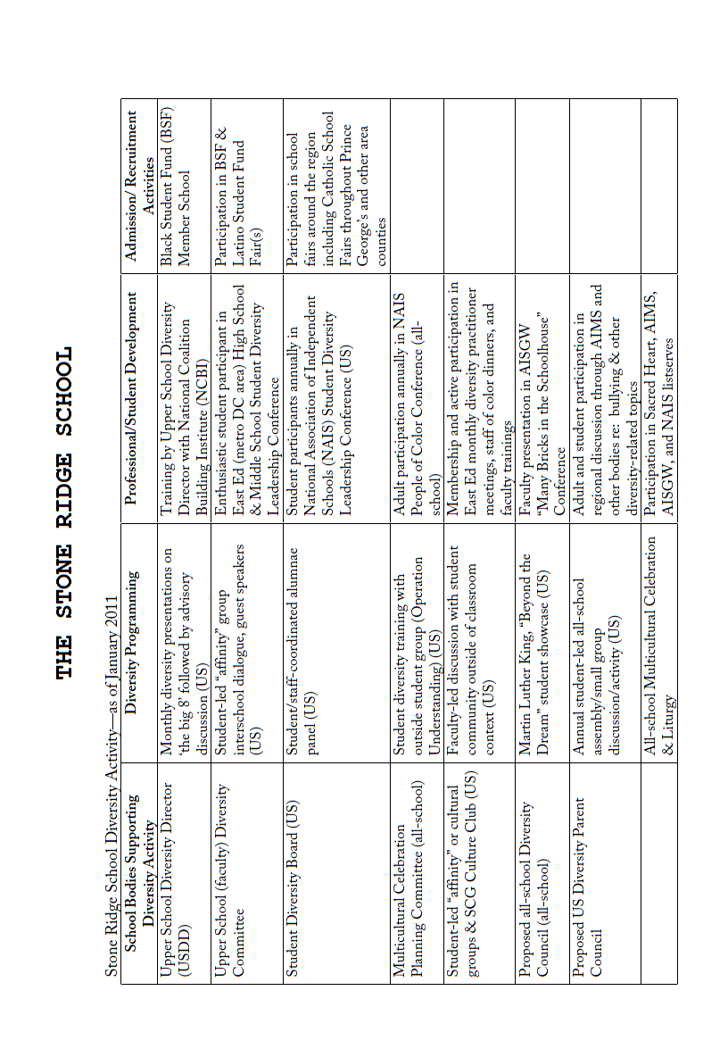
THE WASHINGTON EPISCOPAL SCHOOL
Washington Episcopal School – Diversity program
Washington Episcopal School is a diverse community, where the uniqueness of each member of the school is celebrated. The WES goal is to educate the whole child in order to prepare each graduate to become a citizen of the world. At WES, a diverse student body and broad based academic excellence go hand in hand. Classrooms present students with the opportunity to freely share a range of ideas and experiences to enrich academic, social, and moral learning. Contributions from everyone in the WES community without regard to ethnicity, learning style, physical ability, race, religion, sexual orientation, or socio-economic status are encouraged and welcomed in every classroom and incorporated into the learning experience. As an Episcopal school, WES is dedicated to the Church’s mission of social justice and tolerance and strives to challenge prejudice, intolerance, racism, and oppression.

Multicultural Activities & Events
Foreign Language Night and International Potluck Dinner (2004-present) includes song, dance, and food representative of the parent/student body and the students’ study of French and Spanish.
- Field Trips
  - National Museum of African Art
  - Freer Gallery (Arts of Japan, China, Islamic World, Indian Subcontinent)
  - National Museum of the American Indian
  - Kennedy Center
  - Discovery Theatre (Smithsonian Associates)
  - Theatre Works (Freedom Train: Story of the Underground Railroad)
- Study Trips
  - Civil War sites of Antietam and Harpers Ferry (Grade 5)
  - Native American Culture in the Desert Southwest (Grade 6)
  - History and Culture of Italy (Grade 7)
  - Present and Past in France and Spain (Grade 8)
- School visits and exchanges
  - WES French Exchange Program with La Cité Scolaire Molière
  - WES Spanish Exchange Program with Granada College, Granada, Spain
- Class-sponsored events
  - Black Facts Museum (Grade 3)
  - Native American Display (Grade 5)
- Assemblies
  - Anasegromma of Ghana: African Drums, Songs, Stories, and Games
  - Tappers with Attitude
  - Arabic Music and Culture
  - Wild Zappers: Deaf Dance Theatre
  - India: Its Culture, Costumes, and Classical Dance
  - Fabulous Chinese Acrobats
  - School productions such as sixth-grade musicals including Fiddler on the Roof, The King and I, and Aladdin with multi-cultural theme
- Middle School Advisory Meetings
  - Students meet weekly with their advisors. Meetings often involve discussions of diversity issues.
  - A delegation of WES seventh- and eighth-grade students regularly attends the Annual Diversity Conference for Middle School Students. WES students have been peer facilitators for the past several years leading group discussions and diversity activities. These students continue to discuss issues related to diversity in the Advisory Meetings and plan ways to bring additional awareness-raising activities to the entire WES Middle School.
- Speakers
  - Dr. Freeman Hrabowski, III (President, University of Maryland Baltimore Campus)
  - Robert Goodwin (Immediate Past President and CEO of Points of Light Foundation)
- School Chapels
  - Interfaith Thanksgiving Chapel Service (1998-present) offering prayers of thanksgiving from the Christian, Jewish, Muslim, Hindu, and Buddhist traditions.
  - Martin Luther King, Jr. Annual Chapel featuring local African-American speakers including Rev. Michele Hagans (Bishop's representative to the WES board), James Woody (Executive Director of the Bishop John T. Walker School for Boys), Rev. John Harmon (former WES parent and board member), Rev. Preston Hannibal (Canon for Academic Ministries, Episcopal Diocese of Washington, DC), and Karen Hastie Williams (former clerk to Justice Thurgood Marshall and daughter of first African American federal judge in the U.S.).
  - Other chapels with speakers such as James Woody (Executive Director of the Bishop John T. Walker School for Boys).
THE WASHINGTON INTERNATIONAL SCHOOL
The Washington International School is a community of learners composed of staff, students and parents who are citizens of more than 90 countries.
Our faculty (104 full and part-time teachers) comes from more than 30 countries.
Our parents and students are citizens of more than 60 countries. Approximately 25% of our households are made up of individuals who are all U.S. citizens while another 25% are made up of individuals who are all non-US citizens. The remaining 50% of households have mixed citizenships.
On average, about 30% of each graduating class is made of students who we call “lifers.” These are students who have attended WIS from at least Grade 1 through Grade 12. As might be expected at an international school, we also have a number of students who attend WIS for only a few years because a parent (or both parents) has a temporary work assignment in Washington, D.C. We also have students who attend WIS, transfer overseas and then return to WIS when the family comes back to the DC area. So many of our students have lived outside of the U.S.
Over the past three school years, the percentage of Black/African American, Hispanic/Latino and Multiracial enrolled students at WIS has gradually increased while the percentage of White/Caucasian enrolled students has decreased.

